2014

Christmas Competition

This years fun Christmas competition was played in beautiful weather as the rain stopped for just one day to allow us to play.

Special thanks to Ross for providing the hot drinks and Callum for setting up.

Four rounds were played in glorious sunshine and with the smell of French baguette's in the back ground from the French market, with last years winners Keith & Sue beating Callum & Toby in round 1 and Ross & Dawn topping the round with a 13 - 3 over Alex & Cassie, and a win for David & Alice over Stefan & Brian.

Stefan & Brian got their first win in round 2 over Keith and Sue with a 13 - 5 win and Alice & David beat Ross & Dawn. Alex & Cassie then played exceptionally well to beat Callum & Toby 13 - 8 with both Alex & Cassie firing several boules out on a number of ends.

Alex & Cassie form continued in round 3 beating Alice & David 13 - 5 and Callum & Toby got off the marking against Stefan & Brian. Ross & Dawn then got their second win of the day over Keith & Sue.

The final round saw every team in with a chance of making the top 2 and therefore the final.

David & Alice, despite taking a 7 - 0 lead over Callum & Toby found themselves at 10 - 10 in a very close match before Callum took out his own boule leaving David & Alice with the 3 points needed for their 3rd win to top the table as Toby couldn't make his boules count.

Brian & Stefan beat Ross & Dawn but finished below them on points difference. This meant a win for Alex & Cassie would see them through to the final, however with the match tied at 11-11 Keith fired out their boule to win the game.

So 4 teams had 2 wins but with +6, meant Ross & Dawn got through to face David & Alice.

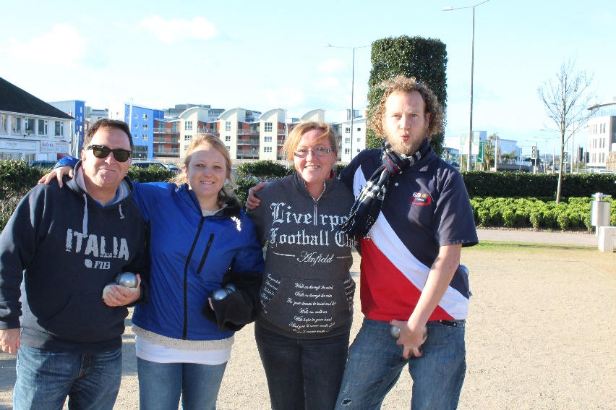

Despite Ross & Dawn moving into an early lead with Ross's trade mark coche moves it was an easy ride for David & Alice winning 13 - 4.

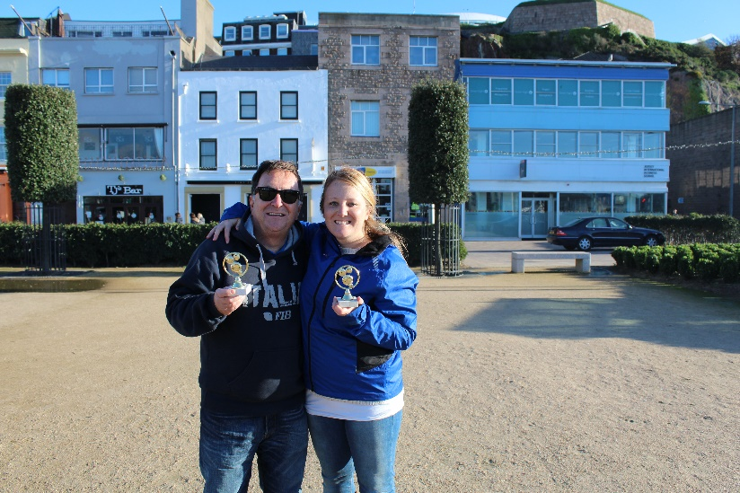

Just one more week before the Christmas break and

Thanks to the Ha'Penny Bridge for continued sponsorship.

Have a great weekend

Kind Regards

Toby

