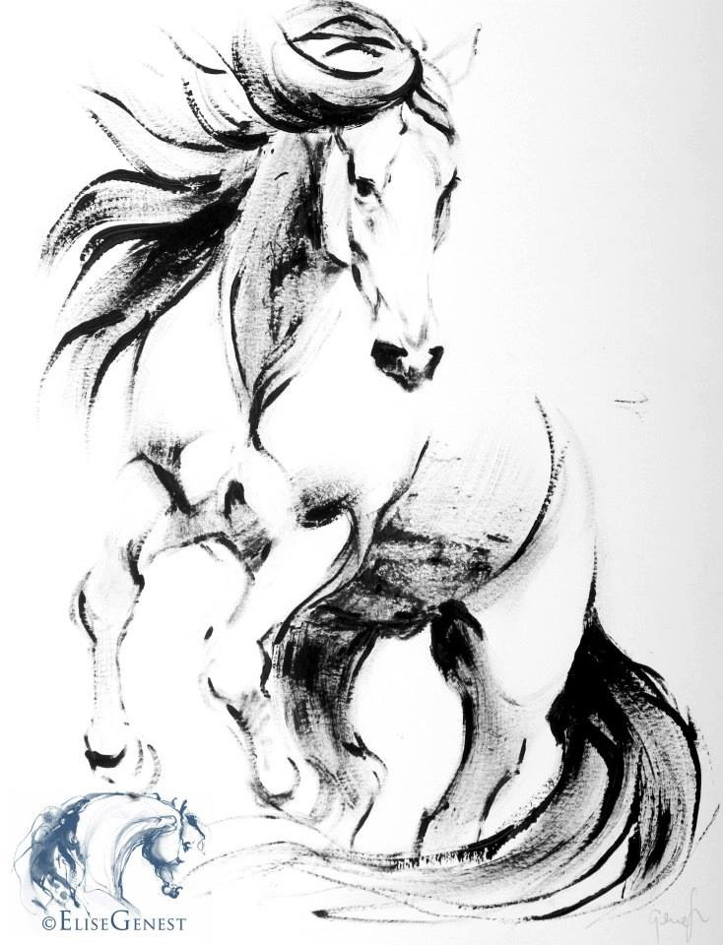

TRANSITONS BIRTHDAY PARTY REGISTRATION FORM

CHILD(REN) INFORMATION
CHILD 1
Last Name ______________________________ First Name ________________________________ Gender ____________________________ Birthday ___________________
Any Medical Restrictions/ Allergies_____________________________________________________________
CHILD 2
Last Name ______________________________ First Name ________________________________ Gender ____________________________ Birthday ___________________
Any Medical Restrictions/ Allergies _____________________________________________________________

PARENT/ GUARDIAN INFORMATION
MOTHER
Mothers - Last Name ______________________________ First Name _____________________________ E-mail __________________________________
Home Phone ____________________________ Cell Phone ______________________________
FATHER
Fathers - Last Name ______________________________ First Name _____________________________ E-mail __________________________________
Home Phone ____________________________ Cell Phone ______________________________
Medical Insurance Company___________________________________________________________________
ASSUMPTION OF RISK/WAIVER OF LIABILITY

As the parent/legal guardian of the above-mentioned person(s), I am fully aware of the potential dangers, including the risk of catastrophic injury, paralysis, and even death, as well as other damages and losses associated with participation in a sport or activity involving height or motion. I am fully aware that height and motion are inherent to the programs offered by Transitions Equestrian Center, and I hereby give my consent for my child(ren) or the person I am guardian for, to participate. I, as the parent or guardian of the above-mentioned person(s), agree and acknowledge that I have made a voluntary choice to allow my child(ren) or person I am guardian for, to participate in these activities at Transitions Equestrian Center with the risk that such activities present. In consideration of being permitted to participate in any horse riding activity program, event or competition, at Transitions, I agree to assume any and all risk of injury or death which might be associated with, or result from the participation in such activities by my child(ren)’s or the person I am appointed guardian for. I agree to accept all responsibility for the risks, conditions and hazards which may occur whether now known or unknown, on behalf of myself and/or my child(ren) or for the person I am appointed guardian for. I further agree that I will accept and abide by all rules and regulations of Transitions Equestrian Center as well as any and all obligations that may be imposed by law. I further agree to indemnify and hold harmless Transitions, its affiliates, owners, directors, sponsors, agents and their heirs and assigns, for any claim, demand, losses, or damages arising out of any personal injury or property damage to me, to my child(ren), or to the person I am guardian for, or any other person as a result of participation in this activities by my child(ren) or by the person I am guardian for. TO HELP PREVENT INJURIES ALL CHILDREN RIDING HORSES MUST DRESS IN LONG PANTS AND CLOSED SHOE WITH A LOW HEEL. WE WILL PROVIDE RIDING HELMETS BUT, YOU ARE WELCOME TO BRING YOUR OWN OR A CERTIFIED BIKE HELMET. ALSO PLEASE REMIND YOUR CHILDREN NO YELLING OR RUNNING AROUND THE HORSES IN THE BARN AREA

PERMISSION TO TREAT

I fully understand that Transitions staff members are not physicians or medical practitioners of any kind. With the above in mind, I hereby provide my express consent that Transitions Staff may call our doctor, _________________________________________ , at telephone no. _______________________ , and in addition, may seek medical help, including transportation, such as the calling of an ambulance for my child(ren) or the person I am guardian for. I agree to provide for all medical expenses incurred by me as a result of injury sustained by my child(ren) or the person I am guardian for, while participating at Transitions Equestrian Center.

PHOTO RELEASE
I grant permission to Transitions to use photographs or videos of my child(ren) or the person I am guardian for, for promotion of Transitions Equestrian Center .
SIGN HERE
I have fully read and understand this agreement and all of its terms. I have signed this agreement freely and voluntarily agree that it
is binding upon me, my child(ren) or the person I am guardian for, including my heirs, assigns and legal representatives.

Signature of Parent/Legal Guardian ___________________________________________ Date _________________________

Transitions Equestrian Center • 2525 E. 850 N. • La Porte, IN 46350 • {219} 778-9592 • Transitionshorses@gmail.com • Transitionsequestriancenter.com
.

