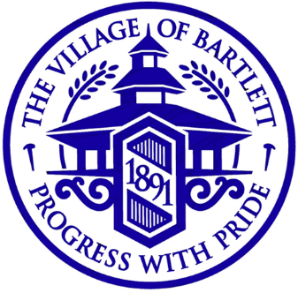
Plans Examiner/Inspector
Bartlett, Illinois
Village of Bartlett
228 South Main Street
Bartlett, IL 60103
Phone: 630-837-0800
Website: www.bartlettil.gov
Starting Salary: $70,000
Population: 42,000
Application Deadline: Open until filled

PLANNING AND DEVELOPMENT SERVICES DEPARTMENT
PLANS EXAMINER/INSPECTOR
The Village of Bartlett, IL (population 42,000), is a progressive, growing community located 35 miles west of downtown Chicago in Cook, DuPage and Kane Counties. The Planning and Development Services Department is seeking Plan Reviewer.
The Plan Reviewer will review plans, specifications and other submitted material for compliance with building codes, policies and jurisdiction requirements for commercial, industrial and residential buildings, both for new construction or renovation to existing buildings. This position is also responsible for serving as the co-project manager for the OpenGov online system, and serving as the CRS Coordinator. Other duties include performing inspections and preparing monthly and yearly reports for each county and updating building codes, handouts and the web page as needed. This person will work collaboratively to review specific building applications and will work with inspectors to resolve field related code issues and will coordinate activities with other departments as directed.
This position requires excellent written and verbal communication skills as well as a high level of customer service. Additionally, this position will require the ability to work well independently and as part of a team to meet timely demands of the department.
The ideal candidate will possess an associate’s degree in engineering, or construction management, with four to six years’ experience in design and construction or an equivalent combination of education and experience sufficient to successfully perform the essential duties of the job as listed above. Selected candidate must have ICC certifications as a Commercial Building Inspector, Residential Building Inspector, Commercial and Residential Plans Examiner or ability to obtain within the first year of employment.
The Plan Reviewer is a full-time, non-union, exempt position. The starting salary is $70,000. The Village of Bartlett offers a generous benefits package, including: medical, dental and life insurance; pension; paid vacation, personal and sick leave; post-retirement health savings plan; and deferred compensation plans.
Applicants must apply on-line at: www.bartlettil.gov
Position open until filled

~ The Village of Bartlett is an Equal Opportunity Employer ~

