REGULAR MEETING
JANUARY 21, 2014

A Regular Meeting of the Town Board of the Town of Hampton, County of Washington and the State of New York was held at the Town Hall, 2629 State Route 22A, Hampton, New York on the 21st day of January, 2015.

PRESENT: David K. O’Brien----------Supervisor
Tamme Taran---------------Councilwoman
David Jensen----------------Councilman
Donald Sady----------------Councilman
Andrea Sweeney-----------Councilwoman
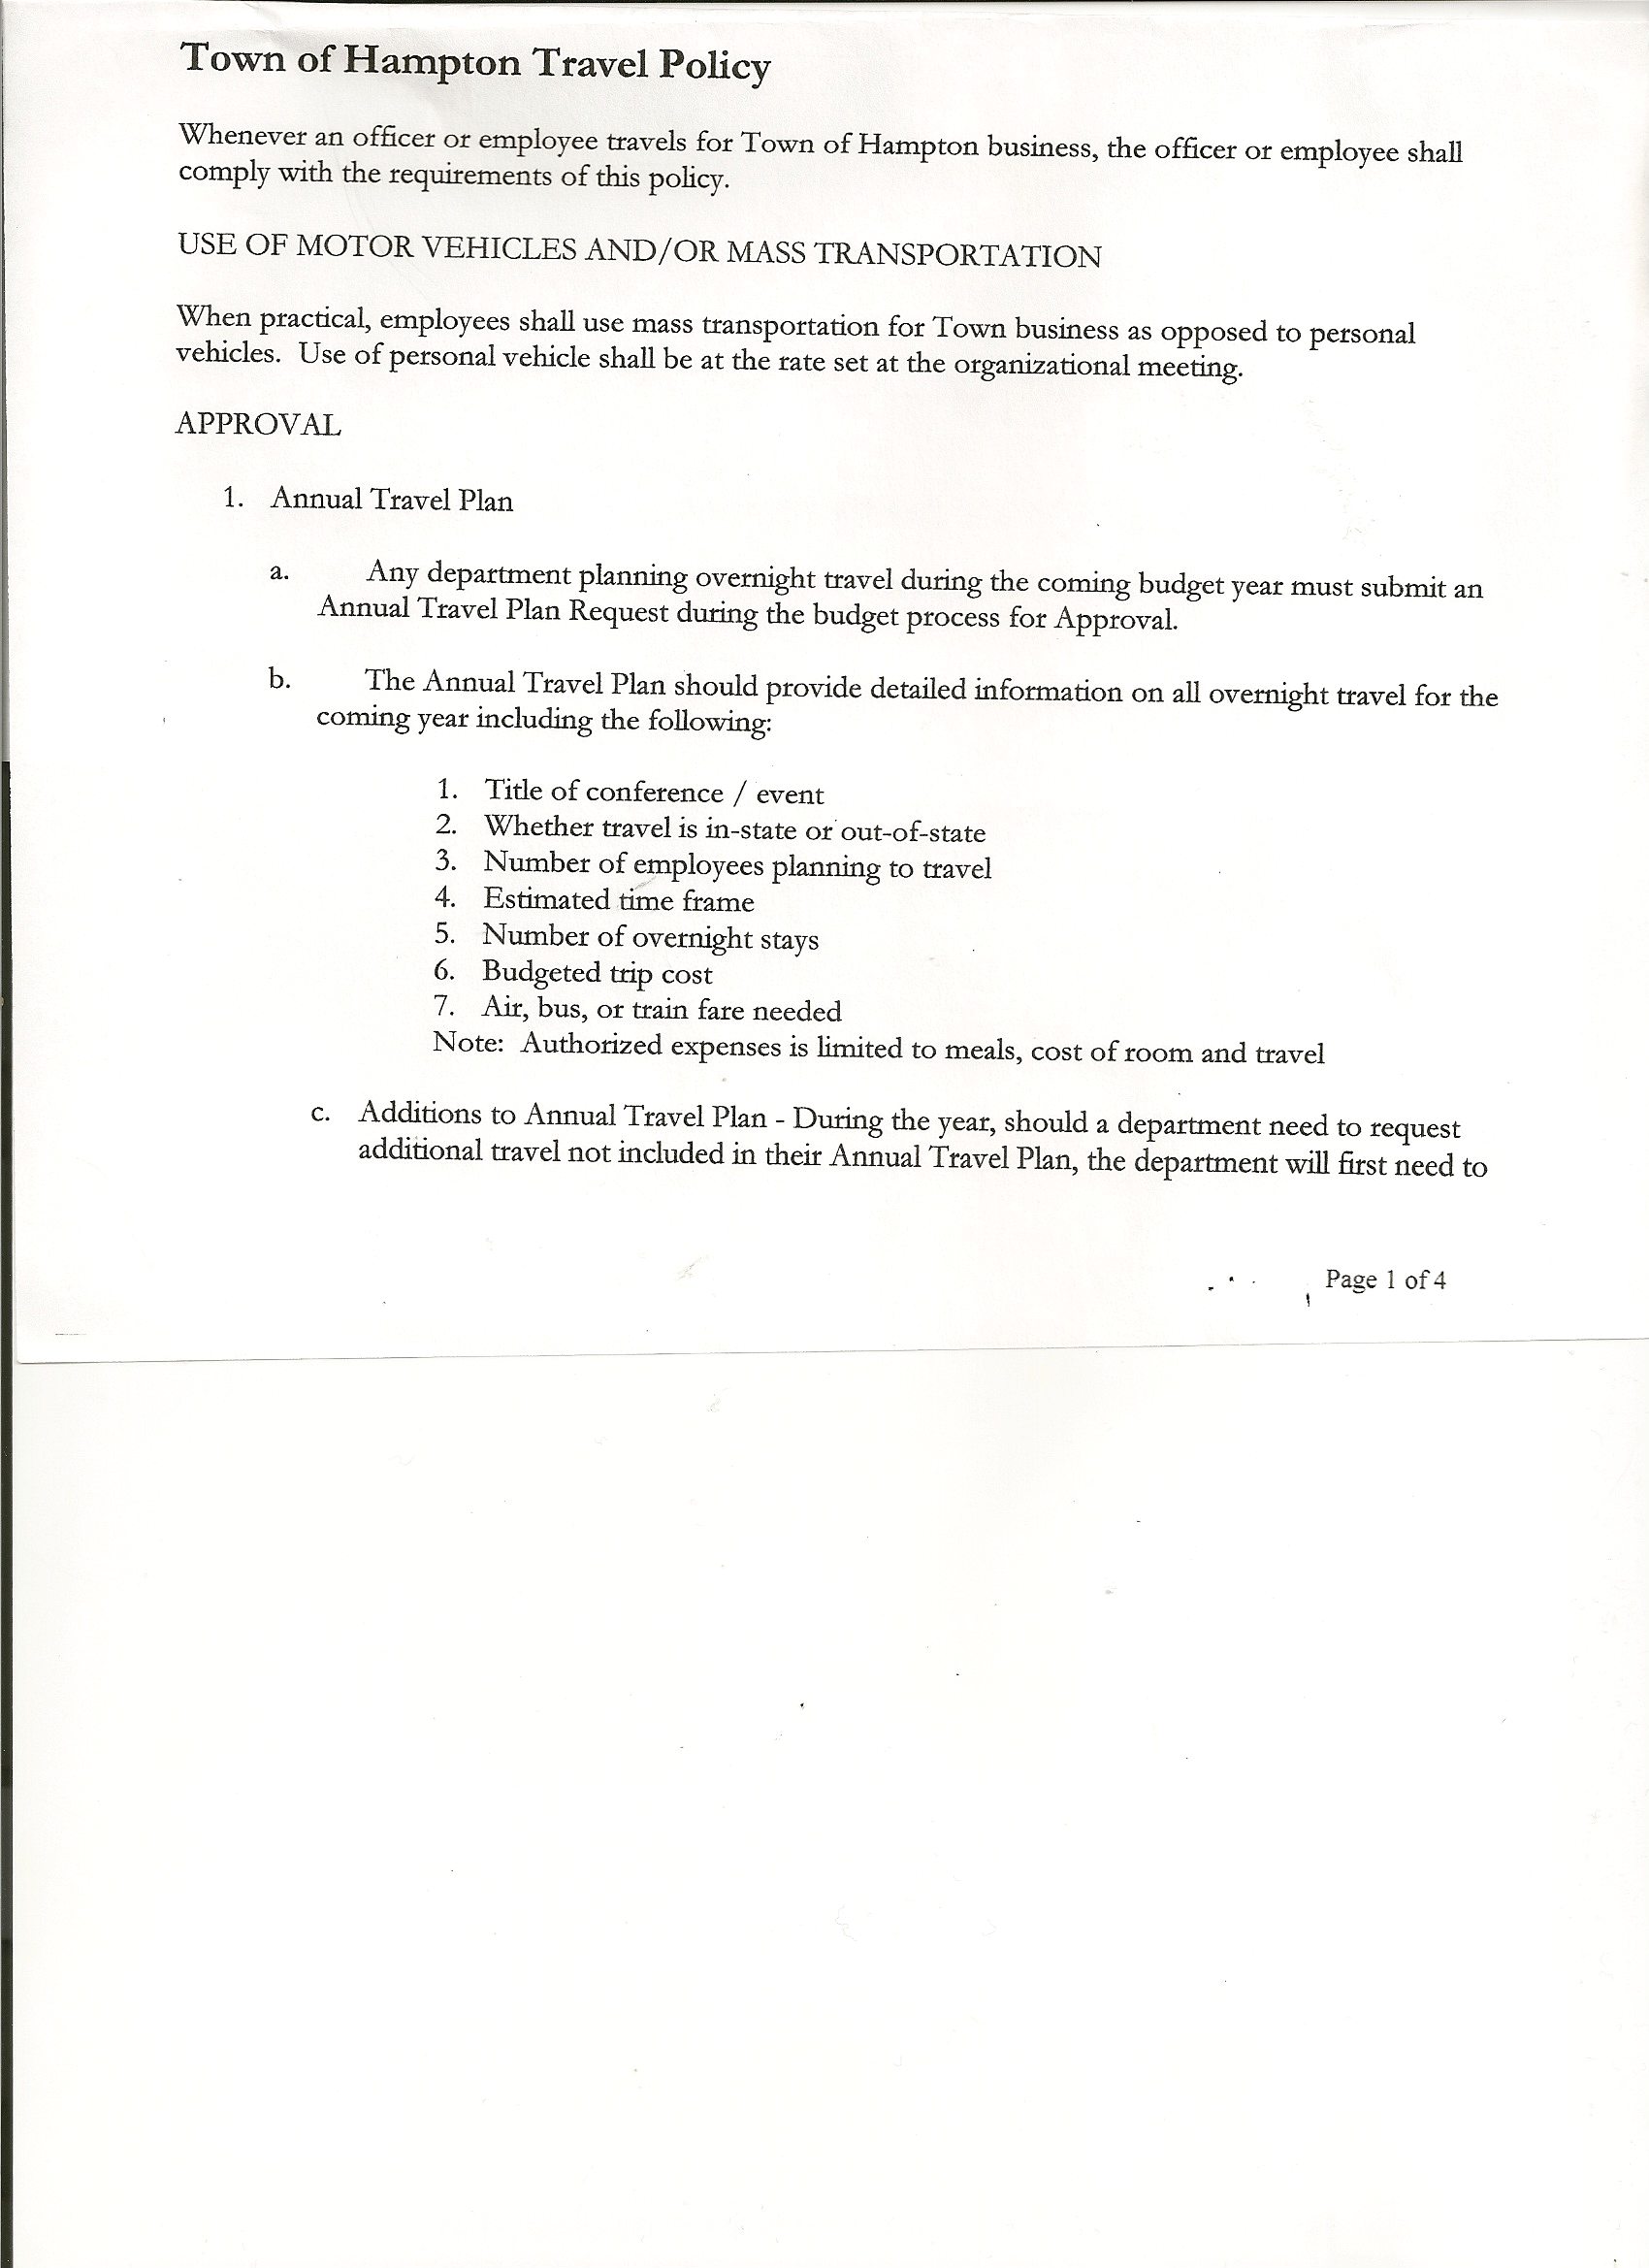 Rebecca Jones--------------Town Clerk
Camilla Shaw---------------Tax Collector/Deputy Town Clerk
Herbert Sady, Jr.------------Highway Superintendent

Planning Board Member(s): no one present

Also present: Artie Pratt and Matthew Pratt

The meeting was called to order by Supervisor O’Brien at 7:30pm followed by the Pledge of Allegiance. Location of Fire Exits was given.

RESOLUTION NO. 6-2015
APPROVAL OF THE MINUTES
On a motion of Councilman Sady, seconded by Councilwoman Taran, the following resolution was
ADOPTED: Ayes 5 O’Brien, Taran, Jensen, Sady, Sweeney
Nays 0
RESOLVED that the Regular Town Board Minutes for December 17th, 2014; the Special Town Board Minutes for December 29th, 2014 and the Special Town Board Minutes for January 1st, 2015 are approved.

Camilla Shaw, Tax Collector reported that she has collected over $160,000.00 thus far, representing 210 parcels.

No Planning Board Report-no members present

RESOLUTION NO. 7-2015
APPOINT PLANNING BOARD MEMBERS
On a motion of Councilman Sady, seconded by Councilman Jensen, the following resolution was
ADOPTED: Ayes 5 O’Brien, Taran, Jensen, Sady, Sweeney
Nays 0
RESOLVED, to appoint Bonnie Hawley as Chairwoman of the Planning Board and Timothy Richards, Francis Baker, Dianna Sofia as Members of the Planning Board.

Larry Carman, Dog Control Officer – no report submitted

TOWN BOARD MEETING
JANUARY 21, 2015 PAGE 2

Herbert Sady, Jr., Highway Superintendent gave his report: (a copy is attached)
- Fellas doing preventive maintenance on equipment
- George Palmer had a mishap with the ’97 International- he went off the Hickey Road, no one was hurt and truck was able to be pulled back on the road with the grader, driver’s side mirror was damaged.
- Issue on Hills Pond Road and Roberts Lane with mud
- Dealt with icy roads on Sunday

Alternative Sentencing will be priming and painting outside of Town Garage sometime this year.

Condition of County Route 18 was discussed… Supervisor O’Brien will meet with County DPW next week.
RESOLUTION NO. 8-2015
BUDGET AMENDMENT
On a motion of Councilman Sady, seconded by Councilwoman Taran, the following resolution was
ADOPTED by Roll Call Vote: Supervisor O’Brien AYE
Councilwoman Sweeney AYE
Councilman Sady AYE
Councilwoman Taran AYE
Councilman Jensen AYE
RESOLVED that, the following Budget Amendments to the General Fund are approved:
Increase Other Unclassified Revenues Account A2770 in the amount of $15241.27
Increase Contingent Fund Account A1990.4 in the amount of $15241.27
Increase Supervisor CE Account A1220.4 in the amount of $668.80
Increase Tax Collector CE Account A1330.4 in the amount of $453.89
Increase Central Printing & Mailing CE Account A1670.4 in the amount of $1187.76
Increase Garage CE Account A5132.4 in the amount of $2552.15
Increase State Retirement Account A9010.8 in the amount of $4000.00
Increase Attorney CE Account A1420.4 in the amount of $19.00
Decrease Supervisor Personal Service Account A1220.1 in the amount of $660.00
Decrease Contingent Fund Account A1990.4 in the amount of $8221.60

RESOLUTION NO. 9-2015
BUDGET AMENDMENT
On a motion of Councilman Sady, seconded by Councilwoman Taran, the following resolution was
ADOPTED by Roll Call Vote: Supervisor O’Brien AYE
Councilwoman Sweeney AYE
Councilman Sady AYE
Councilwoman Taran AYE
Councilman Jensen AYE
RESOLVED that, the following Budget Amendments to the Highway Fund are approved:
Increase General Repairs PS Account DA5110.1 in the amount of $1112.32
Increase Snow Removal CE Account DA5142.4 in the amount of $9659.64

TOWN BOARD MEETING
JANUARY 21, 2015 PAGE 3

Increase State Retirement Account DA9010.8 in the amount of $2161.00
Increase Social Security Account DA9030.8 in the amount of $ 45.61
Increase Consolidated Highway (Income) Account DA3501 in the amount of $5641.89
Decrease General Repairs CE Account DA5110.4 in the amount of $14212.85

RESOLUTION NO. 10-2015
APPROVAL OF SUPERVISOR’S MONTHLY REPORT
On a motion of Councilwoman Taran, seconded by Councilman Sady, the following resolution was ADOPTED Ayes 5 O’Brien, Taran, Jensen, Sady, Sweeney
Nays 0
RESOLVED that the Supervisor’s Monthly report be accepted as submitted for DECEMBER 2014.
11/30/14 12/31/14
ACCOUNT BALANCE RECEIPTS DISBURSEMENTS BALANCE
General Fund $ 49822.01 $ 6290.37 $ 17578.46 $ 38533.92
Highway Fund $ 55694.44 $ 4.45 $ 23468.49 $ 32230.40
Equipment Reserve $ 85145.32 $ 7.23 $ 0.00 $ 85152.55
Fire #1 $ 15997.55 $ 1.21 $ 15992.50 $ 6.26
Fire #2 $ 2362.00 $ 0.00 $ 2362.00 $ 0.00
Totals $ 209021.32 $ 6303.26 $ 59401.45 $155923.13

All Board Members present signed Supervisor’s Report.
The Supervisor’s Report for the Year 2014 was given out to Board Members for their information and review.
01/01/14 12/31/14
ACCOUNT BALANCE RECEIPTS DISBURSEMENTS BALANCE
General Fund $ 41083.90 $ 106901.30 $ 109451.28 $ 38533.92
Highway Fund $ 22909.42 $ 220394.43 $ 211073.45 $ 32230.40
Equipment Reserve $ 64161.28 $ 20991 .27 $ 0.00 $ 85152.55
Building $ 1349.10 $ 60.21 $ 1409.31 $ 0.00
Fire #1 $ 0.00 $ 31991.26 $ 31985.00 $ 6.26
Fire #2 $ 0.00 $ 4724.00 $ 4724.00 $ 0.00
Totals $ 129503.70 $ 385062.47 $ 358643.04 $155923.13

County Updates/Communications
- Probation Officers okayed to carry firearms
- Memo from Washington County Community Engagement Stakeholders Group
Regarding Communities NOW outreach (copy attached)
- Right to Farm Law…ours does not have a limit on income levels as some towns do…leaving our Law the way it is
- Records room as been reconfigured

TOWN BOARD MEETING
JANUARY 21, 2015 PAGE 4

RESOLUTION NO. 11-2015
END OF YEAR AUDITS
On a motion of Councilwoman Taran, seconded by Councilman Jensen, the following resolution was ADOPTED Ayes 5 O’Brien, Taran, Jensen, Sady, Sweeney
Nays 0
RESOLVED, to accept the Audits for 2014 for the Town Justice, Town Clerk, Tax Collector and Bookkeeper.

RESOLUTION NO. 12-2015
AUTHORIZE TO PRE-PAY ITEMS
MOTION BY: COUNCILMAN DONALD SADY
SECONDED BY: COUNCILMAN DAVID JENSEN

TITLE: RESOLUTION AUTHORIZING THE TOWN SUPERVISOR TO PAY BILLS
IN ORDER TO AVOID PENALTIES AND INTEREST

WHEREAS, the Town has determined that due to certain bills being due prior to the Town Board Audit of bills,

AND WHEREAS, the Town Board is desirous of avoiding late fees, penalties and interest and maintain its good credit standing,

NOW THEREFORE, BE IT RESOLVED:
That the Town Board of Hampton hereby authorizes the Supervisor to approve the payment of bills before audit if in the reasonable discretion of the Supervisor, it is necessary to do so to avoid any costs, penalties, interest or termination of service. The supervisor may pay claims for public utilities, postage, freight and express charges, before they are audited. The term “public utilities” includes electric, gas, water, sewer and telephone services and the purchase of fuel oil. All claims must be presented for audit at the next regular board meeting audit. The claimant and the town officer incurring or approving these claims are jointly and severally liable for any amount disallowed upon audit.

BE IT FURTHER RESOLVED:
That the Town Board is not required by law to pre- audit payments of fixed salaries, compensation of officers or employees, principal and interest indebtedness, or amounts coming due on certain contracts
BE IT FURTHER RESOLVED that in the absence of the Supervisor, the Deputy Supervisor is authorized to review the bills and make the determination to authorize payment for the same reason.
BE IT FURTHER RESOLVED that the Town Clerk is hereby authorized and directed to add the following policy to the policy manual/employee handbook for the Town of Hampton.

TOWN BOARD MEETING
JANUARY 21, 2015 PAGE 5

DATED: January 21, 2015 Supervisor O’Brien AYE
Councilwoman Sweeney AYE
Councilman Sady AYE
Councilwoman Taran AYE
Councilman Jensen AYE

RESOLUTION NO. 13-2015
STANDARD WORK DAY and REPORTING RESOLUTION
On a motion of Councilman Sady, seconded by Councilwoman Taran, the following resolution was ADOPTED Ayes 4 Taran, Jensen, Sady, Sweeney
Nays 0
Abstain 1 O’Brien
RESOLVED that the Standard Work Day and Reporting Resolution for Elected and Appointed Officials (RS 2417-A) be approved. (Copy is attached)

RESOLUTION NO. 14-2015
APPOINT BOARD OF ASSESSMENT REVIEW MEMBER
On a motion of Councilman Sady, seconded by Councilwoman Sweeney, the following resolution was ADOPTED Ayes 5 O’Brien, Taran, Jensen, Sady, Sweeney
Nays 0
RESOLVED to appoint Cynthia Hollister to the Board of Assessment Review to fill out the unexpired term of David Bridges.

Hampton Fire Department…2014 Report of Calls/Training and Budget was submitted by President Justin Perry. Supervisor O’Brien also discussed various grants that the Fire Department may want to apply for, contact person at the County willing to help with filing of these grants. Also would like there to be a discussion with Fire Department regarding ownership of building.

Annual Report of payments from the County to the Town for fiscal year 2014 was received . (Copy is attached).

The Town Clerk’s report for December 2014 was submitted to the Board. The Town Clerk had Board Members review and sign bank reconciliation statements for the Town Clerk Account and Special Town Clerk Account dated December 31st, 2014.

TOWN BOARD MEETING
JANUARY 21, 2015 PAGE 6

RESOLUTION NO. 15 -2015

AUDIT OF CLAIMS
On a motion of Councilman Sady, seconded by Councilwoman Sweeney the following resolution was ADOPTED Ayes 5 O’Brien, Taran, Jensen, Sady, Sweeney
Nays 0
RESOLVED that the bills have been reviewed by the Town Board and are authorized for payment in the following amounts.
General Fund No. 1 through No. 17 $ 7289.15
Highway Fund No. 1 through No. 14 $ 2765.40
Total both funds $ 10054.55

On a motion of Councilwoman Taran, seconded by Councilman Sady , the meeting adjourned at 8:45pm. All in favor Aye.

Respectfully submitted,

Rebecca S. Jones, RMC
Town Clerk

