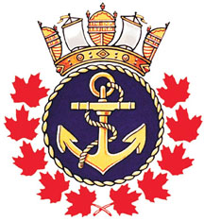 | ROYAL CANADIAN SEA CADET CORPS “REPULSE”  P.O. BOX 2071  SARNIA, ON N7T 7L3  SPONSORED BY  THE NAVY LEAGUE OF CANADA | 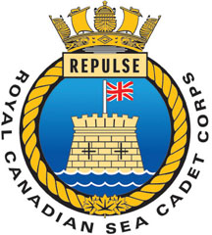

18 September 2018

Dear Parents / Guardians;

Subject: Sailing weekend

The Ships Company will be participating in a Sail training weekend at the Hamilton Training centre on Sept 21st to 23rd . This will be a great sailing experience and we look forward to having a lot of fun. Cadets will be required to arrive at the Corps by 1730 (5:30 pm) on Friday Sept 21st where they will travel by bus to Hamilton. The Cadets will be staying at HMCS Star which is on the Hamilton water front. Lt(N) Brooker will be the prime point of contact during this training, and can be reached at 519-384-8392.
Cadets will arrive at approximately at 2000 (8:00 pm) on Sunday Sept 23rd back at the corps.

If you have any question please contact through email at sarniaseacadets@gmail.com or call and leave a message at 519-337-9842

Yours Aye,

D. Anderson
Lieutenant (N) CD2
Commanding Officer
RCSCC Repulse
519-337-9842

