ENGLISH CONVERSATION CLASSES FOR PARENTS
If you would like to improve your fluency and confidence in English AND make new friends, come and try an English conversation class! These fun, friendly classes are open to all Moss Hall Parents.
Here is what a couple of Moss Hall mums have said about the classes:
“When I joined Melanie’s classes I was surprised that learning English can be so much fun! I met many people from all around the world who I can now call my friends.” Anna, Moss Hall mum
“I had a great time with Melanie's English class. The class gave me not only a plenty chance of chatting in English but also deep knowledge about English culture and customs.” Natsuki, Moss Hall mum
Classes take place every Monday, from 9.15 to 10.45 am in the Seahorse Room (at Moss Hall Infants). The first (trial) class is free.
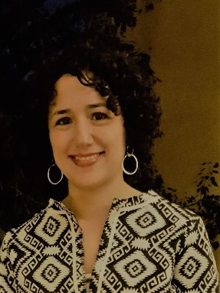
If you would like more information, please contact the teacher, Melanie Bruck, (also a Moss Hall mum!) on: 07886 323 893 / or at: melaniebruck1@yahoo.co.uk

