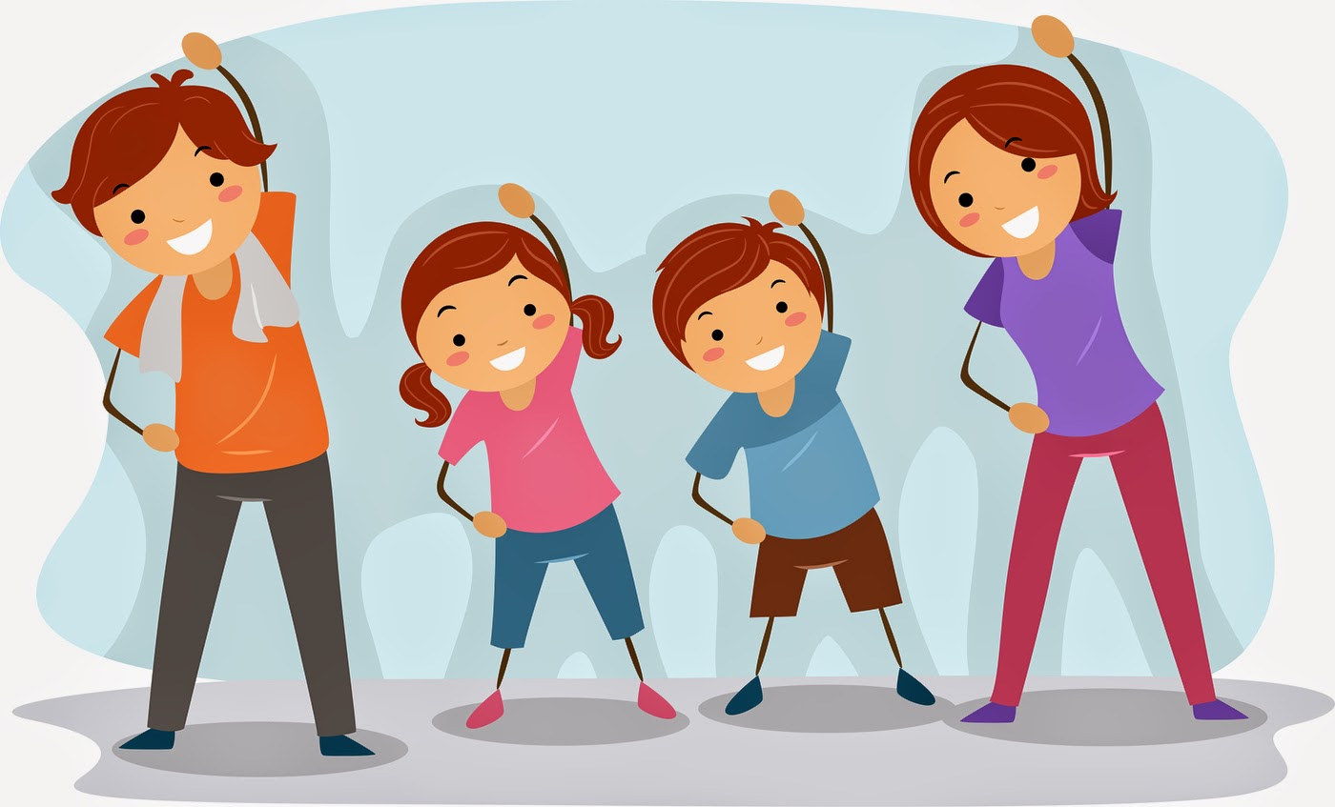

WILL U

Get the family involved?

U&YOURS

personalized to Help you create healthy family habits

Just part of your comprehensive wellness program. Find out more at www.empowerlinc.com or call a health coach today at 888.882.LINC (5462).