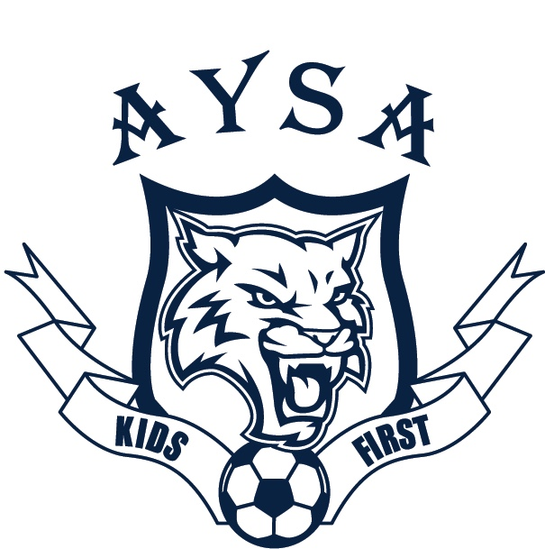
ACUSHNET YOUTH SOCCER ASSOCIATION
P.O. BOX 30089
ACUSHNET, MA 02743

Dear Business Owner/Friend:
I would like to take this opportunity to introduce myself. My name is Fabiana Nunes, and I am the new Sponsor Director, of the Acushnet Youth Soccer Association, for the upcoming 2018 season. The Acushnet Youth Soccer Association (AYSA), has held a proud tradition in our community. We have grown from 46 players at its conception to a current roster of 750 players.

This growth could not have taken place without the support and dedication of our sponsors, volunteers, families, and coaches. This community-based non-profit organization is committed to providing a high-quality youth soccer program for children at all skill level. We have both a recreational (AYSA) and a competitive travel program (Acushnet FC) geared towards meeting the desires of each child in our community.

The recreational program served upward of 54 teams in the fall last year, with instructional divisions from 6U thru 10U and competitive divisions 12U & 15U. The Primary Goal is to expose children to organized sports, to teach values of teamwork, sportsmanship & community, while fostering a love for the game.

Our organization is funded through player registrations, fundraising, and sponsorships. We strive to keep our registration fees affordable. We are able to reach these goals through collaborations with businesses such as yours. Please consider sponsoring one of our teams. In return, we would like to support your business/company and offer an opportunity for marketing and promotion of your services.

$550.00 Company name/logo on Team Shirt for 10 week time frame
Company name/logo on Team Shirt for full day tournament (Summer)
Table at Summer Day Tournament for marketing or distribution of info
2 New England Revolution Tickets for September 22, 2018.
Plaque with picture of sponsored team as well as Framed Jersey

$250.00 Company name/logo displayed for 10 week time frame at the fields
Table at Summer Day Tournament for marketing or distribution of info
2 Banquet Tickets
Plaque with picture of sponsored team

Your tax-deductible sponsorship will go toward the costs of running a quality soccer program, such as field maintenance, coach clinics, referees, balls, nets, and lower player registration fees. Enclosed you will find a sponsorship form. Please check the applicable box of sponsorship level. If you have any sponsor related questions, please contact me at nunes108@comcast.net or at (774) 242-9455.
On behalf of the AYSA, I would like to thank you in advance for your generosity.

Sincerely,

Fabiana Nunes
AYSA Sponsor Director

Like us on FACEBOOK www.Acushnetyouthsoccer.com

Acushnet Youth Soccer Association
Sponsorship Form

Acushnet Premier Sponsorship ($550.00)
Acushnet Standard Sponsorship ($250.00)

Name of Business: __________________________________________________

Signature: _________________________________________________________

Print Name:________________________________________________________

If you have a child in league please request division you would like to sponsor below.
Childs Name: _________________________________ Division/Coach: _____________

Please attach business card if possible. Thank You

Checks should be made out to Acushnet Youth Soccer Association.
Sponsorship payment deadline is May 31, 2018

