

# Summer 2018 Season

# Week 8 – 16.05.18

# Doubles League Report

# 

**Remember if you cannot play on the scheduled fixture date; please try to play in advance.**

**And**

**If you are not playing then you must email club with the date the match is rearranged for within 28 days.**

Did you know that there have now been 102 different doubles teams taking part in Liberations League’s since the clubs inception in March 2011 with 81 13 – 0 certificates being handed out.

Only 5 of the 102 teams have made it into the **100 CLUB** Hall of Fame and just 3 of those are still with their original playing partners.

To find out who – check out the 100 Club page on the clubs website and see how they fared in their first 100 matches.

The current champions Mark Nicol & Jake Romeril, already playing catch up took on Ross Payne & Neil Selby who lost to Matt Pinel & Toby Northern in the first week. It didn’t start of very well losing 6 points on the first end, but only lost another two as they won the first game 13 – 8 and went on to win the match taking the second game 13 – 9. Mark & Jake also won a catch up match against Alex & Cassie to sit on maximum points from their first two matches.

Matt Buesnel & Geoffroy Bufetrille also playing catch up took on Keith & Sue Pinel and as expected a big win for a team expected to be title challenges.

Another experienced team and probable title challenges Callum Stewart & Andrew Bellamy-Burt dropped points against Alex & Cassie Stewart with a draw.

Brian Harris & Paul Le Moine were looking for back to back wins to start of their season but were taking on experienced pair David Ibitson & Matt Ryan who handed Joey & Jonny a 13 – 0 certificate in week 1 before losing the second game. There was no slip up this time though from David & Matt as they won a close match to keep up the pace at the top.

Matt Pinel & Toby Northern looking to make back to back wins in their bid for the Premier League title took on Alan Oliveira & Craig Kelly who lost to Brian & Paul in week 1.

With a late start Alan & Craig were playing catch up in game one, but despite several chances, including one end where they were holding 3 but a coche move with the last boule gave the point away, the end result a 13 – 0 defeat. It didn’t get that much better in game two as Matt & Toby ran out 13 – 3 winners to top the table on points difference.

**Outstanding Matches**

James Rondel & Tom McMinigal v Geoffroy Buffetrille & Matt Buesnel

James Rondel & Tom McMinigal v Joey Le Clech & Jonny Hill

**Division 1**

Alice & Brigitte Ibitson were looking for another win to keep up the pace and head towards the Premier League against Christophe & Iwona, it would have been an upset if it was anything other than a win for Alice & Brigitte who duly obliged.

Alan Mitchell & Mike Robinson took on returning pair Martin & Teresa Koradi who were beaten 13 – 0 in their first match against Karen & Colin Hidrio. They faired a better though this time getting their first point of the season.

Harrison Marie & Richard Williams took on Jean Stewart & Chris Le Gallais and a close affair resulting in a draw.

**Outstanding Matches**

Paul Bell & David Le Gresley v Eamonn & Karen Bougeard

Jean Stewart & Chris Le Gallais v Eamonn & Karen Bougeard

Colin & Karen Hidrio v Laurent Pellaton & Matt Hutchings

Colin Myers & Steve Simpkin v Mo De Gruchy & Stephen Stoneman

Super 6 matches played – would you have got it right? Have a go next week and test your knowledge.

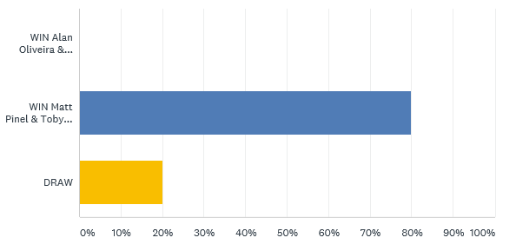

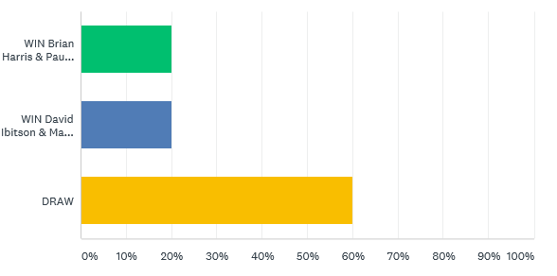

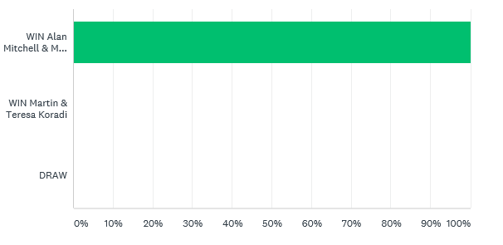

Best of Luck to everyone

***NEXT WEEK***

**23rd May – Singles League – Week 6 & 7 (Doubles Fixture Week)**

**WEBSITE** [**www.liberationpetanque.co.uk**](http://www.liberationpetanque.co.uk)

**EMAIL** [**liberationpc@gmail.com**](mailto:liberationpc@gmail.com)

**Kind Regards**

**Toby Northern**

**Chairman**

**Liberation Petanque Club**

# SPONSORED BY

# http://nebula.wsimg.com/135a1bd6338e1b589a50cdec98bd84d1?AccessKeyId=C6E923731F1A482DD910&disposition=0&alloworigin=1