**Liver Gallbladder Flush**

**Before doing this flush a bowel, parasite and Kidney cleans should be completed first. An enema or colema should be completed on the day of the flush**

**Preparation**

Eat a diet high in [alkaline-forming foods](http://healthybliss.net/alkalize-your-ph-how-alkaline-acid-balance-affects-your-health/) and low in fats for at least 3-5 days before the cleanse.

Help to gently prepare the liver by having a glass of fresh apple juice every day for 1 week prior to the cleanse. Apple juice helps to dissolve the stones.

**Gallstone Live Flush Ingredients**

* Epsom salts (Magnesium Sulfate): 4 tablespoons. *(You can usually buy this at your local pharmacy.)*
* Olive oil: 1/2 cup or 125 ml (light olive oil is easier to get down).
* Fresh pink grapefruit: 1 large or 2 small, enough to squeeze 1/2 cup (125 ml) juice. (Or use 7-8 fresh lemons/limes: squeezed into 1/2 cup juice.)
* 1-liter jar with lid.

**Gallstone Liver Flush Instructions**

Choose a day like Friday for the cleanse, since you will be able to rest the next day. Take no medicines, vitamins or pills that you can do without; they could prevent success. All of the other cleanses should be completed the day before you start the liver flush. Eat a **no-fat** breakfast and lunch such as cooked cereal, fruit, fruit juice, bread and preserves or honey (no butter or milk). This allows the bile to build up and develop pressure in the liver. Higher pressure pushes out more stones.

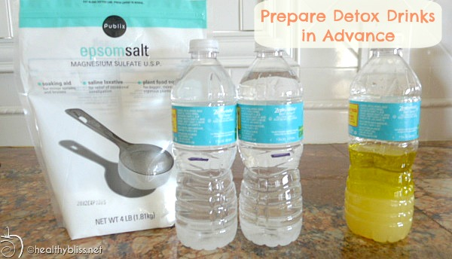

*Mix Epsom Salts and Water, marking the bottles with a black marker to know how much to drink each time*

**2:00 PM.** Do not eat or drink after 2 o’clock. If you break this rule you could feel quite ill later. Get your Epsom salts ready. Mix 4 Tbsp. in 3 cups (750 ml) water and pour this into a container or jar. This makes four servings, ¾ cup (185 ml) each. Set the jar in the refrigerator to get cold (this is for convenience and taste only). Note: make the 9:45pm drink described below at 2pm and put it in the fridge so it is ready to drink later. Making all the drinks at the last meal makes helps you to feel more committed to do the cleanse, and you can prepare everything while not feeling hungry. Do not allow any re-negotiation to skip the cleanse for another day just because you feel slightly hungry at 6pm.

**6:00 PM.** Drink one serving (¾ cup) of the Epsom salts and water drink. If you did not prepare this ahead of time, mix 1 tbs. in ¾ cup water now. You may add 1/8 tsp. vitamin C powder or 1/4 fresh lemon squeezed to improve the taste. You may also drink a few mouthfuls of water afterwards or rinse your mouth.

**8:00 PM.** Repeat by drinking another ¾ cup (185 ml) of Epsom salts and water drink. Get your bedtime chores done. The timing is critical for success.

**9:45 PM.** Pour ½ cup (measured) olive oil into the pint jar. Squeeze the citrus fruit (fresh grapefruit, lime or lemon) by hand into the measuring cup.

Remove pulp with a strainer. You should have at least ½ cup. Add this to the olive oil. Close the jar tightly with the lid and shake hard until watery. Do not drink it yet!

Now visit the bathroom one more time, even if it makes you late for your ten o’clock drink. Don’t be more than 15 minutes late. You will get fewer stones.

**10:00 PM.** Drink the potion you have mixed. Take it all to your bedside if you want, but drink it standing up. Get it down within 5 minutes (fifteen minutes for very elderly or weak persons).

**Lie down immediately**. You might fail to get stones out if you don’t. The sooner you lie down the more stones you will get out. Be ready for bed ahead of time. Don’t clean up the kitchen. As soon as the drink is down get into your bed and lie down on your **right side with your knees pulled up close to your chest**. Try to think about what is happening in the liver. Try to keep perfectly still for at least 20 minutes. You may feel a train of stones traveling along the bile ducts like marbles. There is no pain because the bile duct valves are open (thank you Epsom salts!). Go to sleep, you may fail to get stones out if you don’t. Try to sleep in this position.

**Next morning.** Upon awakening (6:00 am) take your third dose of the Epsom salts and water drink. If you have indigestion or nausea wait until it is gone before drinking the Epsom salts. You may go back to bed. Don’t take this potion before 6:00 am.

**8:00 am** (2 Hours Later.) Take your fourth (the last) dose of the Epsom salts and water. You may go back to bed again.

After 2 More Hours you may eat. Start with fruit juice (see note below). Half an hour later eat fruit (see note below). One hour later you may eat regular food but keep it light. By supper you should feel recovered.

*NOTE – Fresh apple juice is the best juice to break the fast. At 10:00am, make fresh apple juice using 5-6 large apples in a juicer and drink it. The apple juice helps dissolve gallstones and is a nice transition for the liver from the detox back to normal eating. After 30 minutes, prepare a chopped apple salad or a plain apple smoothie using 3-4 apples (with the skin is ok). If feeling unwell, stay with apples and apple juice for the entire day. Only transition to light foods, salads and regular eating when you are feeling good again.

How well did you do? Expect diarrhea in the morning. Use a flashlight to look for gallstones in the toilet with the bowel movement. Look for the green kind since this is proof that they are genuine gallstones, not food residue. Only bile from the liver is pea green. The bowel movement sinks but gallstones float because of the cholesterol inside. Count them all roughly, whether tan or green. You will need to total 2000 stones before the liver is clean enough to rid you of allergies or bursitis or upper back pains permanently. The first cleanse may rid you of them for a few days, but as the stones from the rear travel forward, they give you the same symptoms again. You may repeat cleanses at two week intervals. Never cleanse when you are [acutely] ill.

Sometimes the bile ducts are full of cholesterol crystals that did not form into round stones. They appear as a “chaff” floating on top of the toilet bowl water. It may be tan colored, harboring millions of tiny white crystals. Cleansing this chaff is just as important as purging stones.

*How safe is the liver cleanse?* It is very safe, based on a study of over 500 cases, including many persons in their seventies and eighties that completed the cleanse. None went to the hospital; none even reported pain. However, it can make you feel quite ill for one or two days afterwards, although in every one of these cases the bowel and parasite and kidney program had been neglected before starting the liver cleanse. This is why the instructions direct you to complete the bowel, parasite and kidney cleanse programs first.

**CONGRATULATIONS**