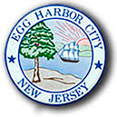
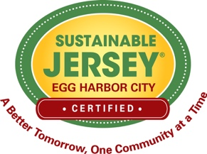

Egg Harbor City Tree Request Form

Property Owner Name:
Address of Property:
Block & Lot Numbers:
Telephone:
Email Address:
No. of Trees Requested: | One  Two
Species Requested:  (Based on availability) | Small (20-30 feet)  Redbud (Cercis Canadensis)  Okame Flowering Cherry (Prunus Okame)  Japanese Ivory Silk Tree (Syringa Reticulata)  Medium (35-40 feet)  American Hornbeam (Carpinus Caroliana)  European Hornbeam (Carpinus Betulus)  Sweetbay Magnolia (Magnolia Virginiana ‘Green Mile’)  Large (40-80)  October Glory Red Maple (Acer Rubrum ‘October Glory’)  Shademaster Honey Locust (Gledistia Triacanthos)  Swamp White Oak (Quercus bicolor)  Willow Oak (Quercus Phellos)  American Linden/Basswood (Tilia Americana ‘Redmond’)  Green Mountain Silver Linden (Tilia Tomentosa ‘Green Mt.’)  Green Vase Zelkova (Zelkova Serrata ‘Green Vase’)
Width of Curb Lawn:
*Stump Roots: | Yes  No
**Overhead Wires: | Yes  No
Location of Water Source:
*City will NOT remove stump roots
**Overhead wires will require selecting from the small tree species list

Visit www.jerseyyards.org website and use the Search Plant Database to see what your tree will look like. Delivery subject to availability and site conditions.

