Why a Founding Father hid human remains.
(www.theodysseyonline.com)
In 1998 construction work began at 36 Craven street in London. For nearly two decades leading up to the signing of the Declaration of Independence Benjamin Franklin lived here. In 1776 Franklin left his English home to come back to America. The construction work was part of a remodelling project to transform the building into a museum to honor the legacy of Benjamin Franklin. However, the project was brought to a halt when a worker replacing the basement floor found skeletal remains. A coroner was called in and the remains were confirmed to be human. Further investigation revealed over 1,200 bones, belonging to people of all ages, children and at least one infant included. A turtle and other animals were also found. Was one of the America's Founding Fathers also a mass murderer? The answer is no, though he was keeping a very dark and murky secret. Experts called in to examine the bones noted that the bones had clean cuts without signs of healing. That being said, it could be confirmed that the bodies were dismembered after death. The turtle found also contained mercury, which was a key piece of evidence. The turtle linked the bones to a close friend of Benjamin Franklin's: anatomist and father of hematology, William Hewson. One of William Hewson's most well known experiments had to do with injecting a dead turtle with mercury documenting its travel through the lymphatic system, thus leaving Hewson to be the first to realize that animals and humans shared a similar lymphatic system. William Hewson was a brilliant mind whose progressive attempts to enhance surgery and the medical practice collided with contemporary law. At the time, due to religious fears, it was illegal to perform autopsies on anyone other than executed criminals as it was believed a body not fully intact would have a hard time passing into its next chapter after death. This caused an extreme dilemma for aspiring anatomists and early medical practitioners who needed a clearer understanding of the inner workings of the human body. Most anatomists and scientists of the age had to resort to the arguably unethical yet needed method of buying stolen bodies off body snatchers who robbed graves and in some cases murdered people in order to profit off their corpse. Desperate times in the field of science were causing disturbing desperate measures. Benjamin Franklin was a supporter of scientific pursuits and had an interest in human anatomy. Because of this Benjamin Franklin allowed his good friend Hewson to run a secret and very illegal anatomy school in his own home’s basement. To say the least, Benjamin Franklin was a rebel of his era. He allowed stolen bodies to be bought and smuggled into his residence. He turned a blind eye to multiple crimes, yet created a space where medical knowledge could progress to eventually save lives. The anatomy school in his basement probably resembled a house of horrors, not the kind of secret one might fathom a Founding Father concealing. However this account amongst many others goes to show that history has many secrets. It also supports the notion that anything remotely interesting about history is censored out of high school textbooks.
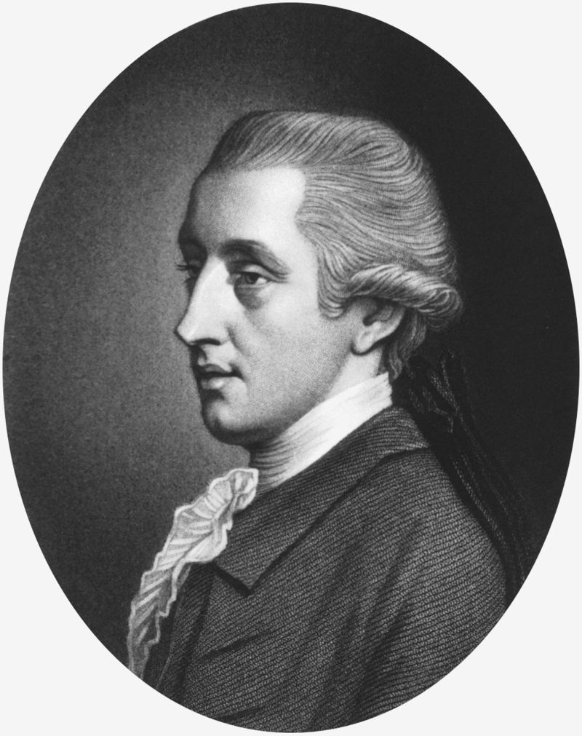
William Hewson, who died in 1774 after contracting sepsis while dissecting a cadaver.

