3rd Annual “Fore” Alarm Golf Tournament Benefiting Shallowater Fire Department

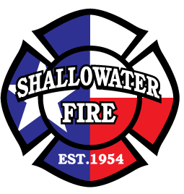

Monday August 17, 2015

Hillcrest Country Club

4011 N Boston Ave. Lubbock, TX 79410

-4 Man Scramble-

$400.00 per Team (non-refundable)

$125.00 per Person (non-refundable)

Lunch Provided

11:00 Lunch- 1:00 Shotgun Start

Mulligans $10 each (limit 2 Per Person)

Longest Drive Award & Closest to the Pin Award

1st Place Team- $100 Per Person

2nd place team- $75 Per Person

3rd Place Team- $50 Per Person

Make Check Payable To Shallowater Fire Department Auxiliary (SFDA)

All Registration Forms and Payment Must Be Turned In By August 8th

Name___________________________________Email_________________________________Phone________________________

Name___________________________________Email_________________________________Phone________________________

Name___________________________________Email_________________________________Phone________________________

Name___________________________________Email_________________________________Phone________________________

