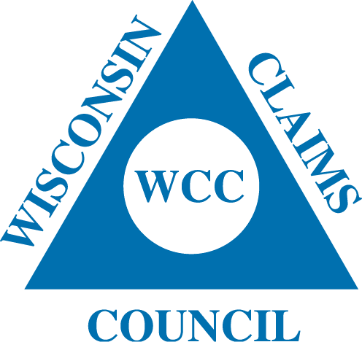
President
Jim Sutter
Society Insurance

Vice President
Axel Rathke
Acuity

Treasurer
Scott Wittliff
Acuity

Secretary
Susan McClone
Society Insurance

Sara Helbing
West Bend Mutual

Stacie Grafton
Society Insurance

Michelle Harker
West Bend Mutual

Leslie Gladwell
SECURA

Executive Committee:

Jamie Loiacono-Acuity
Bill Bunzel-Society

WISCONSIN CLAIMS COUNCIL
PRESENTS
PROPERTY SEMINAR
THURSDAY, October 20, 2022

ACUITY INSURANCE
2800 S. Taylor Drive
Sheboygan, WI

Sponsored by:
Elevate Claims Solutions
SEA

8:30 – 9:00 Registration

9:00 – 9:45 Case Law Update
Attorney Michael Wirth
Borgelt, Powell, Peterson & Frauen, SC

9:45 – 10:30 Asbestos and Lead Safety and Remediation
Rick Edgett
Paul Davis Restoration

10:30 - 10:45 Break

10:45 – 11:30 Matterport use in SIU Investigations
Garrett Boeckler
Acuity Insurance

11:30 – 12:15 Business Income Loss Calculations Post-COVID
Curt Reynolds
Insight Forensic Accountants

12:15 – 1:00 LUNCH (Included)

President
Jim Sutter
Society Insurance

Vice President
Axel Rathke
Acuity

Treasurer
Scott Wittliff
Acuity

Secretary
Susan McClone
Society Insurance

Sara Helbing
Society Insurance

Stacie Grafton
Society Insurance

Michelle Harker
West Bend Mutual

Executive Committee:

Jamie Loiacono
Acuity

Bill Bunzel
Society Insurance

WISCONSIN CLAIMS COUNCIL REGISTRATION FORM

WISCONSIN CLAIMS COUNCIL
LIABILITY SEMINAR
Thursday, October 20, 2022

ACUITY INSURANCE
2800 S. Taylor Drive
Sheboygan, WI

Company Name: _____________________________________________________________

Names and email addresses of Attendees: _________________________________________

___________________________________________________________________________
(Use the back of this form if more space is needed)

Insurance/Adjusting Personnel:
Number of People Attending: ________ (X) $50.00 each = $___________Payment Enclosed

Vendor Company Personnel:
Number of People Attending: ________ (X) $75.00 each = $____________Payment Enclosed

Please Make Checks Payable to: WCC or Wisconsin Claims Council

Mail to:
Wisconsin Claims Council
C/O Susan McClone
PO Box 1029
Fond du Lac, WI 54936

Deadline for Reservations: September 29, 2022
Find us on Facebook, Twitter@WIClaimsCouncil and www.wisccc.com

