***All details must be fully completed on the form for consideration***
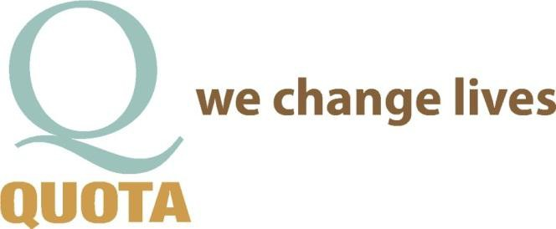
Incomplete forms will delay or reject your application.

Application for an
Individual
Requesting Funds from Quota

DATE: _______________________

How did you hear about Quota? _______________________________________________________________

APPLICANT CONTACT INFORMATION

NAME:
AGE:

PARENT OR GUARDIAN (IF APPLICABLE):

OCCUPATION: GROSS ANNUAL INCOME:

ARE YOU WILLING TO PROVIDE FINANCIAL INFORMATION? YES or NO.
If NO, WHY NOT? _______________________________________

MARITAL STATUS: SINGLE ______ MARRIED ______ SEPARATED______ DIVORCED ______
TOTAL NUMBER OF DEPENDENTS: _______ TOTAL NUMBER IN HOUSEHOLD: _______
ADDRESS CITY STATE ZIP

E-MAIL CELL PHONE# OTHER PHONE#

REQUEST FOR FUNDS: DESCRIBE IN DETAIL WHAT YOU ARE REQUESTING FUNDS FOR & EXPLAIN WHY HELP IS NEEDED.

_____________________________________________________________________________________________________________

_____________________________________________________________________________________________________________

_____________________________________________________________________________________________________________

_____________________________________________________________________________________________________________

_____________________________________________________________________________________________________________

******TO FACILITATE YOUR REQUEST PLEASE ATTACH ANY DOCUMENATION PERTAINING TO YOUR REQUEST ****** OR ADDITIONAL INFORMATION ON A SEPARATE SHEET OF PAPER

FINANCIAL INFORMATION

COST OF THE REQUESTED PRODUCT OR SERVICE:

PROVIDE A QUOTE/INVOICE OR ANY OTHER DOCUMENATION PERTAINING TO THE COST
YES I HAVE or NO I DON’T. IF NO, WHY?

WHO DOES THE PAYMENT GO TO?

WHERE DOES THE PAYMENT NEED TO BE SENT?

WHAT IS THE DEADLINE FOR THE FUNDS TO OBTAIN THE PRODUCT/SERVICE?

DOES THIS ESTIMATE INCLUDE A PROFESSIONAL DISCOUNT? YES or NO IF YES, HOW MUCH

DO YOU QUALIFY FOR BENEFITS THROUGH THE OREGON HEALTH PLAN OR VIM? YES or NO
IF YES, PLEASE DESCRIBE AND HOW MUCH?

CAN YOU OR ARE YOU PREPARED TO PAY A PORTION OF THE COST IF NEED? YES or NO
IF YES, HOW MUCH? IF NO, WHY NOT?

DOES YOUR HEALTH INSURANCE PROVIDE ANY COVERAGE? YES or NO
IF YES, HOW MUCH? _____________________________________________________________________

ARE YOU ELIGIBLE FOR FINANCING THROUGH A BANK, CREDIT UNION, FINANCE COMPANY OR FINANCIAL ASSISTANCE THROUGH THE PROVIDER OF THE SERVICE/PRODUCT? YES or NO

COMMUNITY SERVICE / QUOTA:
ARE YOU WILLING OR ABLE TO VOLUNTEER FOR A COMMUNITY SERVICE PROJECT THROUGH QUOTA?
YES or NO. IF NO, WHY NOT?

IF AWARDED A BENEFIT, CAN YOU ATTEND A QUOTA MEETING TO OFFER A BRIEF TESTIMONIAL?
YES or NO. IF NO, WHY NOT? __________________________________________________________________

SUBMIT COMPLETED REQUEST TO:

QUOTA SERVICE COMMITTEE, PO BOX 1372, BEND, OR 97709
Or EMAIL TO: quotaofcoservice@gmail.com

NOTE: THE PROCESS FOR OBTAINING FUNDING APPROVAL TAKES 30-60 DAYS
FUNDS ARE GENERALLY PAID DIRECTLY TO THE VENDOR.

QUOTA USE ONLY
APP RECEIVED: | SERVICE MTG ____ APPROVE / DECLINED  OTHER | BOARD MTG: ____________ APPROVE / DECLINED  OTHER | GENERAL MTG: __________  APPROVE / DECLINED  OTHER | CHECK REQUEST:  #

