AGMA JUDGING RULES AND JUDGING CONSIDERATIONS

WALKING MULE
Flat Walk is a true, bold, and four-cornered, with fore legs moving straight in an elevated arc, and with a pronounced and cadenced head motion. Head must be held high and proud. The rear legs should follow through close to the ground, comfortable and over striding the front tracks.
Running Walk is the same general motion as the flat walk, but with additional speed. The mule shall exhibit a smooth gliding, overstepping, four-cornered gait with the greater stride and accelerated head.
Canter is a broken three-beat gait, and should be performed in a collected manner. The mule should be relaxed and under control, should not crossfire, and should be in the correct lead. In the canter the outside rear foot hits the ground first, the inside rear and the outside front feet hit the ground simultaneously, and the inside front foot hits last. The rider should be smooth without surging or bouncing. The head will reach its highest point when the outside rear foot hits the ground, and its lowest point when the inside front foot hits the ground. The speed of the canter should be near that of the flat foot walk.
Judging Considerations: The Walking Mule should move freely in each gait and proceed in a smooth fluid, rhythmic manner, with a pronounced and cadenced head motion; head must be held high and proud. At all gaits, the mule should be flexed at the poll with muzzle slightly tucked. The rear legs should follow through close to the ground, comfortable and over striding the front tracks. The deeper the over stride the better. If a walking mule does not stand quietly, he must be penalized. Walking Mules will be ask to back and should do so readily, backing at least 3 steps, if the mule does not back, he must be penalized.

WALKING TRAIL PLEASURE MULE
Flat Walk is a true, bold, and four-cornered, with fore legs moving straight in an elevated arc, and with a pronounced and cadenced head motion. The head set should be natural, neither excessively nosed out nor over flexed at the poll, head must not be held to low but not as high as the walking mule. The rear legs should follow through close to the ground, comfortable and over striding the front tracks.
Running Walk is the same general motion as the flat walk, but with additional speed. The mule shall exhibit a smooth gliding, overstepping, four-cornered gait with the greater stride and accelerated head.
Canter is a broken three-beat gait, and should be performed in a collected manner. The mule should be relaxed and under control, should not crossfire, and should be in the correct lead. In the canter the outside rear foot hits the ground first, the inside rear and the outside front feet hit the ground simultaneously, and the inside front foot hits last. The rider should be smooth without surging or bouncing. The head will reach its highest point when the outside rear foot hits the ground, and its lowest point when the inside front foot hits the ground. The speed of the canter should be near that of the flat foot walk.
Judging Considerations: The Walking Trail Pleasure Mule should move freely in each gait and proceed in a smooth fluid, rhythmic manner with a pronounced and cadenced head motion. The head set should be natural, neither excessively nosed out, nor over flexed at the poll. The head must not be held to low but not as high as the walking mule. The rear legs should follow through close to the ground, comfortable and over striding the front tracks. If a walking mule does not stand quietly, he must be penalized. Walking Mules will be ask to back and should do so readily, backing at least 3 steps, if the mule does not back, he must be penalized.

RACKING MULE
Show Walk is a smooth collected, slow and easy gait. It is a distinctive four-beat gait displaying both style and grace. The mule is alert with head up in the bridle.
Show Rack is a relaxed four beat gait showing style and grace, neither a pace nor a trot. The neck is arched with head and ears alert. The gait should be straight, square and in form at all times.
Style Rack is an accelerated version of the show rack emphasizing showiness and pride.
Speed Rack shows the same style and action as the show rack, displaying style, speed and action. Form should not be sacrificed for speed.
Judging Considerations: In each of the first three gaits the Racking Mule must be collected and presented well, and the rider must be relaxed and smooth in the saddle. At no time should the mule exemplify a gait with animated hock action. The Racking Mule must exhibit good conformation and be free of blemishes and unsoundness. The Racking Mule should not exhibit an exaggerated head nod in the Show Walk, Show Rack, Style Rack, and Speed Rack. Racking Mules head should be held high and proud with muzzle tucked. It should not exhibit an exaggerated hock action with the rear legs, but its stride should be long and natural. The front leg action should exhibit a curved, rolling motion rather than the legs following a straight line commonly termed "pitching or pointing". If a racking mule does not stand quietly, he must be penalized. Racking Mules will be asked to back and should do so readily, backing at least 3 steps, if the mule does not back, he must be penalized.

TRAIL RACKING MULE
The Trail Racking Mule shall display a natural head set. At no time shall a mule breaking level or near level be considered for placement. The mule shall exhibit a smooth natural stride behind. At no time shall a mule exhibiting a deep set, and over striding, exaggerated rear stride be considered for placement. The Trail Racking Mule will be required to perform three gaits.
Brisk Walk: Mule must exhibit a brisk walk, but not a show walk, and be alert in the bridle, well collected and controlled.
Slow Rack: Mule must exhibit a slow, smooth, four-beat gait, be alert and collected in the bridle.
Extended Rack: The extended rack shall be a comfortable, easy going four-beat gait in which speed is not a factor, but easily distinguished from a slow rack. The mule will be collected in the bridle at all times.
Mules shall enter the ring at a slow rack prior to the initial judging of the class. After all entries have entered the ring, they will be judged in the three gaits, beginning with the brisk walk.
The class shall be shown in Western attire and tack, shoe size, and other AGMA show requirements to be determined by class sheet.

GAITED MULE
Show Gait is a saddle gait other than a trot. Head must not be held to low but not as high as the walking mule.
Favorite Gait is to be performed at moderate speed and can be a variation of any smooth gait with no preference given to any particular gait over another. The gait should be consistent and balanced and should appear easy and comfortable to the rider.
Canter is a broken three-beat gait, and should be performed in a collected manner. The mule should be relaxed and under control, should not crossfire, and should be in the correct lead. In the canter the outside rear foot hits the ground first, the inside rear and the outside front feet hit the ground simultaneously, and the inside front foot hits last. The rider should be smooth without surging or bouncing. The head will reach its highest point when the outside rear foot hits the ground, and its lowest point when the inside front foot hits the ground. The speed of the canter should be near that of the flat foot walk.
Judging Considerations: Gaited Mules should move freely in each gait and proceed in a smooth fluid, rhythmic manner, comfortable ride without excessive animation. The mule should exhibit a true, four-beat gait. The head set should be natural, neither excessively nosed out nor over flexed at the poll. The head must not be held to low but not as high as the walking mule. If a mule does not stand quietly, he must be penalized. Mules will be asked to back and should do so readily, backing at least 3 steps, if the mule does not back, he must be penalized. Deep over strides will be penalized.

GAITED TRAIL PLEASURE MULE
Show Gate is a saddle gait other than a trot. Head must not be held to low but not as high as the walking mule.
Favorite Gait is to be performed at moderate speed and can be a variation of any smooth gait with no preference given to any particular gait over another. The gait should be consistent and balanced and should appear easy and comfortable to the rider.
Canter is a broken three-beat gait, and should be performed in a collected manner. The mule should be relaxed and under control, should not crossfire, and should be in the correct lead. In the canter the outside rear foot hits the ground first, the inside rear and the outside front feet hit the ground simultaneously, and the inside front foot hits last. The rider should be smooth without surging or bouncing. The head will reach its highest point when the outside rear foot hits the ground, and its lowest point when the inside front foot hits the ground. The speed of the canter should be near that of the show walk.
Judging Considerations: Gaited Western Mules should move freely in each gait and proceed in a smooth fluid, rhythmic manner, comfortable ride without excessive animation. The head set should be natural, neither excessively nosed out nor over flexed at the poll. The head must not be held to low but not as high as the walking mule. If a western mule does not stand quietly, he must be penalized. Western Mules will be asked to back and should do so readily, backing at least 3 steps, if the mule does not back, he must be penalized.

FOX TROTTING MULES
Fox Trot is a broken diagonal gait, one front foot touching the ground a split second before the diagonal rear foot. The hocks will have a definite break over as the foot is picked up. When the mule is setting down the rear foot, the motion should be a smooth sliding action that is low to the ground. The front foot should move forward in a smooth motion and be set down as the completion of an extension of the shoulder and front leg. The fox trot should be smooth with the head motion in time with the rear feet.
Extended Fox Trot carries more stride, animation, and style than the fox trot. While speed is increased in the extended fox trot, the mule shall remain collected and smooth.
Judging Considerations: In the fox trot the mule nods his head and neck up and down in time with the motion of his shoulders and the reach of his hind legs. His hind quarters will bob up and down in rhythm with his gait. He will seem to take a long, reaching step in front and a quicker, higher step in back, “breaking” (bending sharply) at the hock as his hind hoof hesitates before following the diagonal front to the ground. The mule may “cap” or disfigure his front track with his hind hoof, in this gait. The mule is walking up front and trotting behind. The step should be springy, consistent and smooth. The up and down motion should not be noticeable, but rather a smooth gliding gait without swinging. If a Fox Trotting Mule does not stand quietly, he must be penalized.
Fox Trotting Mules will be asked to back and should do so readily, backing at least 3 steps, if the mule does not back, he must be penalized.

GAITED DONKEY
Show Gate is a saddle gait other than a trot. Head must not be held to low but not as high as the walking mule.
Favorite Gait is to be performed at moderate speed and can be a variation of any smooth gait with no preference given to any particular gait over another. The gait should be consistent and balanced and should appear easy and comfortable to the rider.
Canter is a broken three-beat gait, and should be performed in a collected manner. The donkey should be relaxed and under control, should not crossfire, and should be in the correct lead. In the canter the outside rear foot hits the ground first, the inside rear and the outside front feet hit the ground simultaneously, and the inside front foot hits last. The rider should be smooth without surging or bouncing. The head will reach its highest point when the outside rear foot hits the ground, and its lowest point when the inside front foot hits the ground. The speed of the canter should be near that of the show walk.
Judging Considerations: Gaited Donkeys should move freely in each gait and proceed in a smooth, fluid, rhythmic manner, and comfortable ride without excessive animation. The head set should be natural, neither excessively nosed out nor over flexed at the poll. The head must not be held to low but not as high as the walking mule. If a donkey does not stand quietly, he must be penalized. Donkeys will be asked to back and should do so readily, backing at least 3 steps, if the donkey does not back, he must be penalized.

MULES SHALL BE EXCUSED FOR:
A mule that is a threat to other Exhibitors or, by its behavior offers an obstacle to other Exhibitors (includes mules rearing, balking, kicking, running away, or leaving the ring) it must be excused.
Bits with shanks over 9 ½ and gag bits without shanks are prohibited and mule must be excused.
Any Exhibitor who, in the opinion of the Judge, abuses an entry with a whip or other instruments must be excused.
Entries showing obvious signs of being sedated or tranquilized must be excused. Horse mules that have dropped excessively out of sheath must be excused.
Gingering of tails is prohibited and any mule suspected of having a gingered tail must be excused.
Exhibitor showing in wrong class or wrong attire, improper or wrong tack must be excused.

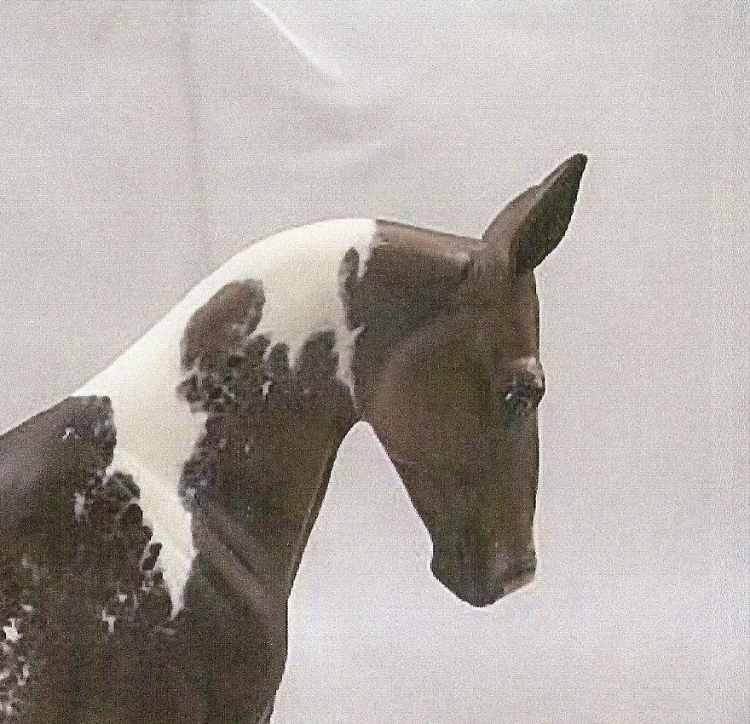

Walking and Racking Mule Head Set

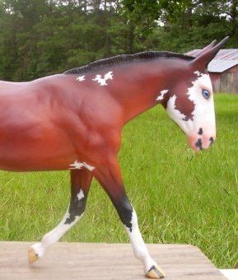

Gaited, Fox Trot, or Walking Trail Pleasure Head Set

