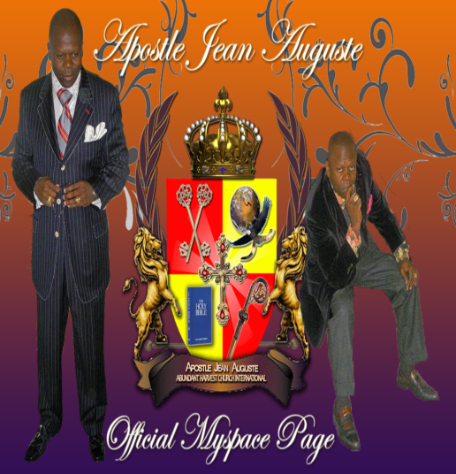
Dr. Jean P. Auguste: known for his oratorical gifting and anointed ability to teach the Word of God in such a profound, provoking and prophetic nature. Dr. Jean Auguste serves as Senior Pastor of Abundant Harvest Church International; located in Forestville, Maryland, where his anointing is known across the world for invoking the call to break curses and to demonstrate miracle signs and wonders that follow his mantel.
Dr. Auguste answered the call to ministry over three decades ago and was licensed and ordained in August 1988. His desire to serve the people took him through his journey of ministry beginning from 1988 to present. He was consecrated into the office of an Apostle on Sunday, 20th August, 2000 at Abundant Harvest Church International where he serves as Apostle and Senior Pastor. Apostle Auguste has licensed and ordained many Pastors, Elders, and Ministers into national and international assignments. He covers several churches nationally and internationally; to include, The Bethel Pastors Fellowship in Nigeria. His passion for nurturing Pastors in church growth and sustainability has earned him the title of the Pastor’s Pastor.
Apostle Auguste is a man of distinction, anointed in the ministry of prayer, healing, deliverance, and the prophetic; someone with a clear sense of purpose and willing to stand in the face of adversity. His anointing is evident and the trademark dynamism associated with him, injects life and restoration, signs and wonders where he goes. Sharing his vision, he challenges the Body of Christ to shake off complacency and live as God intended, fruitful and effective. Operating in his gift as an Apostle and speaking with a prophetic voice, Apostle Jean Auguste, the giant killer, preaches the unadulterated Word of God and, as a consequence, many can attest that their lives have changed for the better.
Apostle Auguste holds three (3) Doctorate Degrees from Agape Bible College, located in North Carolina. Apostle Auguste was born and spent his earlier childhood years in Port-a-Prince, Haiti. He then migrated to the USA with his parents, Pastor Noe Auguste and Prophetess Ghislain Auguste and an older sister, Rachel. He has been married to his loving wife, Dr. Denise Auguste for twenty-seven years and has one beautiful daughter, Jessica, age 17yrs.
In an effort to continue to spread the Gospel to all nations, Apostle Auguste has availed his ministry to various media networks. You can tune in live via conference call lines Wednesday and Friday only at 5:00 a.m. EST on Abundant Harvest Prayer Warriors at 530-881-1400, pin: 992505#. Also, on Prayer time with the Apostle Monday through Friday at 10:30 a.m. EST at 605-562-3140 pin: 486844# and present prayer request on the website: prayertimewiththeapostle.com or email: prayertimewiththeapostle.com.
Dr. Jean P. Auguste is a great leader, loving father, a phenomenal teacher, a visionary and a Holy Ghost filled Pastor…but most importantly, he is truly a SAVED MAN OF GOD!

