Afternoon Tea Suggested Reading
Compiled by Leslie Goddard, Ph.D.
Jane Pettigrew and Bruce Richardson, A Social History of Tea: Tea’s Influence on Commerce, Culture & Community (2013). The definition history on tea, exploring tea’s influence on British and American society, written by preeminent tea historians
Lorna Ables Reeves, Afternoon Tea: Delicious Recipes for Scones, Savories & Sweets (2013). Slim but excellent book by a tea expert and editor of TeaTime magazine. More than 90 wonderful recipes, as well as menus and tips
Downton Abbey, The Official Downton Abbey Afternoon Tea Cookbook (2020). Recipes inspired by the beloved television show, as well as tea etiquette and photos
Lucy Worsley, Tea Fit for a Queen: Recipes & Drinks for Afternoon Tea (2015). The chief curator of Historic Royal Palaces compiled this fascinating book about tea traditions among British royals, including favorite recipes of British sovereigns
Sarah Ferguson, The Duchess of York, and Robin Preiss Glasser, Tea for Ruby (2008). A fun children’s book about the irrepressible Ruby who must tame her hijinks when she is invited to tea with the Queen. Age 4 to 8.
Jane O’Connor and Robin Preiss Glasser, Fancy Nancy: Tea Parties (2010). The best-selling authors of the Fancy Nancy children’s books put together this book of tea-party how-tos and recipes, perfect for young children, age 4 to 8.
Ellen Easton, tea recipes, https://whatscookingamerica.net/HighTeaRecipes.htm

www.lesliegoddard.info ● L-Goddard@att.net
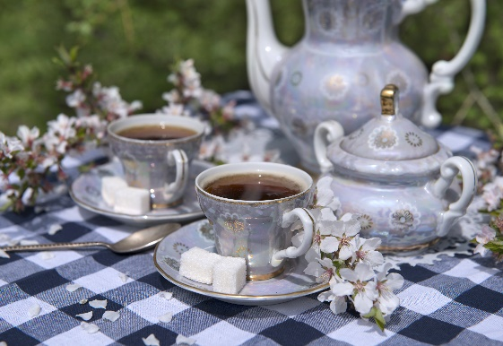
Tea Timeline
1964 – Lipton introduced the first iced tea power mix to the U.S. Bottled iced tea will follow in 1991
1945 – Ruth Bigelow begins blending her own tea
1909 – Thomas Lipton begins blending and packaging his tea in New York
1908 – New York tea importer Thomas Sullivan inadvertently invents tea bags when he sends tea to customers in small silk bags
1904 – Englishman Richard Blechynden popularizes iced tea during a heat wave at the St. Louis World’s Fair
Ca. 1840 – Anna the Duchess of Bedford begins having afternoon tea, popularizing and spreading a lasting English ritual
1840s – With the repeal of the Navigation Acts, foreign ships are allowed to import tea into Britain. American clipper ships speed up tea transports to America and Europe
1838 – First shipment of Indian tea (from Assam) sold in London
1835 – The East India Company loses its monopoly of the China tea trade to England
1773 – The Boston Tea Party, 342 chests of tea are thrown into Boston Harbor as a protest over taxation without representation
1706 – Thomas Twining opens up London’s first tea room, Tom’s Tea Cabin
1669 – The East India Company brings its first consignment of tea from China to England, convinces the British government to ban Dutch imports of tea
1662 – Portuguese Catherine of Braganza brings a chest of tea (and rights to tea navigation routes) to England as part of her dowry when she marries Charles II
1658 – First advertisement for tea in a London newspaper appears

