Eastern Rowan Saddle Club’s
Spring Wagon Train
14210 Old Beatty Ford Rd, Rockwell, NC
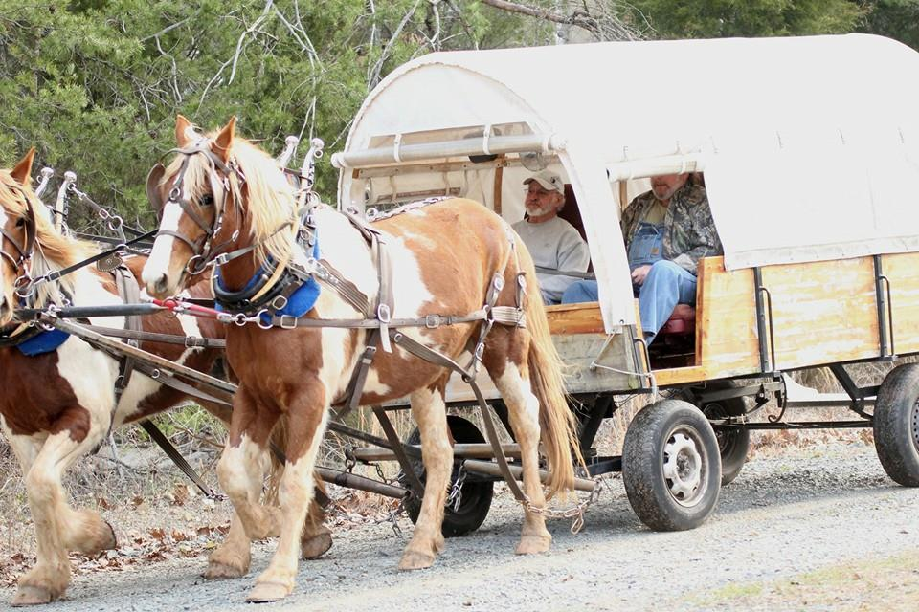
2017 Spring Wagon Train: March 24 – 26
Cost is $5 at the Gate per person which includes camping, Sat. & Sun. Rides (all meals extra.)
10 years & under FREE with paying adult.
Ride leaves promptly at 9:30 on Saturday and *Sunday (*1/2 day ride)
Saturday ride features lunch at Circle K Arena, awards presented
Wayne Coburn wagon master for Saturday
Sunday ride features break at *Historic Gold Hill*.
Jamie Rabon wagon master for Sunday

- Breakfast is served at 7:30am / $3.50 per person
Prizes Awarded for:
Best Dressed Lady
Best Dressed Man
Best Looking Team
Best Looking Horse/Mule

- Saturday night meal is served 5:00pm / $7.50 per person
- Bingo Friday night with prizes awarded.
- Karaoke on Saturday night from 7-10 PM.
- Gate opens at 2:00 pm on Friday.
- Kitchen opens 6:30 pm Friday night.
- Our Chuck Wagon will serve lunch on the trail Saturday ($$)
- Poker Run

Meal Deals Offered: Supper (Steak/Spaghetti) and 1 breakfast - $10
Supper (Steak/Spaghetti and 2 breakfasts - $12
Arena Games on Saturday Night
People Games – Potato Sack Race, Shovel Race, 3- Legged Race
Equine Games – Potato Race, Water Glass Race, Ride-A-Buck, Pole Bending, Barrel Racing

For more info contact Wayne Coburn at 704-970-7224,
Jamie Rabon at 980-521-6461, or Jessica Hellems at 704-202-5701 or visit our Website: www.eastrowansaddleclub.com
Camping (NO electric), fresh water & restrooms available
This is a family oriented event; Alcohol is not to be "openly displayed”.
PROOF OF NEGATIVE COGGINS REQUIRED NO COGGINS, NO ENTRY

