Pleasant Township Board of Trustees Meeting Highlights
Date __March 22, 2022 Next Resolution No.__ 27----3-22-2022_______

- Call to Order

- Please stand for moment of silence. --Pledge of Allegiance-----Roll Call
- Minutes to approve- received minutes to approve at next meeting.

- Financial Reports – Motion to pay expenditures.

- Visitors – (Hannah Poling with the Messenger via WebX)

  - Anyone else in attendance via WebX

- Department Reports

- Franklin County Sheriff’s Report- Deputy Hamilton on vacation but joining via WebX.
From 3-08-22 to 3-22-22 there were; Total Calls for Service: 148, Reports: 5, Arrest made: 4
Burglary/ B and E’s: 3
Thefts: 1
Accidents: 4
Suspicious Activity: 10
Alarm Drops: 12
Traffic Stops: 12
Disabled Vehicles: 15
NOTES: 1 Burglary out of the 3 is being investigated. The other 2 were unfounded. 1 theft was unfounded. 1 of the traffic stops was an ATV in the area of Timberlake.

- Road Department- Rick Haag in for Superintendent, Robert Bausch

  - Reminder: Spring Cleanup will be Friday, April 22 and Saturday, April 23.
  - Did some clean up work at cemeteries.
  - Continued to put up new signs in Timberlake.
  - Got trucks cleaned up from snow event after the last meeting.
  - Continued to fill potholes.
  - Ordered new tires for the pickup.
  - Called Franklin County for the vac truck to come out for Seaman Rd. ditch but it is in Cincinnati for repairs. Will get it out as soon as it is back in service.

Fire Dept. – Chief Taylor absent Lt. Kuno in for him
- Run Stats
  - 72 Runs for the month to date
- Apparatus Maintenance
  - E-231
  - E-232
  - T-231
  - GF231
  - M-231
  - M-232
  - CH-231
  - U-231
  - Boat-231
- Station Projects
  - Magna-Grip was out to service the ventilation system
  - Portable Radio holders have been installed in each vehicle.
  - Installed smoke alarms in a residence on London Groveport
For Your Information
- New E-Draulic rescue tools have been placed in service. We will be meeting with Fire/Marine on April 6 to get an estimate on updating the compartment spaces to accommodate the tools.
- Had a working residential fire on March 17 in the afternoon. Unfortunately the mobile home was a total loss. Red Cross was able to assist the owners/occupants. Fire was ruled accidental/undetermined by Jackson Fire Investigators.
- SWFA has been in the building on multiple occasions.
- Crews have been spending some time at the training house on Young Rd. as weather improves
- Auto Extrication Training @ Eitels with the SWFA students and Station 203
- We will be conducting a smoke alarm drive door to door on April 9th beginning approximately 9-10am and lasting a few hours in the Timberlake Neighborhood.
- Chief will be on vacation from Friday April 8 thru Monday April 18. Will be out of town from Saturday April 9 returning Wednesday April 13. Will miss the April 12 meeting. I will return to work on Tuesday April 19.

- Old Business-
  - Ed and Nancy attended the Springwater Solar Meeting in London Wednesday, March 9th.

- New Business –
- Reminder: Nancy will attend the meeting of Franklin County Board of Health District Advisory Council (DAC). The meeting will be March 29 at 11:30 am and will be held virtually. The purpose of the meeting is for the DAC to appoint a member of the Franklin County Board of Health. Per the Ohio Revised Code the chair of your Board of Trustees is your designee to the DAC. However, the chair may also designate another trustee to attend via a motion as passed by your board.
- Franklin County Township Association 2022 Annual Meeting
Hollywood Casino, 200 Georgesville Road, Columbus, OH 43228
Thursday, April 28, 2022 -6:00 p.m. – 8:00 p.m. RSVP by April 15th
  - Received a letter outlining the 2021 condition ratings for bridges within Pleasant Township that are owned by the Franklin County Engineer. It is submitted for your information as required by Section 5543.20 of the Ohio Revised Code. The original signed letter will be provided to you upon request. Please let me know if you have any questions or comments. Thanks, David R. Dibling, Assistant Bridge Engineer

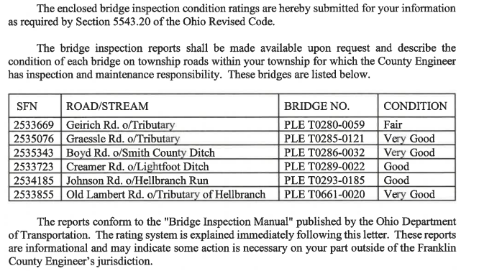

- Clerk Updates- Paula
- Resolution__27_____ to authorize the Fiscal Officer to prepare the 2022 Annual Appropriations.
- Resolution__28_____ to authorize the fiscal Officer to transfer $10,000 to the Medical Reimbursement Account.
- Received a check from Rumpke for $500 for the great recycling efforts going on by the township residents.

- Speaker Sheets-

- Executive Session- (if needed)

“I move to go into Executive Session according to Ohio Revised Code Section 121.22 (G)( ?)- Matters required to be kept confidential by federal law or regulations or state statutes) for the purpose of __________. Do I have a second?” ROLL CALL VOTE
Reconvene-
Under the Ohio Revised Code Section 121.22(G), I move to come out of Executive Session, do I have a second? ROLL CALL VOTE

- Adjourned at 7:20 p.m.

