Western Association of Educational Opportunity Personnel
Arizona ❘ Central California ❘ Nevada ❘ Northern California ❘ Pacific Islands ❘ Southern California

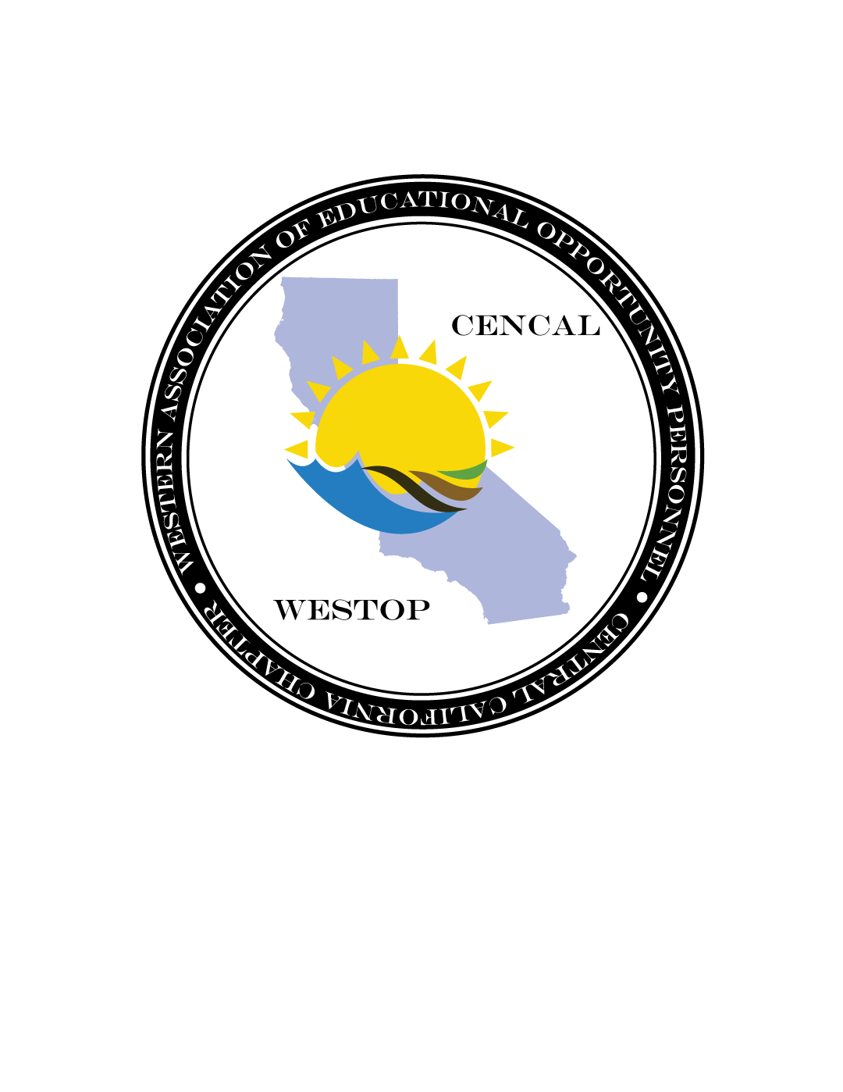

Central California Chapter
Standing Committee Report
March 1, 2017

Title: | Name:
Committee Members:
Committee Contact Info:

- Committee Update: (Examples include new initiatives, ongoing activities and meetings, plans, challenges etc.

- Marketing and Communication: (Examples include ways in which you are planning to market the activities and goals for your particular committee)

- Announcements: (Provide any announcements which are relevant to your committee)

- Budget update if applicable
  - Allocation
  - Expenditures
  - Income
  - Net

