THIS IS AN OPTIONAL ENRICHMENT ASSIGNMENT. PRINT AND COMPLETE IN INK.

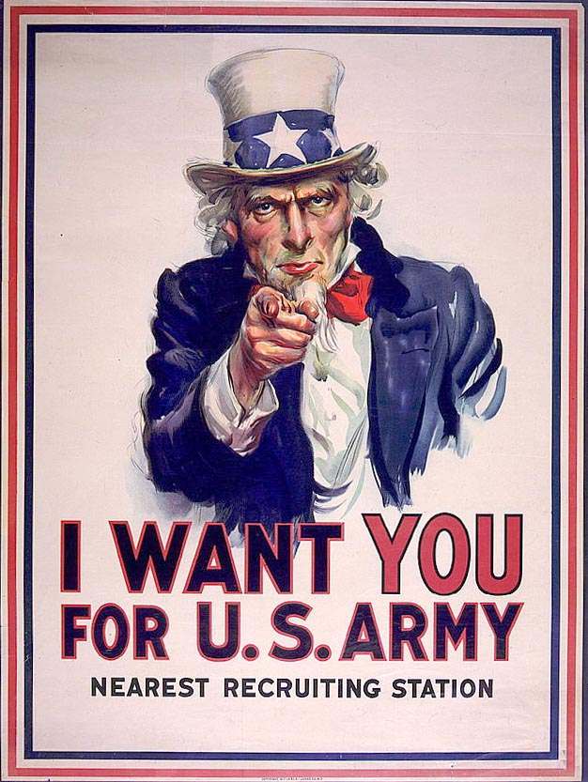
Name:_______________________________________ Class Period:_____
WWI, 1914-1918

Reading Assignment:
Chapter 22 in AMSCO or other resource covering World War I. Mastery of the course and AP exam await all who choose to process the information as they read/receive. This is an optional assignment. So… young Jedi… what is your choice? Do? Or do not? There is no try.

Directions:
- Pre-Read: Read the prompts/questions within this guide before you read the chapter.
- Skim: Flip through the chapter and note titles and subtitles. Look at images and read captions. Get a feel for the content you are about to read.
- Read/Analyze: Read the chapter. If you have your own copy of AMSCO, Highlight key events and people as you read. Remember, the goal is not to “fish” for a specific answer(s) to reading guide questions, but to consider questions in order to critically understand what you read!
- Write Write (do not type) your notes and analysis in the spaces provided. Complete it in INK!

(Image was created by James Montgomery Flagg as one of the many propaganda pieces from WWI,
public domain. It was originally published as the cover for the July 6, 1916, issue of Leslie's Weekly
with the title "What Are You Doing for Preparedness?" Over four million copies were printed between 1917 and 1918, and the image has been used repeatedly in both public and private campaigns ever since. The U.S. government got is nickname, Uncle Sam, in 1813. By 1876, thanks to Thomas Nast, Uncle Sam was portrayed in striped pants, long coat, top hat, white beard etc. image we all recognize today.)

Key Concepts FOR PERIOD 7:
Key Concept 7.1: Growth expanded opportunity, while economic instability led to new efforts to reform U.S. society and its economic system.
Key Concept 7.2: Innovations in communications and technology contributed to the growth of mass culture, while significant changes occurred in internal and international migration patterns.
Key Concept 7.3: Participation in a series of global conflicts propelled the United States into a position of international power while renewing domestic debates over the nation’s proper role in the world.

Learning Goals:
Analyze the causes and effects of World War I including America’s changing foreign policy, economics, and idealism.
Evaluate the effectiveness of Woodrow Wilson’s leadership during WWI.
Explain the ways the American Homefront responded to the change in American foreign policy from neutrality to involvement in the war.

1. OVERVIEW (page 454-456)… Read the first two pages and then thoughtfully answer the two questions below.

1914 1915 1916 1917 1918
WWI Begins/Assassination of Ferdinand U.S. enters WWI WWI ends
Causes | Analysis
WWI was caused by Militarism, Alliance Systems, Imperialism, and Nationalism, with the spark igniting the “powder keg” being the assassination of Franz Ferdinand.  - Archduke Franz Ferdinand  - Austrian ultimatum to Serbia  - Germany (allied with Austria) declares war on Russia and France (allies of Serbia) and invades neutral Belgium  - Great Britain (ally of France) declares war on Germany | WWI began in 1914. Which cause was more significant, the assassination of Austrian Archduke Francis Ferdinand or entangling alliances? Explain your reasoning.  Despite being a more active world player in 1914 in places like China, Philippines, and the Caribbean, the U.S. responded with a declaration of U.S. neutrality. Why?

2. MORAL DIPLOMACY -- Reviewing Wilson’s Foreign Policy (back to ch20 for a moment), pp421-423
Answer the following questions by reviewing main events, defining terms, and analyzing significance in the spaces provided. Consider the
the left hand column the main ideas in your answer, the center column for notes, and the right column for deeper analysis.

American foreign policy during the first years of the war, 1914-1916, was neutrality. Summarize American involvement in world affairs during Woodrow Wilson’s first term, 1913-1917 and evaluate the extent to which they were neutral.

Main Events/Ideas | Definitions/Explanations | Analysis
Woodrow Wilson’s foreign policy was “Moral Diplomacy.” He reversed Taft’s “Dollar Diplomacy” and averted Teddy’s “Big Stick.” He was an anti-imperialist and hoped to lead America into a new era where the U.S. wasn’t an opportunistic bully.  - Moral Diplomacy  - Jones Act  - Citizenship for Puerto Ricans  - Panama Canal tolls  - Secretary of State, William Jennings Bryan  - California land policy & tensions with Japan |  | To what extent was Moral Diplomacy consistent with a policy of neutrality?
Wilson struggled to avoid conflict and intervention in Latin America. He was an anti-imperialist, but as challenges arose in the Caribbean that may have an economic and/or political impact on the U.S…. he found himself behaving like an imperialist.  - Haiti  - Dominican Republic  - Virgin Islands  - Central America |  | To what extent was Wilson’s foreign policy toward Latin American countries neutral?  Explain why Wilson contradicted his beliefs with his actions?
Wilson resisted intervention in the Mexican revolts, because they were financially motivated (and Wilson detested Taft’s Dollar Diplomacy). In the end, however, he sent troops.  - General Victoriano Huerta  - Mexican immigration  - Tampico Incident  - Port of Vera Cruz  - ABC intervention  - Venustiano Carranza  - Pancho Villa & Pershing/American Expeditionary Force |  | To what extent was American involvement in Mexico consistent with a neutral foreign policy?  Why did Wilson contradict his beliefs with his actions?  Why did Wilson give up on finding Pancho Villa?
3. NEUTRALITY -- Guided Reading, pp 455-457

Compare U.S. neutrality in the early 19th century to neutrality in the early 20th century.

Main Events/Ideas | Definitions/Explanations | Analysis
Wilson faced the same problems Jefferson and Madison faced prior to the War of 1812. Essentially the challenge is being a neutral nation but also maintaining trade.  Pre-War of 1812  (see pp 137-138)  - Embargo Act  - Non-Intercourse Act  - Macon’s Bill No. 2  - Impressment  Pre-U.S. involvement in WWI  (pp 455-456)  - British seize U.S. ships & blockade Germany  - Germany’s unrestricted submarine warfare  - Sussex Pledge  - Lusitania  - U.S. economic boom & trade  - North Sea Embargo (by Great Britain)  - loans |  | To what extent was asserting neutrality for Wilson similar the asserting neutrality for Jefferson and Madison? Cite two specific reasons in your answer.  a.  b.  Support or refute the following statement: The U.S. didn’t choose sides in either war based on loyalty or alliance. They chose sides based on economic priorities. Cite two specific pieces of evidence in your answer.  a.  b.

Identify other events that pulled or pushed the United States into WWI on the side of the Allies.

Main Events/Ideas | Definitions/Explanations | Analysis
Public sentiment toward Germany deteriorated, increasing support for the Allies.  - Kaiser Wilhelm  - Italian Americans  - German-Americans  - Irish Americans  - British war propaganda |  | Did the United States enter WWI on the side of the Allies because Americans were pro-British and anti-German? Explain your reasoning.

Events that pushed or pulled the U.S. into war… continued…
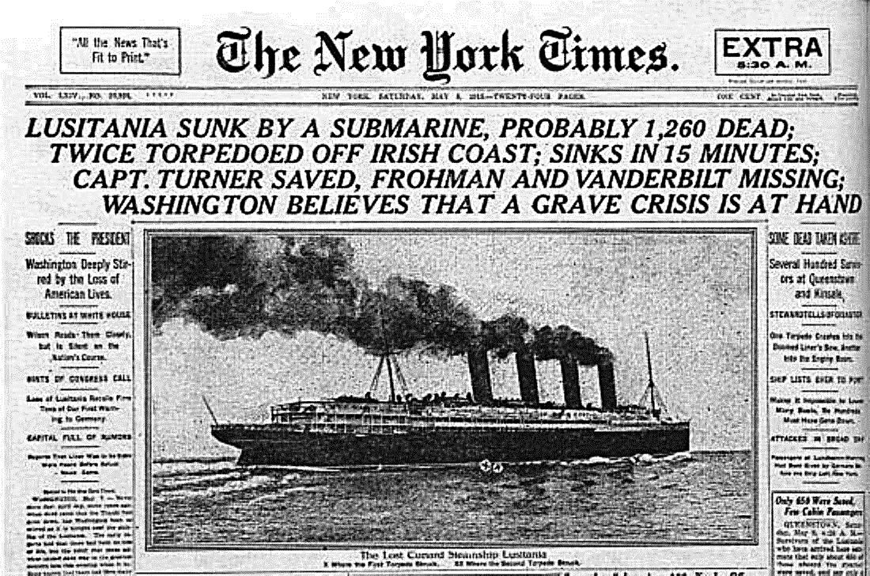
Newspaper Analysis

Historical Context…

Viewpoint of Headline…

Impact on Americans…

- DECISION FOR WAR, pp 459-460

Main Events/Ideas | Definitions/Explanations | Analysis
Despite Wilson’s efforts to keep the country out of war, events escalated creating an “unavoidable” involvement.  - National Security League  - National Defense Act  - “He Kept Us Out Of War!”  - Colonel Edward House sent to Berlin  - Unrestricted submarine warfare resumed  - Zimmerman Telegram  - Russian Revolution  - Declaration of War, April 1917 |  | Support or refute the following statement: U.S. involvement in WWI was unavoidable. Explain your reasoning, and cite two specific pieces of evidence to support your answer.  a.  b.
- MOBILIZATION, pp 460-462

How did the American Homefront respond to the declaration of war on Germany?

Main Events/Ideas | Definitions/Explanations | Analysis
American troops were untrained and ill prepared for battle, so the first step toward fighting the war was economic.  - War Industries Board; Bernard Baruch  - Food Administration; Herbert Hoover  - Fuel Administration, Harry Garfield  - National War Labor Board; William Howard Taft  - Liberty Bonds  - Increased taxes |  | How did Wilson’s mobilization efforts reflect Progressivism? Explain your reasoning.
Anti-War sentiments threatened the success of the quick paced mobilization. Conflicts arising led to a suppression of civil liberties and increased nativism.  - William Jennings Bryan  - Jeannette Rankin  - Robert La Follette  - Committee on Public Information; George Creel  - American Protective League  - Espionage act, 1917  - Sedition Act, 1918  - Eugene Debs  - Schenck v. United States |  | Compare Wilson’s response to anti-war and anti-American sentiments during WWI to Lincoln’s response to anti-union sentiments during the Civil War and Adams response to anti-Federalist sentiments during his term in office. Were the responses justified?  Wilson and Lincoln… similar or different?  (see pp 268-269)  Wilson and Adams… similar or different?  (see pp 116-117)  Was Adams justified?  Was Lincoln justified?  Was Wilson justified?
MOBILIZATION continued…

Main Events/Ideas | Definitions/Explanations | Analysis
The American military mobilized for and entered the battle fields of Europe. This led to new opportunities for women and African Americans, but racial and gender discrimination continued.  - Voluntary enlistment  - Selective Service Act, 1917  - African American troops  - Jobs for women  - Mexican migration  - African American migration-  The Great Migration |  | Explain the social impact of military mobilization on the American Homefront during WWI.  Compare the Selective Service Act of 1917 to the Enrollment (Draft) Act of 1863.  The Enrollment Act (or Conscription/Draft) of 1863, was a controversial act required the enrollment of every male citizen and those immigrants who had filed for citizenship between ages twenty and forty-five in order to keep Union troops replenished. Federal agents established a quota of new troops due from each congressional district. In some cities, particularly New York City, enforcement of the act sparked civil unrest as the war dragged on, leading to the New York Draft Riots on July 13–16. African Americans were allowed to serve in 1863 following the Emancipation Proclamation, which also sparked unrest in some populations in the North.  Selective Service Act implementation and impact similar or different? Explain!

- FIGHTING THE WAR and MAKING THE PEACE, pp 463-467

How did the United States help the Allies defeat the Central Powers, and how were Americans impacted by war?

Main Events/Ideas | Definitions/Explanations | Analysis
The American military joined the fight as the Russians withdrew, entering a bloody war with new weapons and grueling trench warfare that moved to a single front to stop the Germans. They entered with patriotic romanticism and left disillusioned and scarred.  - Ship construction  - American Expeditionary Force; John J. Pershing  - Second Battle of the Marne; turning point  - Battle of Argonne Forest  - Weapons of war  - U.S. casualties  (skip to page 466)  - Demobilization  - The Red Scare & Palmer Raids  - The 1919 Steel Strike and the Great Seattle Strike  - Chicago race riot |  | List three reasons why Pershing was a notable leader before and during WWI.  a.  b.  c.  Which factor was most significant in creating postwar disillusionment? Explain your reasoning.
Contextualization of The Fourteen Points

Local Historical Context…

Broad Context/Main Theme and Idea…

Comparative Context/ Similar theme in Other time period…
Analyze the extent to which the United States satisfactorily reached its goals in fighting/winning WWI.
(back to page 464)
Main Events/Ideas | Definitions/Explanations | Analysis
When Wilson shifted the nation from neutrality to intervention, he devised his Fourteen Points for Peace which outlined American goals for war.  - Fourteen Points  - Treaty of Versailles  - Article X  - The Big Four  - Henry Cabot Lodge  - Irreconcilables and reservationists  - Wilson’s tour  - Rejection of treaty |  | How did Wilson’s goals differ from British, French, and Italian goals?  To what extent was Wilson’s plan for peace made into a reality? Defend your answer with historical evidence.

- Connecting to next era… pp 475 (read first paragraph of next chapter)
What was the short term political consequence of the U.S. not signing the Treaty of Versailles and post WWI disillusionment?

Main Events/Ideas | Definitions/Explanations | Analysis
The United States retreated and became isolationists following WWI. This decision had both short and long-term consequences for Europe, Asia, and the United States.  - Election of 1920; Old Guard;  Warren Harding & Calvin Coolidge;  Association of Nations, not a League of Nations  - Election of 1920; Democrats; James M. Cox & Franklin D. Roosevelt  - Election of 1920; Socialist; Eugene Debs  - Return to Normalcy |  | By not participating in a new world order as envisioned by Wilson, the U.S. retreated and the Allies implemented their Treaty (intense punishment for Germany). What was the long term consequence of this decision?
Woodrow Wilson: Realist or Idealist? (From American Pageant)

Read, highlight main ideas, then read page 468 in AMSCO and answer the questions on the following page.

As the first president to take the United States into a foreign war, Woodrow Wilson was obliged to make a systematic case to the American people to justify his unprecedented European intervention. His ideas have largely defined the character of American foreign policy ever since—for better or worse.

“Wilsonianism” comprises three closely related principles:
(1) the era of American isolation from world affairs has irretrievably ended;
(2) the United States must infuse its own founding political and economic ideas—including democracy, the rule of law, free trade, and national self-determination (or anti-colonialism)—into the international order; and
(3) American influence can eventually steer the world away from rivalry and warfare toward a cooperative and peaceful international system, maintained by the League of Nations or, later, the United Nations.

Whether that Wilsonian vision constitutes hardnosed realism or starry-eyed idealism has excited scholarly debate for nearly a century. “Realists,” such as George F. Kennan and Henry Kissinger, insist Wilson was anything but. They criticize the president as a naive, impractical dreamer who failed to understand that the international order is, and always will be, an anarchic, unruly arena, outside the rule of law, where only military force can effectively protect the nation’s security. In a sharp critique in his 1950 study, American Diplomacy, Kennan condemned Wilson’s vision as “moralism-legalism.” In this view Wilson dangerously threatened to sacrifice American self-interests on the altar of his admirable but ultimately unworkable ideas. Wilson’s defenders, including conspicuously his principal biographer, Arthur S. Link, argue that Wilson’s idealism was in fact a kind of higher realism, recognizing as it did that armed conflict on the scale of World War I could never again be tolerated and that some framework of peaceful international relations simply had to be found. The development of nuclear weapons in a later generation gave this argument still more force. This “liberal” defense of Wilsonianism derives from the centuries-old liberal faith that, given sufficient intelligence and willpower, the world can be made into a better place. Realists reject this notion of moral and political progress as hopelessly innocent, especially as applied to international affairs.

Some leftist scholars, such as William Appleman Williams, have argued that Wilson was in fact a realist of another kind: a subtle and wily imperialist whose stirring rhetoric cloaked a grasping ambition to make the United States the world’s dominant economic power. Sometimes called “the imperialism of free trade,” this strategy allegedly sought to de-colonialize the world and open up international commerce not for the good of peoples elsewhere, but to create a system in which American economic might would irresistibly prevail. This criticism itself rests on a naive assumption that international relations are a “zero-sum game,” in which one nation’s gain must necessarily be another nation’s loss. In a Wilsonian world, Wilson’s defenders claim, all parties would be better off; altruism and self-interest are not mutually exclusive. Still other scholars, especially John Milton Cooper, Jr., emphasize the absence of economic factors in shaping Wilson’s diplomacy. Isolationism, so this argument goes, held such sway over American thinking precisely because the United States had such a puny financial stake abroad—no hard American economic interests were mortally threatened in 1917, nor for a long time thereafter. In these circumstances Wilson—and the Wilsonians who came after him, such as Franklin D. Roosevelt—had no choice but to appeal to abstract ideals and high principles. The “idealistic” Wilsonian strain in American diplomacy, in this view, may be an unavoidable heritage of America’s historically isolated situation. If so, it was Wilson’s genius to make practical use of those ideas in his bid for popular support of his diplomacy.

Lie: Woodrow Wilson failed to achieve his goals because he was too idealistic.
The Truth: Things might have turned out better for Europe and the rest of the world if President Wilson had been a little more idealists—or at least, more consistent. (From The Mental Floss of United States History)

When the smoke cleared after World War I, the United States had clearly bumped aside Britain as top dog. Wilson, dubbed by the press as “the most powerful man in the world” and “the Prince of Peace,” was widely expected to forge a fair settlement balancing the interests of the victorious Allied Powers (Britain, Italy, France) with those of the defeated Central Powers, (Germany, Austria, Turkey). This wasn’t unreasonable. Although the United States fought on the side of the Allied Powers, America’s short involvement left its citizens relatively untainted by the bitterness permeating Europe. Thus, Wilson had room to present himself as an impartial mediator who could exercise a restraining influence on the victors. Plus, France and Britain both owed the United States billions of dollars and were hoping to renegotiate their enormous debts on more favorable terms, giving him leverage, if he chose to use it (in the end he didn’t). The situation seemed ideal, especially since the Germans were already on board with Wilson’s plan for peace—or so they thought.

In three addresses to Congress during 1918, Wilson outlined a framework for peace negotiations, consisting of “Fourteen Points” elaborated by “Four Principles” and capped by “Five Particulars.” These included “absolute freedom of navigation upon the seas,” implying the British blockade would be lifted; “no discrimination or favoritism between peoples,” implying the United States would favor the Allied powers over Germany; and last but not least, “people and provinces are not to be bartered about from sovereignty to sovereignty,” implying that German would retain its territorial integrity. This Powerpoint for Peace was consistent with Wilson’s call for “peace without victory,” meaning a fair settlement that didn’t blame or punish the losers.

Mr. Wilson bores me with his Fourteen Points. Why, God Almighty has only ten! –French Prime Minister Georges Clemenceau, 1918. Two days after Wilson made the promise about territorial integrity, the top German general, Erich von Ludendorff, instructed his staff to open negotiations for a cease-fire. Wilson had offered Germany peace with honor, and his generous terms were critical to von Ludendorff’s decision: Germans wanted peace, but not at the price of German territory, which would dishonor the sacrifice of over 2 million German soldiers and the half a million German civilians who died. And while Germany was in bad shape, it wasn’t finished—with Russia out of the war due to a Bolshevik uprising, the German army appeared capable of fighting on if necessary. By September 1918, roughly 1.4 million German soldiers were conducting a fighting withdrawal, inflicting huge casualties on a combined French, British, and American force of about 1.7 million.

Unfortunately, Wilson didn’t stick to his promises. On October 29, 1918, Wilson’s personal representative, Edward House, met secretly in London with French Prime minister Georges Clemenceau and British Prime Minister David Lloyd George to secretly hear their “commentary” on the president’s proposal. Their secret revisions basically gutted Wilson’s most important promises, calling for the breakup of the Austro-Hungarian Empire, the creation of a new Polish state using a chunk of Germany, and the transfer of the province of Alsace-Lorraine from Germany to France. The Brits and French also demanded that the treaty include a statement of Germany’s official “war guilt,” a meaningless insult practically designed to make the Germans angry—by not as angry as the subsequent bill for the damages. The Allies figured something along the lines of $33 billion ($2.2 trill in today’s money) should do it, with payments scheduled until 1988. After secretly saying goodbye to the two prime ministers, House sent a telegraph to Wilson summarizing the French and British revisions, so the president knew about them when the Allies agreed to begin armistice negotiations just a week later. But he neglected to inform the Germans about these incredibly important changes. It was a classic bait and switch. When the Germans finally did find out about the revisions in March of 1919, another promise to them was broken: instead of a negotiation between the Central Powers and the Allies, as Wilson had guaranteed, German and Austria were simply told to sign.

So the question remains: if the Germans objected to the final treaty, why didn’t they just refuse to sign it and keep fighting? By this point, it wasn’t an option. Six months had passed since the armistice took effect, and both sides were already demobilizing, sending exhausted, traumatized soldiers home as fast as they could. And by the time the German delegation arrived in Versailles to sign the treaty, the government of the new Weimar Republic was barely able to maintain order at home. The delegation had no choice but to sign under protest and then tell the German people they’d been duped. A common response at the time was: so what? After all, the Germans had just imposed an incredibly unfair peace treaty on the Russians at Brest-Litovsk in 1917—so why should they expect to be treated any better? Besides, the whole war was pretty much their fault anyway, according the Allies. But the deception was a big deal. It triggered a wave of outrage across the German political spectrum—left, right and center--- which almost never agreed on anything. If Allied diplomats didn’t understand why this was a problem, then they’d just have to wait and see. It wouldn’t be long.

To this day, nobody really knows what Wilson was thinking. It’s possible he deliberately deceived the Germans—but the implication that he drew up an idealistic peace program as part of the biggest con job in history just seems too perversely cynical. Alternatively, it may have just slipped his mind; there are, in fact, questions about Wilson’s mental health during this period. In April 1919, while in Paris, he suffered a minor stroke, which can change one’s personality and cause disordered thinking. And there may have been earlier strokes that were covered up. But the most likely explanation is that he just deferred these unpleasant, complicated issues to the new League of Nations proposed by Britain: sure, the Germans would be wildly upset for a few years, but his successors in the White House could make sure the new international body address Germany’s grievances. That plan would maybe have worked had the United States actually joined the newly formed League of Nations, but partisan policies and senile dementia ensured the United States would never join the League. Without U.S. participation, the terms of the Treaty of Versailles were never revised—meaning Germany stayed angry, and indeed, got even angrier.

- HISTORICAL PERSPECTIVES PAGE 468 (and excerpt above)
Was Woodrow Wilson was an idealist or a realist? A good or bad president?

Main Events/Ideas | Definitions/Explanations | Analysis
Woodrow Wilson is often judged as one of the greatest presidents for his leadership in progressive reform and world affairs. However, others judge him as being the first of three radical liberals who have transformed the country in a way that distances us from what our Founding Fathers and Republican ideals intended.  - Wilsonianism  - George Kennan & Henry Kissinger and the realist view  - Arthur Link and idealist view  - William Appleman and the realist-imperialist view  - John Milton Cooper and the idealist-diplomacy view  - Harry Elmer Barnes view  - Gordan Levin’s view  - Erik Sass’s view  - Your view |  | Was Wilson an idealist or a realist? Defend your answer.  Was Wilson a “good” or “bad” president? Defend your view.

CLOSURE

The world must be made safe for democracy. Its peace must be planted upon the tested foundations of political liberty. We have no selfish ends to serve. We desire no conquest, no dominion. We seek no indemnities for ourselves, no material compensation for the sacrifices we shall freely make. WOODROW WILSON, WAR MESSAGE, APRIL 2, 1917

FOOD FOR THOUGHT
Read the excerpt below, highlight main ideas, and then support or refute the view.

Let’s call a spade a spade. For most of its history, America hasn’t given a darn about other democracies. There have been some heroic interventions –like WWI—but these were really just heroic justification for protecting American trade (which America has always cared about). Over the decades, the “preserving democracy” excuse was only trotted out when the nation’s leaders needed to rally public opinion. Thus it wasn’t until trade was threatened that the United States discovered that WWI was putting Democracy in danger. To be fair, American isolationists had some good arguments against entering WWI. From the U.S. perspective, that arrogant Europeans had foolishly gotten themselves into the war through a ridiculous tangle of treaties. And the players weren’t exactly defenseless: Britain stood at the head of the largest empire in history, French soldiers were considered the bravest in Europe, and Russia was really, really big. So the Allied powers didn’t seem to need American help. Further, Germany was a multiparty democracy at the time, and millions of Americans were descended from German immigrants.

By 1915 public opposition to the war was mushrooming, and it spawned dozens and dozens of civic and religious organizations, many organized by Quakers and women. In a politically savvy, though not entirely truthful reaction to the broad-based feelings of opposition, President Woodrow Wilson won the 1916 election with the catchy slogan “He Kept Us Out of the War.” [we declared war 1 month after he too office for 2nd term.] Of course skeptics noted that Wilson actually seemed to be preparing for war by expanding the U.S. Army, National Guard, and Navy, establishing the Army Reserve Officer Training Corps (ROTC), and giving himself authority over the National Guard in case of emergency. But not everyone in the United States shunned the fight: America’s political and economic elite favored intervention as early as 1915, knowing that key trade relationships with Britain and France would be ruined if they were defeated. After American trade with Germany was severed by the British blockade, trade with Britain and France grew even more important. During the war, American exporters supplied both countries with vehicles, fuel, food, and consumer goods, allowing the Allied Powers to devote their own industry exclusively to armaments –and American exporters were making out like bandits. Then bankers got in on the act: starting in 1915 American banks loaned Britain and France hundreds of millions of dollars to continue buying American goods. These war financiers feared that the debts might never be repaid if the Allied Powers lost. With so much trade and money at risk, these business interests were all the motivation that the United States needed to get in on the Allied action. But how would the politicians and elite get ordinary Americans on board?

Luckily, they had some help from the Germans. In the throes of warfare, German “U-boats” (from unterseeboot or “undersea boat”) began sinking British and French merchant ships and then started going after neutral ships and passenger vessels as well –especially those carrying armaments and supplies to their enemies. Before long, U-boat attacks had claimed the lives of hundreds of American civilians; the most infamous incident was the sinking of the … Lusitania… 1915. Indeed, the ship had been carrying arms—including 4.5 million rifle cartridges—but the huge number of civilian casualties (1,198 lives, including almost 100 children and 128 Americans) triggered a wave of anti-German sentiment. In response, Germany—which was wisely trying to avoid baiting the United States into the war—forbade attacks against neutral shipping and passenger liners. But the position didn’t last: German civilians were suffering from the British blockade, and as the war dragged on, German hard-liners demanded a return to unrestricted submarine warfare against neutral shipping, American vessels or not. The German strategy almost worked: in the last two years of the war, U-boats sank 8.9 million tons of shipping, and the effort nearly starved Britain into surrender. But it also gave Wilson the support he needed to get Congress to declare war in April of 1917.
It all culminates in the fabrication of a system of all evil, and of another which is the system of all good…It is not enough to say our side is more right than the enemy’s, that our victory will help democracy more than his. One must insist that our victory will end war forever, and make the world safe for democracy.
–Walter Lippmann, Public Opinion, 1922

A few days after obtaining the declaration of war, Wilson established the Committee for Public Information (CPI), tasked with unleashing a barrage of propaganda to get Americans marching to the same tune. Guided by marketing all-stars from journalist Walter Lippmann (the Pulitzer prize winner who also introduced the concept “Cold War”) to Edward Bernays (considered the “father of public relations”), the CPI launched a propaganda blitz through every medium possible: newspapers, magazines, books, pamphlets, radio, movies, public events, and public school curricula. The campaign had two main thrusts: first, highlight the German brutality, and second, link the war efforts to democracy instead of, you know, business interests. Here, the German military again pitched in by effectively overthrowing the democratic government in January 1917. Once the military coup took over Germany, American sympathy for the nation waned, and the anti-war movement was promptly pushed aside to make way for the Great War. (Erik Sass, The Mental Floss History of the United States)

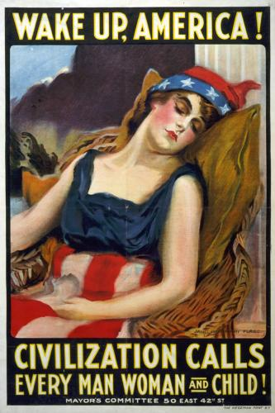

Reading Guide written by Rebecca Richardson, Allen High School
Sources include but are not limited to: 2015 edition of AMSCO’s United States History Preparing for the Advanced Placement Examination,
2015 Revised College Board Advanced Placement United States History Framework, 12th edition American Pageant, Wikipedia.org, and other sources as cited in document and collected/adapted over 20 years of teaching and collaborating

