RELEASE AND WAIVER OF LIABILITY, ASSUMPTION OF RISK, AND INDEMNITY AGREEMENT (“AGREEMENT”)
In consideration of participating in the gymnastics, tumbling and/or cheerleading I represent that I understand the nature of this Activity and that I am qualified, in good health, and in proper physical condition to participate in such Activity. I acknowledge that if I believe event conditions are unsafe, I will immediately discontinue participation in the activity. I fully understand that this Activity involves risks of serious bodily injury, including permanent disability, paralysis and death, which may be caused by my own actions, or inactions, those of others participating in the event, the conditions in which the event takes place, or the negligence of the “releases” named below; and that there may be other risks either not known to me or not readily foreseeable at this time; and I fully accept and assume all such risks and all responsibility for losses, cost, and damages I incur as a result of my participation in the Activity.
I hereby release, discharge, and covenant not to sue Black Hawk Gymnastics and Cheer, its respective administrators, directors, agents, officers, volunteers, and employees, other participants, any sponsors, advertisers, and, if applicable, owners and lessors of premises on which the Activity takes place, (each considered one of the “RELEASEES” herein) from all liability, claims, demands, losses, or damages, on my account caused or alleged to be caused in whole or in part by the negligence of the “releases” or otherwise, including negligent rescue operations and future agree that if, despite this release, waiver of liability, and assumption of risk I, or anyone on my behalf, makes a claim against any of the Releasees, I will indemnify, save, and hold harmless each of the Releasees from any loss, liability, damage, or cost, which any may incur as the result of such claim.
I have read the RELEASE AND WAIVER OF LIABILITY, ASSUMPTION OF RISK, AND INDEMNITY AGREEMENT, understand that I have given up substantial rights by signing it and have signed it freely and without any inducement or assurance of any nature and intend it to be a complete and unconditional release of all liability to the greatest extent allowed by law and agree that if any portion of this agreement is held to be invalid the balance, notwithstanding, shall continue in full force and effect.
___________________________________________________ __________________________
Printed Name of Participant Date
PARENTAL CONSENT
AND I, the minor’s parent and/or legal guardian, understand the nature of the above referenced activities and the Minor’s experience and capabilities and believe the minor to be qualified to participate in such activity. I hereby Release, discharge, covenant not to sue and AGREE TO INDEMNIFY AND SAVE AND HOLD HARMLESS each of the Releasees from all liability, claims, demands, losses or damages on the minor’s account caused or alleged to have been caused in whole or in part by the negligence of the Releasees or otherwise, including negligent rescue operations, and further agree that if, despite this release, I, the minor, or anyone on the minor’s behalf makes a claim against any of the above Releasees, I WILL INDEMNIFY, SAVE AND HOLD HARMLESS each of the Releasees from any litigation expenses, attorney fees, loss liability, damage, or cost any Releasee may incur as the result of any such claim.
___________________________________________________ __________________________
Printed Name of Participant Date
___________________________________________________
Signature of Parent/or Legal Guardian

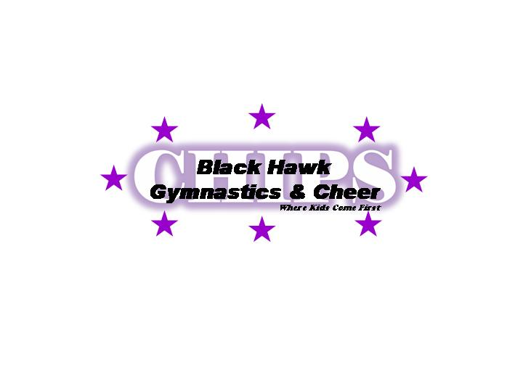
___________________________________________________ _________________________________________ ________________________
Address City Zip code

__________________________________________________ _________________________________________
Telephone Email

