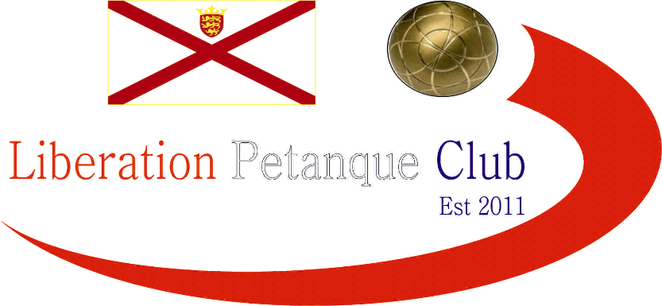

# Summer 2017 Season

# Week 11

# 7th June 2017

# Melee 2

# LIBERATION DOUBLES OPEN – Saturday 10th June – Entry Form on the website.

# A

# 

***NEXT WEEK***

**Doubles League (Double Fixture) – Start Time 6pm**

**WEBSITE** [**www.liberationpetanque.co.uk**](http://www.liberationpetanque.co.uk)

**EMAIL** [**liberationpc@gmail.com**](mailto:liberationpc@gmail.com)

**Kind Regards**

**Report Editor**

**Liberation Petanque Club**

# SPONSORED BY

# http://nebula.wsimg.com/135a1bd6338e1b589a50cdec98bd84d1?AccessKeyId=C6E923731F1A482DD910&disposition=0&alloworigin=1