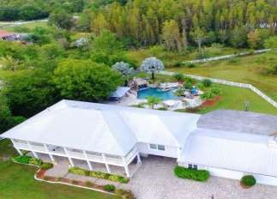

Book Your Staycation or Destination Wedding 2017 Price Sheet
Escape to our Southern Plantation Oasis and Have the Event of a Lifetime!
Includes
- Accommodations for up to 12 guests for a 2-night minimum.
– 5 Bedrooms Available
- Early check-in of 9 a.m. for accommodations
- late check-out of 3 p.m. for accommodations
- Rehearsal Dinner Space for up to 50 people
- Ceremony and Reception Space for up to 50 people
- Day of parking for guests during event/s
- Day of property use for guests
- One Time Cleaning Fee
- Enjoy full use of the home, resort style pool, and picturesque property for you and your guests to relax, have fun and sun, and enjoy the Florida lifestyle.
Prices Start at $4995 (Excludes Holidays) Additional Fees:
- Additional Ceremony and Reception guests can be added to the package for $10 per guest. Maximum guests: 100 for events
- An additional 3 guests can be added to accommodations for $75. (15 guest maximum)
- A 5% discount is honored for weekly rentals and military.
- Additional nights for accommodations: Fri and Sat: $ 900 per night
Sun – Thurs: $795 per night
Contact Jennifer Henry at (813) 763-1826 for a tour or more information!

Hourly Rates:
$100/hour per 20 guests
$200/hour per 40 guests
$300/hour per 60 guests
$400/hour per 80 guests

