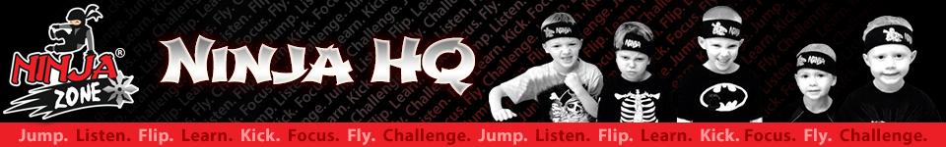

COMING SOON TO TRIPLE T!!
This is a cool new sport that is just getting started and we are thrilled to be a part of it. This fast paced class is a combination of the coordination of gymnastics, the discipline of martial arts, the strength and agility of obstacle course training, and the creativity of breakdance. They will learn all of this while learning to train and live by the Ninja Creed.

Our ninjas will learn to tumble, and kick, but they will also get to flip off the walls and other equipment. The coach’s job is to run them until they are tired and THEN teach them some skills.

There are 4 levels of Ninjas: White, Yellow, Green, and Blue.

Class start date as well as day/time will be published soon!!! Spaces will be limited so be sure and get your son on the list to start with the first group of Ninjas!

