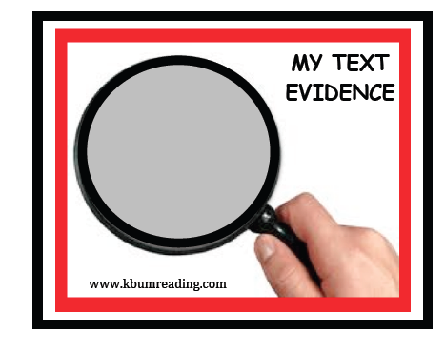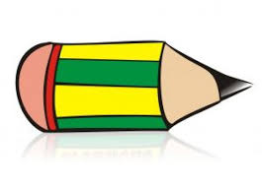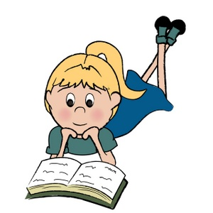

www.kbumreading.com

MY CLOSE READING

________________________________________

Read with pencil in hand.

________________________________________

**What does the text say?**

Mark the BIG IDEAS and

KEY DETAILS.

___________________________________

**How does the text say it?**

Look for patterns,

repetitions, word choice, similarities, and contradictions.

_______________________________________

**What does that mean?**

Ask questions about

patterns, word choice, message, structures,

and viewpoints.

_______________________________________________

How? Why?

Reread and Think.

Look for Text Evidence

to support your thinking.