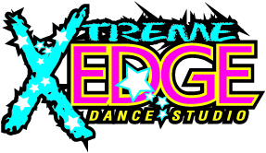
2016-2017 Calendar
Aug. 9th Open House/Registration/Shoe Fitting 5-7 p.m.
Aug. 11th Open House/Registration/Shoe Fitting 5-7 p.m.
Aug. 18th Open House/Registration/Shoe Fitting 5-7 p.m.
Aug. 20th Open House/Registration/Shoe Fitting 10 a.m. – 1 p.m.
Aug. 22nd Fall Classes Begin
Sept. 5th Labor Day Holiday (Studio Closed)
Sept. 17th Apple Festival (Downtown Lincolnton)
Oct. 10th Recital Costume Deposits Due
Nov. 14th–17th Parent Observation Week (Recital Classes)
Nov. 23rd -25th Thanksgiving Holiday (Studio Closed)
Nov. 27th Lincolnton Christmas Parade
Dec. 21st -Jan. 2nd Christmas Holiday (Studio Closed)
Jan. 3rd Classes Resume
Jan. 16th Martin Luther King Holiday (Studio Closed)
Feb. 6th Recital Costume Final Payment Due
April 3rd Recital Fee & Ad Sales Due
April 17th-21st Easter Holiday/Spring Break (Studio Closed)
April 24th Classes Resume
May 29th Memorial Day (Studio Closed)
June 2nd Recital Dress Rehearsal (North Lincoln High School)
June 3rd Recital (North Lincoln High School)
www.xtremeedgedance.com (704) 735-8200 xtremeedgedance@gmail.com

