REGULAR MEETING
APRIL 15, 2021

A Public Hearing and the Regular Meeting of the Town Board of the Town of Hampton, County of Washington and the State of New York was held at the Town Hall, 2629 State Route 22A, Hampton, New York, also via Zoom and live streaming on the You Tube Channel for “Town of Hampton New York” on the 15th day of April 2021.

Due to the Corona Virus, occupancy inside the Town Hall is limited at this time. Supervisor O’Brien did provide a link to join the meeting via Zoom.

PRESENT: David K. O’Brien------------Supervisor
Donald Sady-----------------Councilman
Tamme Taran----------------Councilwoman
Andrea Sweeney------------Councilwoman – via Zoom
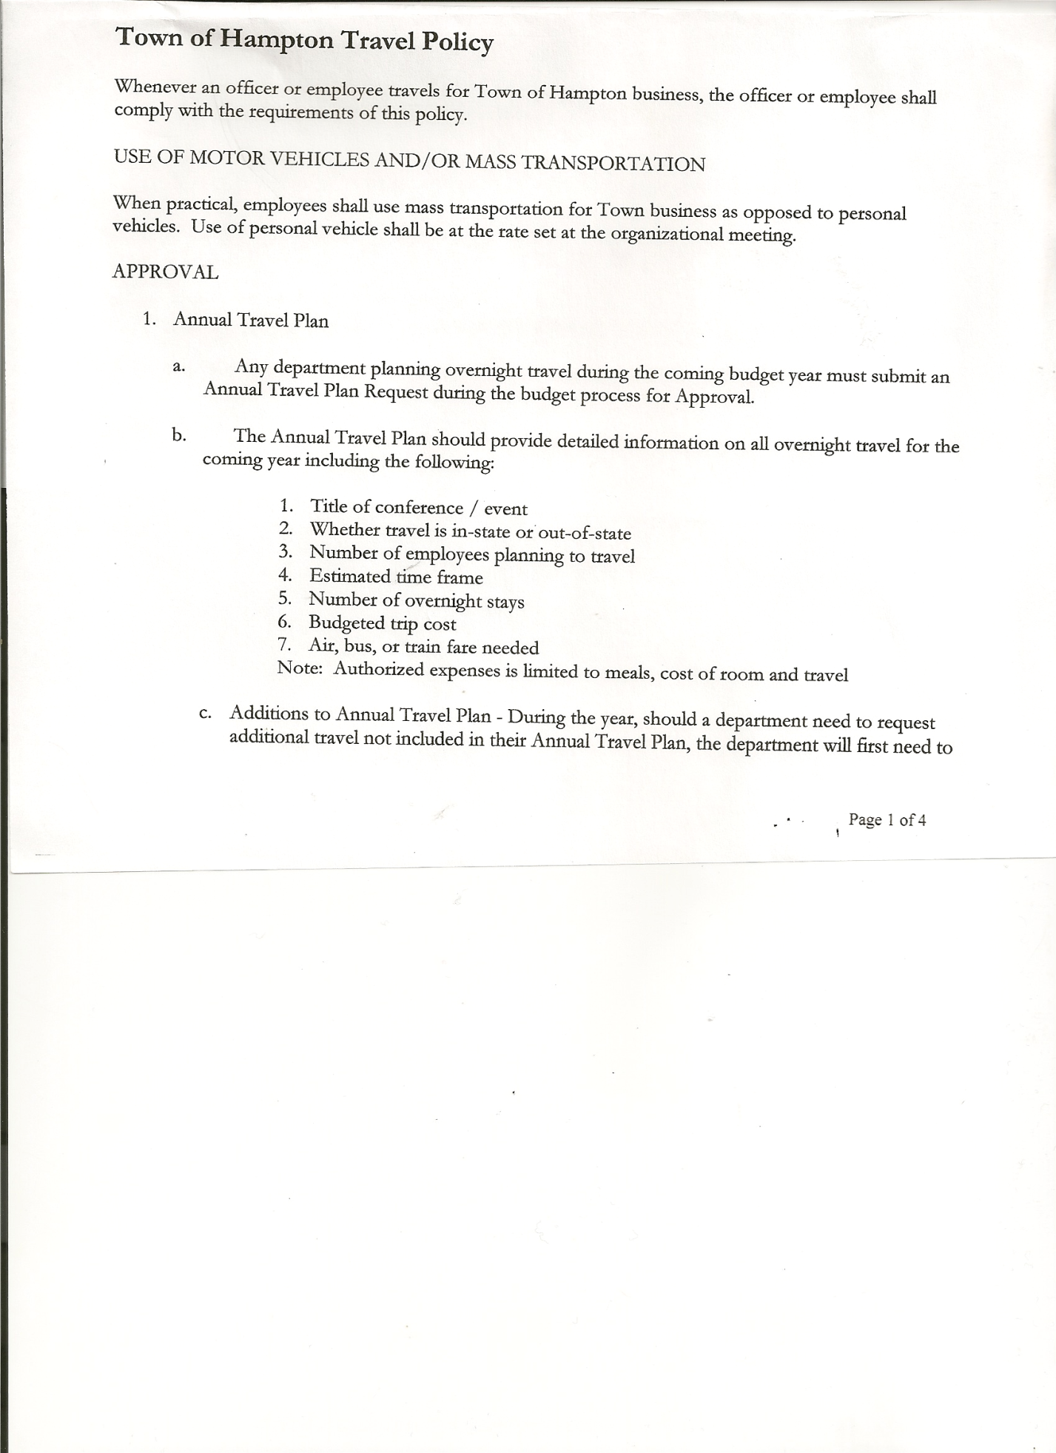
Michael Pietryka------------Councilman
Rebecca Jones---------------Town Clerk
Camilla Shaw----------------Tax Collector/Deputy Town Clerk
Herbert Sady, Jr.-------------Highway Superintendent – via Zoom

Planning Board Member(s): via Zoom… Bonnie Hawley, Chair; and Matthew Pratt and Renee Rountree
Others present at the Town Hall: Artie Pratt and Leonard Reed
Others present via Zoom: Travis Dean

The Public Hearing was called to order by Supervisor O’Brien at 7:01pm

Town Clerk Jones read the Legal Notice of Public Hearing (copy attached), which was published in the Manchester Newspapers (The Granville Sentinel and Whitehall Times) on 4/1/21 on proposed Local Law titled “Authorizing the Position of Superintendent of Highways of the Town of Hampton to reside outside the corporate limits of the Town of Hampton, Washington County, New York”.

Question was asked to clarify what the local law stated.
Supervisor O’Brien answered that whether appointed or elected a person can be outside of Town limits, but within Washington County and immediately adjoining the corporate limits of the Town of Hampton. Also that only Highway Superintendents can be from adjoining towns, no other Town Offices.

Question asked if other people can still run for the Highway Superintendent position.
Supervisor O’Brien answered if they run on other party lines than the ones that have already had to be filed.

Supervisor O’Brien asked three (3) times if there were any more comments. Hearing none, the Public Hearing was closed at 7:10pm

REGULAR MEETING
The Regular Meeting was called to order by Supervisor O’Brien at 7:30pm, followed by the Pledge of Allegiance. Location of Fire Exits were given. Quorum of board members present.

TOWN BOARD MEETING
APRIL 15, 2021 PAGE 2

RESOLUTION NO. 35-2021
APPROVAL OF THE MINUTES
On a motion of Councilwoman Taran, seconded by Councilman Pietryka, the following resolution was ADOPTED:
By Roll Call Vote: Supervisor O’Brien AYE
Councilman Sady AYE
Councilwoman Sweeney AYE
Councilman Pietryka AYE
Councilwoman Taran AYE
RESOLVED, that the Regular Town Board Minutes for March 18th, 2021 are approved.

Larry Carman, Dog Control Officer submitted his report, which was read by Supervisor O’Brien, copy of report is attached. Supervisor O’Brien picked up a dog on 22A twice and returned it home.

Camilla Shaw, Tax Collector gave her report – Submitted March/April 2021 report. Also submitted Bank Statement to the Board for review and signatures. Collections are done, settlement complete with the County Treasurer. 69 unpaid parcels were returned.

Bonnie Hawley, Chair gave Planning Board Report… Copy of report is attached.

Herbert Sady, Jr., Highway Superintendent submitted his report, copy of which, is attached.
Information on Paving Funds for 2021 handed out and also attached.

SUPERVISOR’S REPORT/ COUNTY UPDATES/ COMMUNICATIONS

RESOLUTION NO. 36-2021
APPROVAL OF SUPERVISOR’S MONTHLY REPORT
On a motion of Councilman Sady, seconded by Councilwoman Taran, the following resolution was ADOPTED:
By Roll Call Vote: Supervisor O’Brien AYE
Councilman Sady AYE
Councilwoman Sweeney AYE
Councilman Pietryka AYE
Councilwoman Taran AYE
RESOLVED that, the Supervisor’s Monthly report be accepted as submitted for MARCH
2/28/21 3/31/21
ACCOUNT BALANCE RECEIPTS DISBURSEMENTS BALANCE
General Fund $ 72,935.81 $ 1,461.51 $ 14,145.29 $ 60,252.03
Highway Fund $ 287,295.10 $ 12.01 $ 18,171.32 $ 269,135.79
Equipment Reserve $ 54,902.46 $ 2.33 $ 0.00 $ 54,904.46
Fire #1 $ 43,297.00 $ 0.00 $ 0.00 $ 43,297.00
Fire #2 $ 10,200.00 $ 0.00 $ 0.00 $ 10,200.00
Cemetery $ 1,743.54 $ 2.35 $ 0.00 $ 1,745.89
Totals $470,373.91 $ 1478.20 $ 32,316.61 $439,535.50
All Board Members present signed Supervisor’s Report.

TOWN BOARD MEETING
APRIL 15, 2021 PAGE 3

RESOLUTION NO. 37-2021
APPROVAL OF SUPERVISOR’S 2020 YEARLY REPORT
On a motion of Councilman Sady, seconded by Councilwoman Taran, the following resolution was ADOPTED:
By Roll Call Vote: Supervisor O’Brien AYE
Councilman Sady AYE
Councilwoman Sweeney AYE
Councilman Pietryka AYE
Councilwoman Taran AYE
RESOLVED that, the Supervisor’s Yearly report be accepted as submitted for 2020
1/01/20 12/31/20
ACCOUNT BALANCE RECEIPTS DISBURSEMENTS BALANCE
General Fund $ 39,850.83 $ 109,693.80 $ 112,414.77 $ 37,129.86
Highway Fund $ 9,912.40 $ 304,284.17 $ 258,208.95 $ 55,987.62
Equipment Reserve $ 29,854.42 $ 35,027.60 $ 9,984.00 $ 54,898.02
Fire #1 $ 0.00 $ 42,448.00 $ 42,448.00 $ 0.00
Fire #2 $ 0.00 $ 10,000.00 $ 10,000.00 $ 0.00
Cemetery $ 1,726.50 $ 16.50 $ 0.00 $ 1,743.00
Totals $ 81,344.15 $501,470.07 $ 433,055.72 $149,758.50
All Board Members present signed Supervisor’s Report.

Broadband….There is approximately 3 miles from Kirby’s (next to the Town Hall) to the Vermont border that is not covered. Spectrum may build out with grants. Stimulus funds might be able to be used toward broadband.

Stimulus Funds…..Paving funds that are not reimbursed can possibly be applied. A listing of proposed use of funds is attached.

OLD BUSINESS
Reassessment….If anyone wants an appointment with Board of Assessment Review they may do so via online or by phone.

RESOLUTION NO. 38-2021
Introduced by Councilman Donald Sady
who moved its adoption
Seconded by Councilman Michael Pietryka

RESOLUTION ADOPTING LOCAL LAW AUTHORIZING THE POSITION OF SUPERINTENDENT OF HIGHWAYS OF THE TOWN OF HAMPTON TO RESIDE OUTSIDE THE CORPORATE LIMITS OF THE TOWN OF HAMPTON, WASHINGTON COUNTY, NEW YORK

WHEREAS, the Town Board (the “Town Board”) of the Town of Hampton (the “Town”) has seen an inability to obtain residents of the Town of Hampton as candidates for the office of superintendent of highways of the Town of Hampton and wishes to permit and authorize any individual to hold the office of superintendent of highways of the Town of Hampton who resides within the corporate limits of the Town, or within the corporate limits of a town within Washington County, New York that immediately adjoins the corporate limits of the Town; and

TOWN BOARD MEETING
APRIL 15, 2021 PAGE 4

WHEREAS, in order to permit same, the Town Board must consider a proposed local law authorizing any individual to hold the office of superintendent of highways of the Town of Hampton who resides within the corporate limits of the Town, or within the corporate limits of a town within Washington County, New York that immediately adjoins the corporate limits of the Town; and

WHEREAS, a proposed local law authorizing same has been drafted and is attached hereto; and

WHEREAS, the Town Board held a public hearing on April 15, 2021 at 7:00 p.m., at which time interested persons were permitted to be heard on the proposed local law; and

WHEREAS, said local law will require the Town Board to supersede Town Law §23(1) pursuant to Municipal Home Rule Law, §§2(5) and (12), 10(1)(ii)(a)(1), as well as 1987 N.Y. Op. Atty. Gen 87-52 and by way of reference to Town Law §23(2), which rendered Town Law §23 other than a law of general applicability in New York State, permitting the Town Board to supersede Town Law §23(1) as set forth herein; and

WHEREAS, the Town Board wishes to proceed with the adoption of said local law.

NOW, THEREFORE BE IT

RESOLVED, that the Town Board finds that the adoption of the proposed local law is in the best interests of the residents and taxpayers of the Town; and be it further

RESOLVED, that the proposed local law 1 of 2021 authorizing any individual to hold the office of superintendent of highways of the Town of Hampton who resides within the corporate limits of the Town, or within the corporate limits of a town within Washington County, New York that immediately adjoins the corporate limits of the Town, is hereby adopted; and be it further

RESOLVED, that by this resolution and local law the Town Board supersedes Town Law §23(1) pursuant to Municipal Home Rule Law, §§2(5) and (12), 10(1)(ii)(a)(1), as well as 1987 N.Y. Op. Atty. Gen 87-52 and by way of reference to Town Law §23(2), which rendered Town Law §23 other than a law of general applicability in New York State, permitting the Town Board to supersede Town Law §23(1) as set forth herein; and be it further

RESOLVED, that this resolution shall take effect immediately.

DATED: April 15, 2021 Supervisor O’Brien AYE
Councilman Sady AYE
Councilwoman Sweeney AYE
Councilman Pietryka AYE
Councilwoman Taran AYE

Supervisor O’Brien reminded everyone of the Special Election on Tuesday, April 20th from 12 to 7pm at the Town Hall regarding the Highway Superintendent position, keep the position elected or change the position to appointed.

TOWN BOARD MEETING
APRIL 15, 2021 PAGE 5

Following a discussion regarding the Public Employer Health Emergency Plan for the Town of Hampton, the following resolution was introduced:
RESOLUTION NO. 39-2021
PUBLIC EMPLOYER HEALTH EMERGENCY PLAN
On a motion of Councilwoman Taran, seconded by Councilman Sady, the following resolution was ADOPTED:
By Roll Call Vote: Supervisor O’Brien AYE
Councilman Sady AYE
Councilwoman Sweeney AYE
Councilman Pietryka AYE
Councilwoman Taran AYE
RESOLVED that the New York State Public Employer Health Emergency Plan for the Town of Hampton be adopted.

The Town Clerk’s report for March 2021 was submitted to the Board. The Town Clerk had Board Members review and sign bank reconciliation statements for the Town Clerk Account and Special Clerk Account dated March 31, 2021.

PUBLIC COMMENTS/COUNCIL COMMENTS
Councilwoman Sweeney asked about a fire at William Jones’ property in Low Hampton whether any fines were imposed. Fireman Matthew Pratt responded that the DEC and police were there. Matt was unaware if he received a fine or not. There is a NYS Burn Ban in effect from 3/14/21 to 5/14/21. There are exemptions for Agriculture property burning.

RESOLUTION NO. 40 -2021
AUDIT OF CLAIMS
On a motion of Councilwoman Taran, seconded by Councilman Pietryka the following resolution was ADOPTED:
By Roll Call Vote: Supervisor O’Brien AYE
Councilman Sady AYE
Councilwoman Sweeney AYE
Councilman Pietryka AYE
Councilwoman Taran AYE
RESOLVED that the bills have been reviewed by the Town Board and are authorized for payment in the following amounts.
General Fund No. 44 through No. 59 $ 2,938.04
Highway Fund No. 39 through No. 49 $ 4,500.85
Total both funds $ 7,438.89

RESOLUTION NO. 41-2021
MEETING ADJOURNED
On a motion of Councilman Sady, seconded by Councilwoman Taran, the following resolution was ADOPTED:
By Roll Call Vote: Supervisor O’Brien AYE
Councilman Sady AYE
Councilwoman Sweeney AYE
Councilman Pietryka AYE
Councilwoman Taran AYE
RESOLVED that the meeting adjourned at 8:13pm.

Respectfully submitted,
Rebecca S. Jones, RMC
Town Clerk

