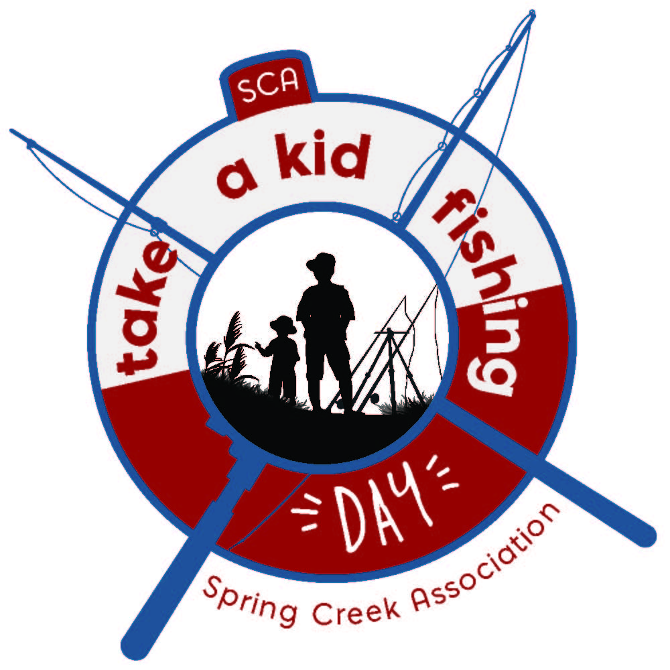
Spring Creek Association
Take A Kid Fishing

Date: Saturday, May 13, 2017

Fee: Free to the Public.

Time: Registration starts at 8:00 AM. Fishing Until 11:30 AM

Information: Enjoy a fun filled day of fishing with the family! The first 100 children to register receive a free t-shirt. Event will also include lunch by the Spring Creek Ruby Mountain Lion’s Club and raffle prizes for the youth. Free to all children 12 years old and under. Each child’s parent or guardian must be present with the child at all times. Please limit your catch to two fish per child.

Contact: (775) 753-6295 ● 451 Spring Creek Parkway, Spring Creek, NV 89815● www.springcreeknv.org

Name of Child: _____________________________________________________________ Age: ____ Shirt Size: ______

Name of Child: _____________________________________________________________ Age: ____ Shirt Size: ______

Name of Child: _____________________________________________________________ Age: ____ Shirt Size: ______

Address: ___________________________________________________________________________________________

City: _________________________________________________ State: _________________Zip Code: ______________

Mom/Guardian: ____________________ Phone: (C) _____________________ E-mail: ____________________________

Dad/Guardian: _____________________ Phone: (C) _____________________ E-mail: ____________________________

_______________________________________________________________________________________________________________________________________
Release and Waiver of Liability: I, the undersigned, do hereby forever release, hold harmless, and discharge Spring Creek Association, its agents, employees, successors, and assigns from any and all liability for property damage or personal injury which I or my children or wards may incur as a result of or in connection with my involvement as an organizer, spectator or participant in the “Take a Kid Fishing” day at the Spring Creek Marina on May 13, 2017. As against Spring Creek Association, it’s agents and employees. I assume full risk of and such loss in which I incur. This release is also Covenant NOT to Sue and includes any claims by any minor regarding whom I am either a natural or court-appointed guardian. I hereby grant the organizing hosts the unconditional right to use the name, voice, and photographic likeness of the participant and/or family members in connection with any of their audio/video productions, articles, or press releases, but not as an endorsement.

I have read, understand, and affirm that I am in agreement with the Release of Liability and am signing this of my own free will as the representative for myself and the children named above. I agree to all of the foregoing.

__________________________________________________________________________________________ ________________________
Parent/Guardian Signature Date

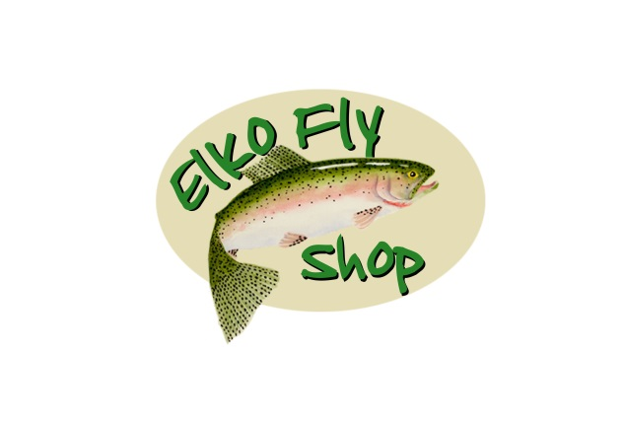
Thank You To Our 2017 Sponsors!
