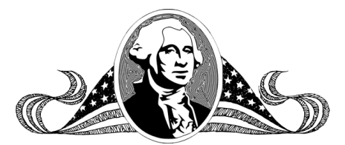
George Washington was the 1st 11st16th
George Washington
Name _______________________________________________ Date ______________
Copyright © 2011 Integreat! Thematic Units
www.thematicteacher.com
president of the United States.
president. He refused to be a
Name _______________________________________________ Date ______________
George Washington was the 1st
king and began the presidency.
George Washington

Copyright © 2011 Integreat! Thematic Units
www.thematicteacher.com
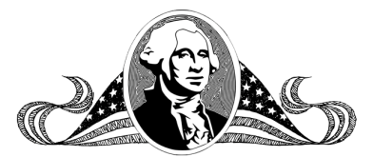
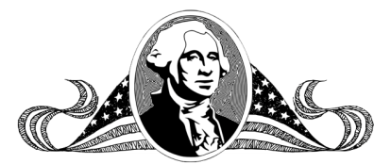
Name _______________________________________________ Date ______________
George Washington

Copyright © 2011 Integreat! Thematic Units
www.thematicteacher.com
Name _______________________________________________ Date ______________
George Washington

Copyright © 2011 Integreat! Thematic Units
www.thematicteacher.com
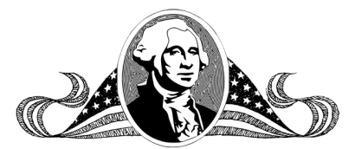
Name _______________________________________________ Date ________
George Washington

Copyright © 2011 Integreat! Thematic Units
www.thematicteacher.com

