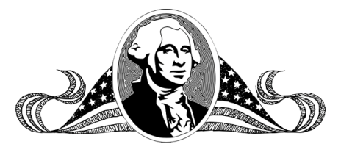

**George Washington was the 1st 11st16th**

**George Washington**

Name _______________________________________________ Date ______________

Copyright © 2011 Integreat! Thematic Units

www.thematicteacher.com

**president of the United States.**

**president. He refused to be a**

Name _______________________________________________ Date ______________

**George Washington was the 1st**

**king and began the presidency.**

**George Washington**

Copyright © 2011 Integreat! Thematic Units

www.thematicteacher.com

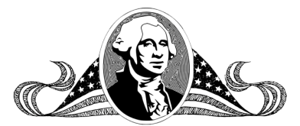

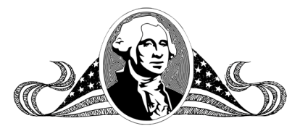

Name _______________________________________________ Date ______________

**George Washington**

Copyright © 2011 Integreat! Thematic Units

www.thematicteacher.com

Name _______________________________________________ Date ______________

**George Washington**

Copyright © 2011 Integreat! Thematic Units

www.thematicteacher.com

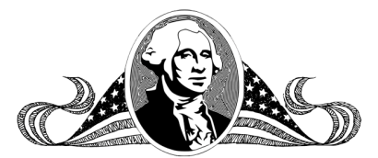

Name _______________________________________________ Date ________

**George Washington**

Copyright © 2011 Integreat! Thematic Units

www.thematicteacher.com