

# Winter 2017-2018 Season

# Week 6

# 16th December 2017

# Singles

A double header of fixtures right before Christmas would have a big impact on player’s league positions going into the New Year.

Two players joint top of the Premier League had to play each other first, in Matt Buesnel and Matt Pinel who played together in this year’s Men’s European Triples Championship in France. A big win for Matt B in game one was overturned in game two for a draw.

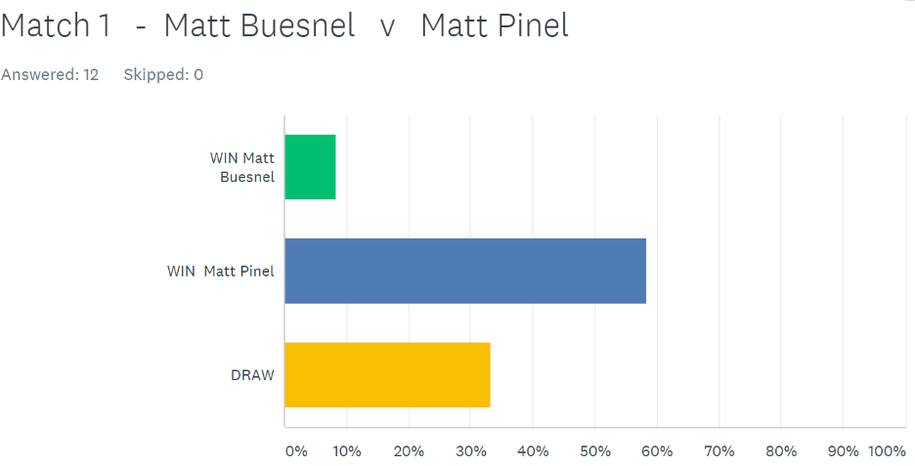SUPER 6

Neil Selby with two draws before the start of the day took on Callum who finished 3rd last Winter after dropping vital points at the end of the season.  Callum had only played 1 match so far losing to Matt Pinel. Callum took the first game in style 13 – 1, and was so close to making it 3 points but lost the 2nd game 13 – 11.

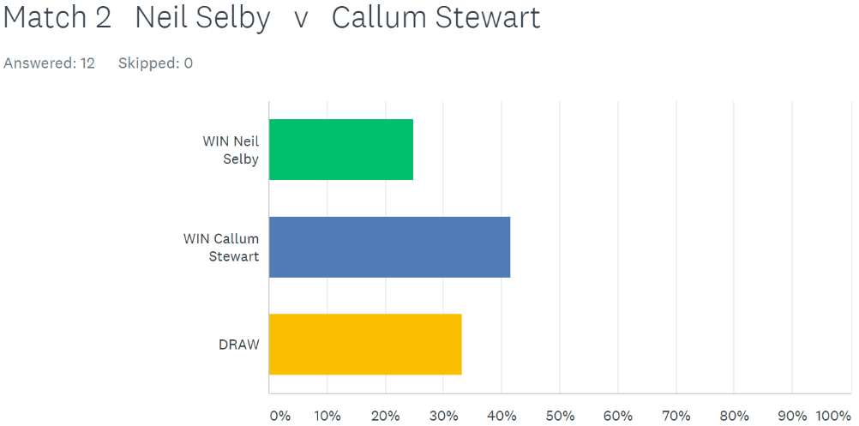SUPER 6

Geoffroy Buffetrille was last year’s runner up and he played current champion Toby Northern.  Geoffroy lost his first match against David Ibitson whilst Toby had drawn both his matches against David and Neil. Geoffroy though was on form today winning very comfortably 13 -3, 13 – 4. Geoffroy went on to also beat Neil Selby to move up to 3rd place.

Elsewhere Ross Payne had just 1 point from two matches, losing to Matt Buesnel and drawing with Alice Ibitson. Well after four matches still has one point after losing to Keith Pinel (including a 13 – 0!!!) and was nearly beaten 13 – 0 again by David Ibitson losing 13–1.

Alice Ibitson handed Matt Pinel a defeat to boost her league chances and hand Matt a huge blow in his title bid.

Matt Buesnel tops the leagues after beating Callum Stewart as he bids for his first ever Premier League title.

Division 1

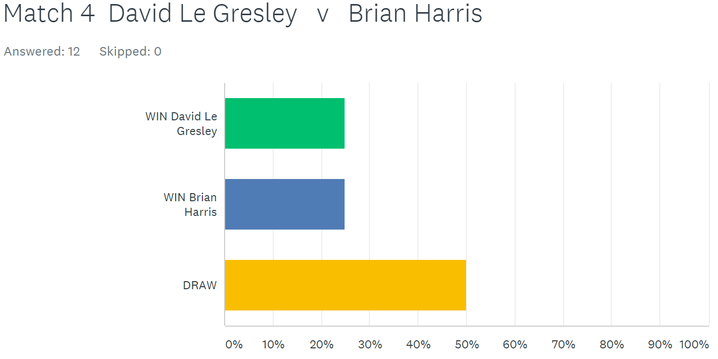No surprise to everyone that Brian Harris tops Division 1 with 3 wins out of 3 after beating David Le Gresley and leads by 5 points after just four weeks.

Paul Le Moine joins his doubles team mate Brian in the top three with a win over Cassie Stewart and a draw with Colin Myers who stays bottom.

Alex Stewart lost to John McGaw who is on 4 points and in the top 3 along with Paul. John also drew with Paul Bell.

The Stewart’s (Alex and Cassie) did get one point each with a draw against each other.

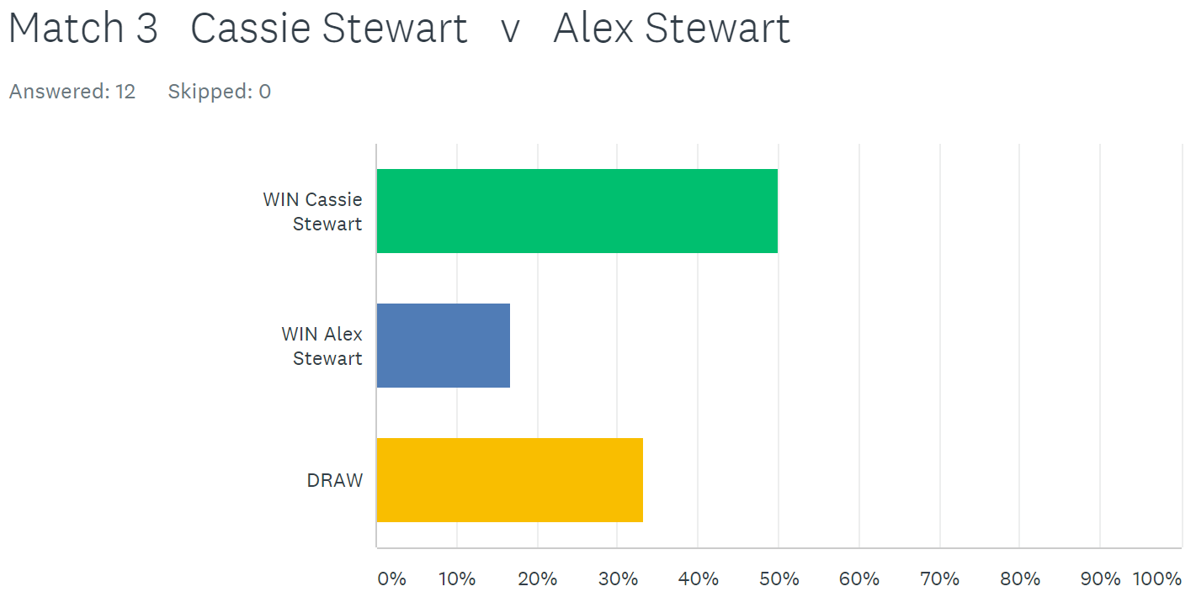

Division 2

Just 3 matches out of 8 in Division 2. Jean Stewart took on Matt Hutchings and was just one point from a win. Jean took the first game 13 – 5, before losing the second 12 – 13 to drop two valueable points. Jean though didn’t have any luck against Brigitte losing 13 – 11, 13 – 3.

Matt Hutchings must have used all his luck against Jean as he was well and truely beaten by Luke Canavan who won his first ever singles match at the club – well done Luke.

# 

# 

***NEXT WEEK***

**FREE WEEK - Merry Christmas to everyone**

**WEBSITE** [**www.liberationpetanque.co.uk**](http://www.liberationpetanque.co.uk)

**EMAIL** [**liberationpc@gmail.com**](mailto:liberationpc@gmail.com)

**Kind Regards**

**Report Editor**

**Toby Northern**

**Liberation Petanque Club**

# SPONSORED BY

# http://nebula.wsimg.com/135a1bd6338e1b589a50cdec98bd84d1?AccessKeyId=C6E923731F1A482DD910&disposition=0&alloworigin=1