Pleasant Township Board of Trustees Meeting
Date _October 24, 2023 Next Resolution No._ _48---10-24-2023_ _

- Call to Order -- The meeting tonight will also be on WebEx.
- Please stand for moment of silence. --Pledge of Allegiance-----Roll Call
- Minutes to approve- No minutes
- Financial Reports – Motion to pay expenditures.
- Visitors –
- Guest speakers Dave Ruetter SWCD and Nathan Ralph FCPH.
- Department Reports
- Franklin County Sheriff’s Report- none
- Road Department- Robert Bausch
- Safety meeting
- Final grade Teal Ct. tile
- Finishing ditch mowing
- Any updates on Gay Rd. about repairs due to heavy rains washing the roadway and gravel away. (meeting on 8-8-23 we said we’d keep it on the agenda till resolved in some way.)
- Fire Dept. – Lt. Johnson (Chief Whiting is out of town)
  - Apparatus
  - E-2 @ Prairie
  - All-American repaired lights, seatbelts on E-231
  - Staffing
  - Received Resignation Letter from Daniel Rice effective October 11, 2023 Motion to accept resignation from Daniel Rice.
  - Training
  - Chief Whiting is attending executive leadership training this week at the National Fire Academy.
  - Three firefighters are doing well in paramedic school.
  - Station
  - Compton Doors are doing maintenance before winter.
  - Replaced light bulbs and bad ballasts in the station.
  - Replaced furnace filters and cleaned them out in preparation for winter months.
  - Drain issue at gear washing machine/plumber will be into snake and clean
  - Community Risk Reduction
    - Scheduled to do presentation at Darbydale School on 10-25-23
  - Levy Update
- Ongoing
- Old Business-
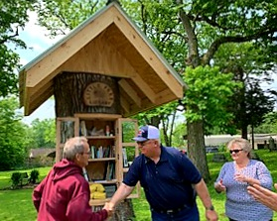
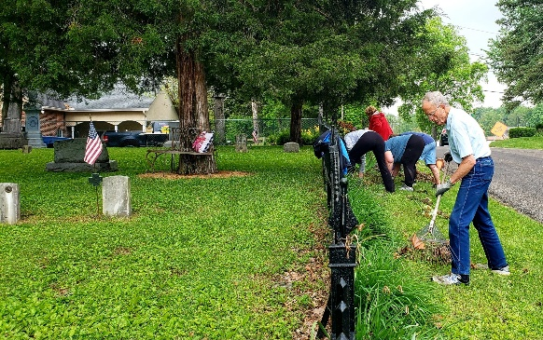
  - Resolution__48_______ to reimburse Bill Dawson, the amount of $1,336.13 for various expenses for the Ebenezer Cemetery Tree Library Project, of which a $1,300.00 Grant obtained by Mr. Dawson was received by the Township prior to this request. Also, to include an additional expense of $113.99 for the solar panel to supply power to the lighting that was installed.
We thank Bill Dawson and all his volunteers for all the donations of time and supplies, hard work, dedication, and organization skills for the Tree Library and for all the beautification and overseeing of this very special Cemetery that Bill does so selflessly.
- A response has been prepared and ready to a grievance filed by Union Local 2937
- New Business –
  - At the last meeting we received the Audit Report for 2018-19-20. Randi and Paula attended a tele meeting with Jason Ward of the State Auditor’s office yesterday to review the report findings.
  - The Franklin County Engineers Office is holding their required meeting with townships to give updates of the roads and bridges. It is November 16th registration starts at 5:15 pm at Villa Milano. RSVP by November 10th.
- Clerk Updates- Paula
- Miscellaneous correspondence
- Resolution___49__authorizing the fiscal officer to prepare and submit street lighting assessments for Timberlake 2023-24 costs to County Auditor.
- Resolution___50__authorizing the fiscal officer to prepare and submit street lighting assessments for Timberlake 2023-24 costs to County Auditor.
- Adjourn-

