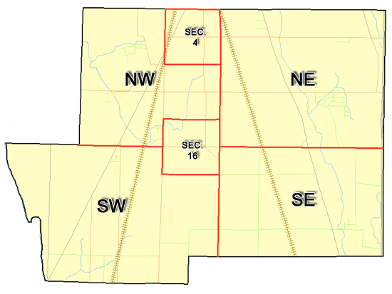 | Pleasant Township  Zoning Commission Minutes  1035 Owens Rd W.  Marion, Ohio 43302
Meeting called by: | Scheduled | Type of meeting: | Regular Monthly
Chairperson: | Mr. Holler | Secretary: | Stephanie Barkley
Timekeeper: |  | Date: Oct 19th,2023 | Time 7:30 pm
Call to Order by: | Mr. Holler Moment of silence followed by the pledge to the flag.
Roll Call: | Jack Dean, Harry Holler, Tom Leib, Dwight Williams, Joe Thompson, Tyron Canterbury  Stephanie Barkley
Minutes: | Read and approve minutes from previous meeting.  Motion to approve minutes by: Mr. Thompson Seconded by Mr. Williams: All approved
Attendees Address Board: Have sign in sheet on desk by door.
Type in attendees and addresses: see attached.
.
----- Agenda Topics -----
Business
Zoning Reports: | Zoning Inspector goes over reports and provides copy to board.
Unfinished:
New:
Announcements: | Next meeting will be Nov16th, 2023
Adjournment: | Motion to adjourn by: Mr. Williams and seconded by Mr. Dean all in favor all approved

Pleasant Township
Zoning Commission Minutes

1035 Owens Rd W.
Marion, Ohio 43302
Business Notes:

 | Discussion:
 | Conclusions:
 | Action items: |  | Minutes signed by: | Date approved:
 | Provide copy of approved minutes to Zoning |  | Chairperson:
 | Inspector. File original in township office. |  | Secretary:
Other Information
Trustees Present: |  | Mr. Lust, Mr. Schrote
Zoning Inspector: |  | Tom Baker
Special Guests: |  | Tristian Beeney, Fire Chief Clint Canterbury, Toni Wray, Michael Burkhert, Tyler Lowe, Lavon Verity

Minutes
The Pleasant Township Zoning Commission met for their regularly scheduled monthly meeting Oct 19th, 2023, at the Pleasant Township Senior Centre Zoning Commission Board Members were present: Mr. Dean, Mr. Leib, Mr. Thompson, Mr. Williams, Mr. Canterbury, Mr. Holler and Secretary Miss Barkley and Zoning Inspector Tom Baker trustee Mr. Lust and Mr. Schrote and Fire Chief Mr. Canterbury.
- Minutes were read from the Sept 21st, 2023 regularly scheduled Zoning Commission meeting. There were no corrections to be made. A motion to approve the minutes was made by Mr. Williams and second by Mr. Thompson motion carried.
- Mr. Tom Baker Pleasant Township Zoning Inspector gave the Zoning report were 7 permits for September Mr. Baker so far there has been a total of 64 permits for the year. Mr. Baker presented Mr. Hensel from Hensel Ready mix the proposed concrete plant that was approved by the appeals board with conditional use of some kind of barrier or fencing all the set-backs. After discussion Mr. Leib made a motion to approve the site-plan and the barriers/fencing will go back to the appeals board with the final say from the Trustees second by Mr. Williams all in attendance was approved of the site-plan. Fire Chief Mr. Canterbury mentioned that bids are in process with the side-walk from the grant money that the Township received. Mr. Holler mentioned that regional planning should be at the next meeting
4. There being no additional business for discussion Mr. Williams made motion to adjourn, seconded by Mr. Dean all members in attendance agreed and the meeting was adjourned. The next Board Meeting will be held on Nov 16th ,2023 at 7:30 PM.

