Major General Adna R. Chaffee, Jr.

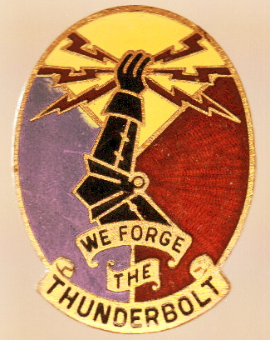

The Father of the Armor Force

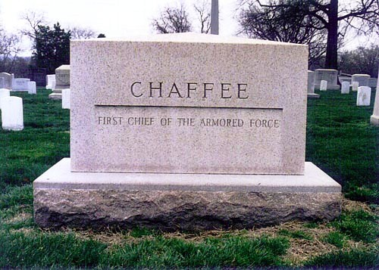

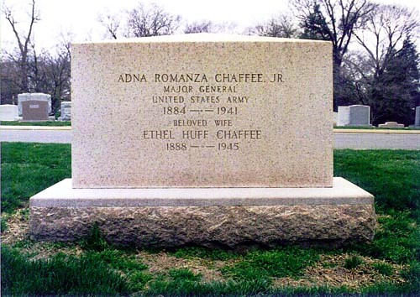

The final resting place of the Father of the Armor Force is located at Arlington National Cemetery. The graves of Major General Chaffee and his wife Ethel can be found at Plot: Section 3, Lot 1944, Map grid S/T15.5

