Think Sheet

Name: Date:

1. What Happened
- Inappropriate Language  - Disrespect  - Physical Contact  - Fighting  - Non-compliance  - Disruption in class | - Property Misuse  - Lying / Cheating  - Harassment / Bullying  - Forgery / Theft  - Other:____________

2. Where did it happen?  Classroom  Restroom  Cafeteria
 Arrival / Dismissal  Hallway  Playground  Other: ___________

3. I was having a problem being…  Safe  Responsible  Respectful

4. With whom?
Teacher/Staff | Myself | Myself and others | My class
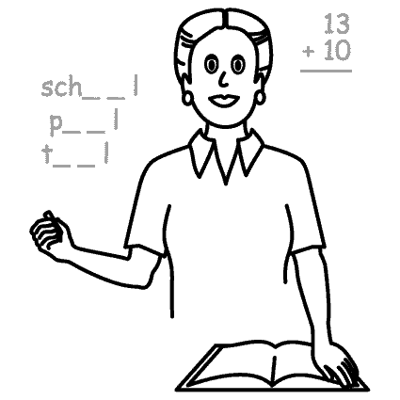 | 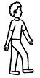 | 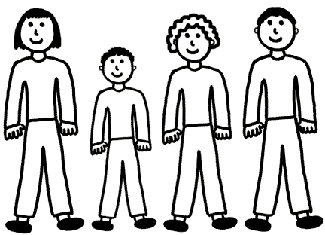 | 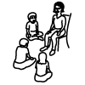

5. I feel:
Angry | Sad | Scared | Happy | I don’t know
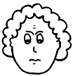 | 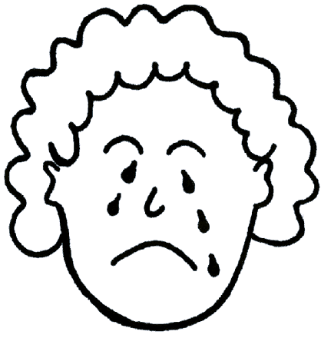 | 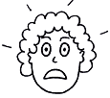 | 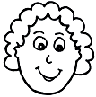 | 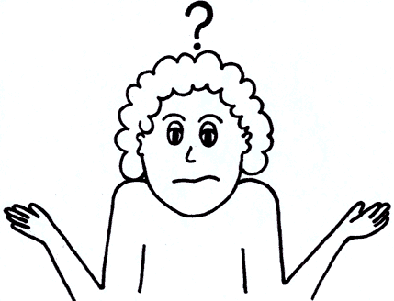
Embarrassed | Jealous | Frustrated | Other: _________________  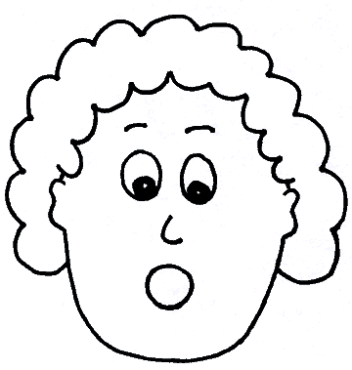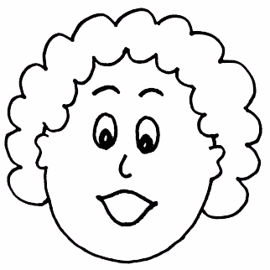
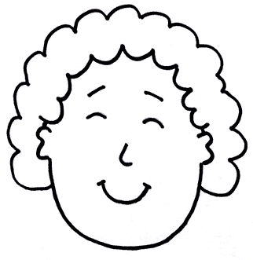 | 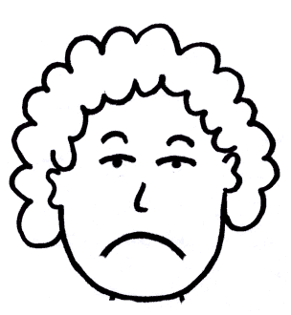 | 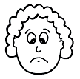

6. Next time I plan to…

Student signature: Adult signature:

