THIRD SUNDAY OF EASTER
APRIL 29 & 30, 2017
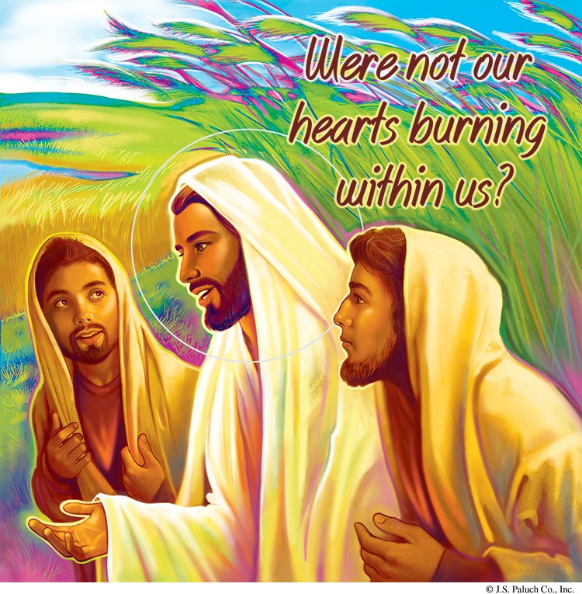
ON THE ROAD
One central metaphor employed to describe the Christian life is a journey. In today’s second reading, Peter addresses the early Christian community: “Conduct yourselves with reverence during the time of your sojourning” (1 Peter 1:17). When we think of a journey, we normally think of some kind of movement from point A to point B. The Christian journey, begun in waters of baptism (point A), has as its ultimate destination eternal life with God in heaven (point B). Unfortunately we find ourselves on all kinds of detours along then way. Because of sin, we make foolish turns and sometimes seem unable to detect the presence of the Lord. Today’s story of the two disciples on their way to Emmaus illustrates for us the fact that, even when we are dejected or on one of our many detours, the Lord is there, walking right beside us.

WEEKLY READINGS
Monday: Acts 6:8-15; Ps 119:23-24, 26-27, 29-30; Jn 6:22-29 or, for the memorial, Gn 1:26—2:3 or Col 3:14-15, 17, 23-24; Ps 90:2-4, 12-14, 16; Mt 13:54-58
Tuesday: Acts 7:51—8:1a ; Ps 31:3 cd-4, 6, 7b, 8a, 17, 21ab;
Jn 6:30-35
Wednesday: 1 Cor 15:1-8; Ps 19:2-5; Jn 14:6-14
Thursday: Acts 8:26-40; Ps 66:8-9, 16-17, 20; Jn 6:44-51
Friday: Acts 9:1-20; Ps 117:1bc, 2; Jn 6:52-59
Saturday: Acts 9:31-42; Ps 116:12-17; Jn 6:60-69
Sunday: Acts 2:14a, 36-41; Ps 23: 1-6; 1 Pt 2:20b-25;
Jn 10:1-10

PLEASE PRAY FOR OUR SICK PARISHIONERS
Julián Palomar, Luisa Martínez, Jennifer Vera, John Braet, Graciela Morales, Ana María López, Kim Koskinen, Margaret Valencia, Matthew Marcoulier, Dennis Tavares, Jose Freitas, Alfredo Sousa, Joel Morales, Manuel Muñoz Mendoza, Juana Arreguín, Aron Yasskin, Victoria Walzer, Fidela Yáñez Jara, Erika Ramos, Bill Gibson, Carla Tomas, Erasmo Yáñez, Memo Soria, Patricia Vargas, Fidela Yáñez, Rogelia Serrano, Elvia Flores, Camila Blanco-Cherrez, Yonel Ruíz, Angie Freitas, Russel Bryant, Derrick Heater, Luis Angel, Juan Barrera-Terán, Gabriel Hurtado, Gerald Butler, Helen Reynolds, Ruth Cimolino, Toni Clark, Ann Gallagher, Brianna Lopez, Margaret Milliken, Gina Pivirotto, Nick Quin, Mary Servis, Denis Sousa, Victor Venegas, Matty Walker, Charles Lorenz, Rebecca Lorenz, William Miller, Ofelia Ibarra, Leonardo Nal, Gina Leal, & Ernest Nuñez.

THE DEACON
Submitted by: Jane Vartanian

My father-in-law, Ohannes (John) Vartanian, was a man with a positive attitude and a cheerful disposition. He grew up in a small village in the Caucasus mountains of Turkey. We have an old Kodak picture of him, dressed in full pantaloons with a wide sash, wearing an earring and those odd shoes with the curly toes. (He could have been posing for an Arabian Nights movie.) He is leading a donkey, and smiling broadly: a proud, contented man.
When he and his family moved to Istanbul, he became a successful building contractor, dressed in a business suit. His family of five lived comfortably, and owned their own home.
Then came in April 1915, when he and his family were suddenly ordered to leave everything, except what they could carry. Soldiers, on horseback, forced them to walk out of the city and across the Turkish countryside into the bleak Syrian desert. They were kept moving mercilessly, with little rest or food. Many died, including their newborn, a little girl, who had been baptized Elise. She was buried hurriedly alongside the trail, and they were pushed along. Ohannes, a religious man, promised God that if he and his family survived, he would serve Him for the rest of his life as a deacon in the Armenian Catholic church.
Finally they ended up in the area of Jerusalem, where they were allowed to stay. They were still together, father, mother, and a daughter and son. They found other still-surviving relatives, although all had suffered losses to their families. They lived as refugees in Jerusalem until the World War was over and they were allowed to return to Turkey, with the promise that they would not be killed if they chose to do so.
They returned to Turkey as paupers; their home had been sold to a Turkish citizen, and they had to rent. He kept his promise to become a deacon in his church, and continued until his death at age 99. My husband was born after their return, and said there was little laughter, and no music in his childhood memories. When relatives came to visit they talked of nothing else but the tragedy that had befallen them. Yet, if outsiders were present, they were silent about it. They did not know why it had happened, and were ashamed to discuss it before strangers. Although I knew them for many years, it was never mentioned in my presence.
Now the story is openly discussed by the descendants, and books and movies made of the tragedy. But many Jews, who have a similar story, and probably felt the same way, forced themselves to talk about it in the hope that it would never happen again in the history of mankind.

PRAY FOR OUR FAMILY AND FRIENDS IN THE MILITARY
Edgar Toscano, Joel Morales, Jr., Marina González, Jacob Lazio, Alondra Jara, Sonia Jara, Jason Lorenz, Matt Mills
& Jared Schroeder

Vigil Mass for the Anniversary for
Our Lady of Fatima
Attention Parishioners:
We need your help!

In honor of Our Lady of Fatima we will be celebrating a Vigil Mass on Friday, May 12, 2017 at 6:00 pm. Mass will be preceded by Confessions starting at 4:00pm, the Rosary, and a candle-lit procession at 5:30pm. Father Andre will consecrate our parish to Our Lady and the children will crown Mary in honor of her Immaculate Heart.
Following Mass there will be a candle-lit procession to the Michael-Raj Hall with the singing of Marian hymns and a pot-luck dessert social to culminate our celebration.
Candles for the processions will be available for a donation of $3 each.
There is a tradition at Fatima, Portugal that pilgrims wave white handkerchiefs as the procession of Our Lady passes by. We would like to honor this tradition as well. White Handkerchiefs will be available for a donation of $6 each, (embroidered with the face of Our Lady).
The families of the Confirmation Students are asked to help host the pot-luck dessert social following the Mass.
Please contact your child's teacher to sign up to help. Parishioners are asked to help, by bringing a light dessert to share. These can be dropped off in the hall prior to Mass.
Donations of white flowers are needed for the church and rose petals for the procession.

EDUCATIONAL GRANTS

KNIGHTS OF COLUMBUS-COUNCIL # 4025
APPLICATION FORMS ARE AVAILABLE AT THE PARISH OFFICE,
MONDAY – FRIDAY FROM 10AM-2PM.
APPLICANTS MUST BE A GRADUATING SENIOR OF THE FBHS AND A MEMBER OF OUR LADY OF GOOD COUNSEL PARISH.

FORMS ARE TO BE COMPLETED AND RECEIVED BY:
MAY 17, 2017.
(STUDENTS MUST COME TO PICK UP APPLICATION)
Thank you,
David Swensen

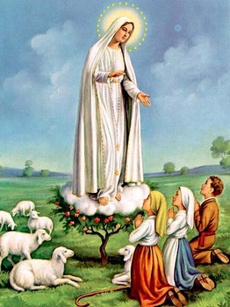
FEAST OF OUR LADY OF FATIMA
WE WOULD LIKE TO INVITE OUR COMMUNITY TO ANOTHER MEETING TO FINISH PLANNING FOR THIS FEAST. IT WILL BE ON
TUESDAY, MAY 2ND AT 6PM.
IN THE RECTORY.
EVERYONE IS WELCOME!!

MASS INTENTIONS
MAY 2 - 7, 2017
Tuesday (02)  Wednesday (03)  Thursday (04)  Friday (05)  Saturday (06)  Sunday (07) | 12:05pm  6:00pm  12:05pm  6:00pm  9:00am  5:00pm  6:30pm  8:00am  10:00am  12:30pm | Communion Service  Maria Trinidad Mojarro †  James Melo †  Crisanto Del Rosario  (healing)  OLGC’s mass  Ladis Cuevas (b-day)  Acm. Weera-Knunying Supa Kitchathorn (b-day)  Margarito Martin †  Angeles Renteria †  Beatriz Valencia †  Manuel Calleja †  Juan Mendoza †  Efren Mendoza †  All Souls in Purgatory  Helen Scheff †  James Melo †  Albino Ambrocio†  Eleanor Fereira Campbell†  Philo Mass

WEEKLY COLLECTION
APRIL 22 & 23, 2017…….$1,932.50
YOUTH MINISTRY……..…$643.00
THIS WEEKEND’S SECOND COLLECTION: GENERAL FUND
NEXT WEEKEND’S SECOND COLLECTION: LIABILITY INSURANCE
THANK YOU FOR YOUR SUPPORT & CHRISTIAN GENEROSITY

Hispanic Community Raffle
The Hispanic Community of OLGC is selling raffle tickets.
1st price: A nice set of gold earrings (medium size).
2nd price: A pair of gold stud earrings.
3rd price: A wood mail organizer.
$1.00 per ticket or 6 for $5.00.
The purpose of the raffle is to gather funds for the remodeling of Our Lady of Good Counsel Church’s sacristy.
Winning tickets will be drawn on May 6, 2017 after the 6:30pm mass. Winners will be notified.

WEEKLY EVENTS
Sun. –11:00am  11:30am | Kids Faith & Art Class  Parish Choir | Classroom #4  Choir loft
Mon. – 1:00pm  6:30pm-8:00pm | English Bible Study  RCIA in Spanish | The Rectory  Parish School. For more information, call Rosa Hernandez @ 964-6743
Tues. – 1:00pm | Altar Society Meeting  (as needed) | Parish Hall
Tues. – 7:30pm | (2nd & 4th Tues. of the month) Knights of Columbus Mtg. | Classroom #2
Wed. – 4:00pm  4:00pm  6:00pm  6:30pm – 8pm  7:00pm  8:00pm | Music Class  Al-Anon Mtg.  BINGO  CCD for Confirmation  RCIA  Hispanic Choir | Rectory  Classroom #2  Parish Hall  Parish Classrooms  The Rectory. For more information, call Jim Gross @ 964-4921.  Church  Choir loft
Thu. – 6:00  6:30pm | Spanish Bible Study  Parish Choir | Parish School  Choir Loft
Friday 6pm – 7:30pm  Sun. – Fri. 5:00pm | CCD for First Communion  Rosary | Parish Classrooms  Church

TERCER DOMINGO DE PASCUA
29 Y 30 DE ABRIL, 2017
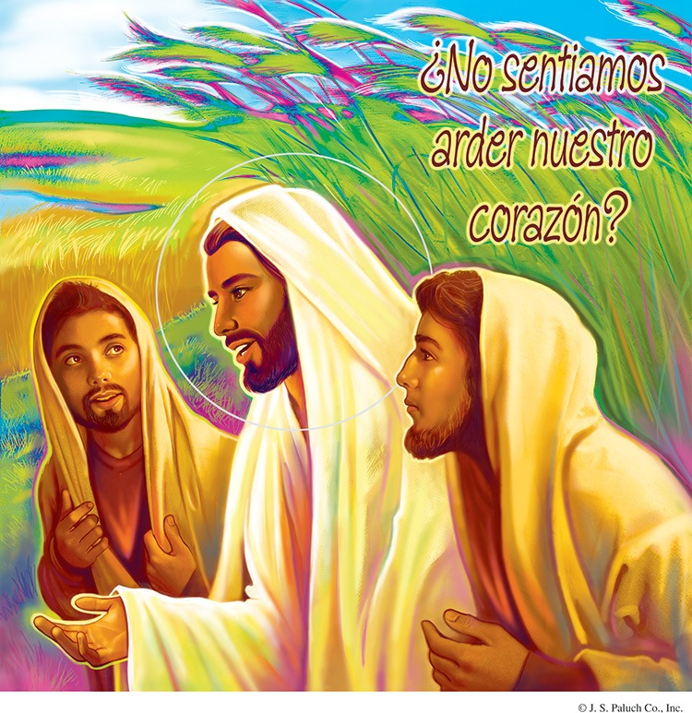
EN EL CAMINO
Una metáfora importante que se emplea para describir la vida Cristiana es la de una peregrinación, En la segunda lectura de hoy, Pedro se dirige a la primera comunidad Cristiana: “Vivan siempre con temor filial durante su peregrinar por la tierra” (1 Pedro 1:17). Al pensar en una peregrinación, normalmente se nos ocurre algún tipo de movimiento del punto A al punto B. La peregrinación Cristiana, que comenzó en las aguas del bautismo (punto A) tiene como destino final la vida eterna con Dios en el cielo (punto B). Desafortunadamente, en el transcurso, tomamos todo tipo de desvíos. Debido al pecado, tontamente nos desviamos y a veces parecemos incapaces de detectar la presencia del Señor. Hoy, el relato de los dos discípulos camino a Emaús, ilustra el hecho de que, aunque nos sintamos abatidos o muy desviados, el Señor está allí, caminando junto a nosotros.

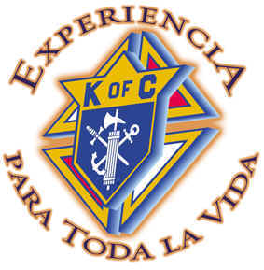
BECAS ESTUDIANTILES
DE LOS CABALLEROS DE COLON
DEL CONCILIO #4025
YA ESTAN DISPONIBLES EN LA OFICINA PARROQUIAL.
LOS ESTUDIANTES TIENEN QUE ESTAR A PUNTO DE GRADUARSE DE FORT BRAGG HIGH SCHOOL Y SER MIEMBROS DE NUESTRA SEÑORA DEL BUEN CONSEJO.
LAS APLICACIONES TIENEN QUE SER ENVIADAS ANTES DEL 17 DE MAYO DEL 2017.
LA OFICINA ESTA ABIERTA DE LUNES A VIERNES DE 10AM-2PM.
MUCHAS GRACIAS,
David Swensen

FIESTA DE NUESTRA SEÑORA DE FATIMA
VENGAN Y AYUDEN A PLANEAR ESTE EVENTO. TENDREMOS OTRA JUNTA PARA TERMINAR DE PLANEAR DICHA FIESTA.
EL MARTES 2 DE MAYO A LAS 6PM. EN LA RECTORIA.
¡¡TODOS ESTAN INVITADOS!!

Aniversario de
Nuestra Señora de Fátima
Atención Feligreses:
¡Necesitamos de su ayuda!

En honor a Nuestra Señora de Fátima tendremos una Misa de Vigilia, el viernes, 12 de mayo de 2017 a las 6:00 pm. La misa será al termino de Confesiones y Rosario a partir de las 4:00 pm, y una procesión a la luz de las velas a las 5:30 pm. El Padre Andrés consagrará nuestra parroquia a Nuestra Señora y los niños coronarán a María en honor de su Inmaculado Corazón.
Después de la misa habrá una procesión con velas al Salón Michaelraj con himnos marianos y tendremos una convivencia en la cual tendremos postres, café y té, donde los padres de familia del grupo de Confirmación estarán a cargo de organizarlo. Y se les pide que cada familia de nuestros feligreses que traigan un delicioso postre para compartir con toda la comunidad. Lo pueden dejar en el salón antes de la misa.
Velas para las procesiones estarán disponibles por una donación de $3.00 c/u.
Hay una tradición en Fátima, Portugal, que todos los peregrinos agitan pañuelos blancos mientras pasa la procesión de Nuestra Señora. Y también nos gustaría honrar esta tradición.
Los pañuelos blancos y bordados con la imagen de Nuestra Señora estarán disponibles por una donación de $ 6.00 c/u.
Póngase en contacto con el maestro (a) de su hijo (a) para que nos pueda decir en que area puede ayudar.
Se necesitan donaciones de flores blancas para la iglesia y pétalos de rosa para la procesión. Para más información, favor de llamar a la oficina parroquial, al 964-0229.

OREMOS POR NUESTROS FAMILIARES Y AMIGOS QUE SE ENCUENTRAN EN EL SERVICIO MILITAR
Edgar Toscano, Joel Morales, Jr., Marina González, Alondra Jara, Sonia Jara, Jason Lorenz, Matt Mills
y Jared Schroeder

OREMOS POR LOS ENFERMOS DE LA PARROQUIA
Julián Palomar, Luisa Martínez, Jennifer Vera, John Braet, Graciela Morales, Ana María López, Kim Koskinen, Margaret Valencia, Matthew Marcoulier, Jose Freitas, Alfredo Sousa, Juan Barrera, Jr., Joel Morales, Juana Arreguín, Aron Yasskin, Victoria Walzer, Fidela Yáñez Jara, Erika Ramos, Bill Gibson, Carla Tomas, Erasmo Yáñez, Memo Soria, Patricia Vargas, Fidela Yáñez, Rogelia Serrano, Elvia Flores, Camila Blanco-Cherrez, Yonel Ruíz, Angie Freitas, Russel Bryant, Derrick Heater, Luis Angel, Juan Barrera-Terán, Gabriel Hurtado, Gerald Butler, Helen Reynolds, David Soto, Ruth Cimolino, Toni Clark, Ann Gallagher, Brianna Lopez, Margaret Milliken, Gina Pivirotto, Nick Quin, Mary Servis, Denis Sousa, Victor Venegas, Matty Walker, Charles Lorenz, Rebecca Lorenz, William Miller, Ofelia Ibarra, Leonardo Nal, Gina Leal y Ernest Nuñez.

COLECTA SEMANAL
22 Y 23 DE ABRIL, 2017…….$1932.50
MINISTERIO JUVENIL……$643.00
ESTA SEMANA, LA SEGUNDA COLLECTA SERA PARA:
FONDO GENERAL
LA PROXIMA SEMANA LA SEGUNDA COLLECTA SERA PARA:
SEGURO DE RESPONSABILIDAD CIVIL
¡¡¡GRACIAS POR SU COOPERACION!!!

RIFA ESPECIAL A BENEFICIO DE NUESTRA PARROQUIA
La Comunidad Híspana de Nuestra Señora del Buen Consejo está vendiendo boletos para una rifa.
1er. premio: un juego de aretes de oro de tamaño mediano.
2o. premio: un par de broqueles de oro
3er. premio: Un separador de cartas de madera.
La recaudación de fondos será para arreglar la sacristía de Nuestra Señora del Buen Consejo.
La rifa se llevará acabo el 6 de mayo después de la misa de las 6:30pm. Se le notificará al ganador en caso de no estar presente ese día.
El valor del boleto es de $1.00 c/u ó 6 boletos por $5.00.

LECTURAS DE LA SEMANA
Lunes: Hch 6:8-15; Sal 119 (118):23-24, 26-27,
29-30; Jn:22-29 o (por la memoria), Gn 1:26— 2:3 or Col 3:14-15, 17, 23-24; Sal 90 (89):2-4, 12-14, 16; Mt 13:54-58
Martes: Hch 7:51—8:1a ; Sal 31 (30):3 cd-4, 6, 7b, 8a, 17, 21ab; Jn 6:30-35
Miércoles: 1 Cor 15:1-8; Sal 19 (18):2-5; Jn 14:6-14
Jueves: Hch 8:26-40; Sal 66(65):8-9, 16-17, 20;
Jn 6:44-51
Viernes: Hch 9:1-20; Sal 117 (116):1bc, 2; Jn 6:52-59
Sábado: Hch 9:31-42; Sal 116 (115):12-17; Jn 6:60-69
Domingo: Hch 2:14a, 36-41; Sal 23 (22): 1-6; 1
Pe 2:20b-25; Jn 10:1-10

ARBOL MEMORIAL DE NUESTRA SEÑORA DEL BUEN CONSEJO

EN LA ENTRADA DE NUESTRA IGLESIA, EN LA PARED QUE DA HACIA EL SUR, TENEMOS UN ARBOL MEMORIAL, DONDE CADA HOJA REPRESENTA A NUESTROS DIFUNTOS. POR LA CANTIDAD DE $200.00 QUE PUEDE ENTREGAR EN LA OFICINA, CON LOS NOMBRES Y FECHAS DE NUESTROS DIFUNTOS, EN CUESTION DE UNA SEMANA SE GRABA LA HOJA Y SE COLOCA EN EL ARBOL, “UN RECUERDO DE LA PARTIDA DE NUESTROS SERES QUERIDOS”.
PARA MAS INFORMACION, FAVOR DE LLAMAR
A LA OFICINA AL 964-0229.(MUY SEGUIDO SE CELEBRAN MISAS PARA EL DESCANSO ETERNO DE LAS ALMAS DE NUESTROS SERES QUERIDOS QUE ESTAN EN NUESTRO ARBOL MEMORIAL.)

HORARIO DE MISAS
DEL 2 AL 7 DE MAYO DEL 2017
Martes (2)  Miércoles (3)  Jueves (4)  Viernes (5)  Sábado (6)  Domingo (7) | 12:05pm  12:05pm  12:05pm  6:00pm  9:00am  5:00pm  6:30pm  8:00am  10:00am  12:30pm | Servicio de Comunión  Maria Trinidad Mojarro †  James Melo †  Crisanto Del Rosario  (salud)  Misa de NSBC  Ladis Cuevas  (cumpleaños)  Acm. Weera-Knunying Supa Kitchathorn (cumpleaños)  Margarito Martin †  Angeles Renteria †  Beatriz Valencia †  Manuel Calleja †  Juan Mendoza †  Efren Mendoza †  Animas del Purgatorio  Helen Scheff †  James Melo †  Albino Ambrocio†  Eleanor Fereira Campbell †  Misa En Philo

EVENTOS DE LA SEMANA
Domingo- 11:00am  11:30am | Clase de arte para niños  Coro de Adultos (inglés) | Salon #4  Iglesia
Lunes – 6:30pm | RICA  Rosa Hernández  964-6743 | Salones del Catecismo
Martes- 7:00pm | Junta de los Caballeros de Colón  (2 y 4 martes del mes) | Salón #2
Miércoles: 6:00pm  6:30pm  6:00pm  7:00pm  8:00pm | Junta de Al-Anon  Clases de Catecismo para Confirmación  BINGO  RCIA (inglés)  Coro Hispano | Salón de clases #2  Salones del Catecismo  Salón de la Iglesia  Rectoría.  Jim Gross 964-4921  Iglesia
Jueves- 6:00pm  6:30pm | Estudio Bíblico en español  Coro de adultos (inglés) | Salón de Clases  Se les avisará
Viernes 6:00pm | Clases de Catecismo para Primera Comunión | Salónes de Catecismo

