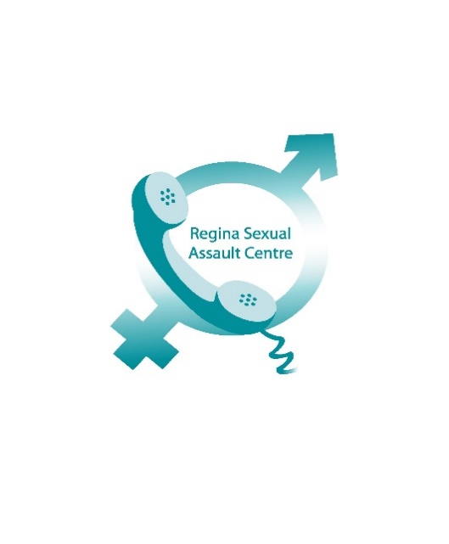

Dear Donor or Future Donor:
Thank you for looking at the Regina Sexual Assault Centre as a place for your donation. It is important to us that you know what it being done with your donation money and how we are continually improving how we help those who have been impacted by sexual assault, as well as how we educate the public about this issue.
In 2016-2017, the Centre answered 271 Crisis Line calls and provided over 1,400 counselling sessions to individuals who have been impacted by sexual assault, child sexual abuse and domestic violence. The Centre staff also attends numerous public education and awareness events, including our children’s program, which presented to over 4,000 children in 2016-2017.
__________________________________________________
April 2017 the Centre allocated $1,500 for the purchase of books for our library. Language and current theories and treatment of sexual assault, child sexual abuse and domestic violence are evolving. It is important that our resources reflect the most up-to-date and helpful information possible.
__________________________________________________
May 2017, two staff from the Centre attended a week-long Facilitator Training for first responders to sexual assault and sexual abuse. This is a province wide initiative aimed at ensuring a consistent and sensitive response to disclosures. In Fall 2017, the Centre will be developing and distributing information about this training to professionals and paraprofessionals who work in areas where they may receive disclosures. Additionally, we will be offering this two day certified training to all new volunteers. Costs for materials and workbooks for our volunteers will be covered by the Centre.
__________________________________________________
June 2017, our front waiting area was enhanced by some lovely “new to us” chairs and a small fish tank. It has made the area more welcoming and the fish tank provides some separation for clients who may not be comfortable seated directly next to another person.
__________________________________________________
In August 2017, with client and counsellor input, we decided to convert a mostly unused downstairs office into a quiet space for clients (or staff) to go to read and reflect. This space will also be used for future group counselling. The Centre will be looking for donations of a sofa, chairs, tables and lamps to furnish this space.

