

Summer - 2022 Season

Pre – Season Report

Welcome to the Summer 2022 Season. Laurent Pellaton starts his defence of the Premier League title. Its no easy feat winning it once, never mind twice.

Newly crowned Winter Champion Geoffroy Buffetrille will be hoping to make it back-to-back titles. He had a fairly disappointing Summer season in 2021 by his standards, but we are sure he will once again be challenging for that prestigious top spot.

Neil Selby had a disappointing Winter campaign but finished runner up last Summer, can he go one better this time around. Ross Payne was one of three players tied for third place with points difference giving him a bronze medal, will he but up there again.

Andrew Bellamy-Burt missed out on third by two points on points difference and has won more Summer Premier League titles than anyone else, but despite being one of the toughest players to beat he also struggles to turn draws into wins. Likewise for Alice Dilks who was undefeated in the Winter but had ten draws.

Joining the likes of Brian Harris and Joey the Clech is newly promoted Gavin Scott who won Division 1 last season and Division 2 the season before that, with his shooting ability could he top the Premier League?

Also promoted were experienced Premier League player Alex Stewart making up a very strong league as usual.

Let us know on Facebook who your top three will be, a prize for anyone who gets all three players (in the correct order).

In Division 1, relegated Callum Stewart and Matt Buesnel (who won Division 1 in the Winter) will be looking for an immediate return to the top league in the Summer and they play each other in Week 1 fixture.

Andrew Limbrick just missed out on promotion last season so will be hoping to convert his excellent cup form into the leagues for another promotion push.

Strong players all around with David Ibitson, Paul Bell and Wendy Ritzema, Cassie Stewart and Tim Jackson being joined Mo de Gruchy for another strong line up.

Let us know on Facebook who your top three will be, a prize for anyone who gets all three players (in the correct order).

Brigitte Ibitson dropped down to Division 2 and should be strong candidate to move back up. They are joined though by some very experienced players, not just league experience but European experience. This includes Lorna Limbrick.

Daniel and James Villalard are improving year on year so could be in with a shout for promotion but several new players in this division, many of which are new or fairly new to the game , so could be some dark horses, with Martin Schwartz, Luc Rochefort, Colin Floyd, Jim Waddell, John Flaherty and returning Ian Black so should be an interesting league this year.

Let us know on Facebook who your top three will be, a prize for anyone who gets all three players (in the correct order).

The Doubles Premier League champions Laurent Pellaton & Matt Pinel are back looking to become the second team to make it three titles in a row after Antony Di Santo & Ross Payne (2013 - 2015). Considering they won the title by 10 points last season then the rest of the teams are going to have to improve some way to catch them.

Geoffroy Buffetrille & Matt Buesnel who have a few titles under their own belt will be looking to prevent Laurent & Matt from winning again as will Neil Selby & Ross Payne who finished runners up last Summer.

Another top team in Andrew Bellamy-Burt & Callum Stewart who are consistently winning competitions will also be in with a shout as will Gavin Scott & James Rondel.

Gary Cowburn & Wendy Ritzema and Graeme Follain & Keith Pinel make up the teams and are joined by newly promoted Alex & Jean Stewart, who had a very good Winter season in the end after a poor start, along with Cassie Stewart & Chris Le Gallais who will be playing in the Premier League for the first time. Alan Mitchel & Mike Robinson make up the teams joining the topflight.

Let us know on Facebook who your top three will be, a prize for anyone who gets all three players (in the correct order).

Dropping down to Division 1 and probably pre-season favourites to go straight back up is Alice Dilks & Brigitte Ibitson, they will be pushed hard though by fellow relegated team Colin Myers & Steve Simpkin.

Andrew & Lorna Limbrick missed out on promotion last Summer despite having the best points difference so expect them to be challenging for the title this season.

Will Daniel & James Villalard cup form translate to consistent league form as they bid for their first promotion. Brande De La Haye & Tim Jackson had their worst season yet in the Winter and failed to win a match last Summer, will their form change for this season.

John McGaw & Nick Pallot will be taking points off a lot of teams as they draw more matches than most and Kat Stewart & Paul Bell will be there or there abouts when it comes to promotion along with Dawn Buckley & James Gennoe.

Let us know on Facebook who your top three will be, a prize for anyone who gets all three players (in the correct order).

Good Luck to everyone.

Please like and follow us on Facebook.

League tables will be posted on Facebook each week (Wednesday Night) as well as on the club Website which will have all the scores and reports as well, each week.

WEBSITE www.liberationpetanque.co.uk
EMAIL liberationpc@gmail.com

Sponsored by



CoinShares | Digital Asset Investment Strategies for Professionals 🚀



SUMMER - 22 SEASON
WEEK 11 – 6th April 2022
SINGLES LEAGUE

Welcome to the new season, albeit a very cold start to the Summer Leagues.

Laurent starts his task of defending his Premier League title, he played Summer 2020 champion Joey. Laurent took a 11 – 0 lead before Joey finally got off the mark before losing 13 – 5 in the first game. A slightly closer game but Laurent is playing great at the moment and also took the second game 13 – 8 to get the defence of his title off to a great start.

Newly crowned winter champion Geoffroy also got off to a great start beating Alex for maximum points.

Alice was the only player undefeated in the winter Premier League but lost her first match of this campaign to Ross who was close to handing out a certificate in the first game winning 13 – 3, 13 – 10.

Regular top three player Neil lost the first game to Brian 13 – 8 before a big win in the second game 13 – 2 for a good draw for both players.

Gavin played his first ever match in the Premier League and was close to beating Andrew winning the first game 13 – 8, before just losing 13 – 11 in the second. Toby having a bye in the first round of matches.

In Division 1, Matt found the going tough giving a way several points as he lost the first game against Branden before handing out the first certificate of the season in the second game for a draw.

Callum, one of the pre-season favourites also could only draw, but against experience and one of the top female players in the Island in Wendy.

Andrew won his first match of the season against Mo and therefore tops the league early on with Paul and Cassie drawing their match.

Jean v Tim un-played and David on a bye in week 1.

Division 2 saw a lot of new players, which is great to see. Four of them played each other with Colin taking on Martin winning an extremely close match 13 – 11, 13 – 12.

Jim played Luc with a good draw as Jim took the first match 13 – 4, before Luc got the hang of the second game to win 13 – 7. Also a draw for James v Lorna

Newly crowned Summer 21 player of the season Daniel took all three points from Brigitte for a great start to the season topping the league early on.

Ian v John un-played.

SUMMER - 22 SEASON
WEEK 2 – 13th April 2022
DOUBLES LEAGUE

Welcome to the start of the Doubles League season.

A number of matches off this week with players off to Spain for a competition.

Last years Runners up Neil & Ross, did get their match played in advance and pulled off a good win pulling back a big deficit in game one to win 13-12 and then won more comfortably in the second game to take all three points.

The only other scheduled match played was Gavin & James v Cassie & Chris with the former taking all three points to top the league after week 1.

In a match played in advance Alex & Jean ended Gary & Wendy eight match unbeaten run.

Matches un-played –

Geoffroy & Matt v Alex & Jean

Callum & Andrew v Alan & Mike

Alan & Joey v Laurent & Matt

In Division 1

Alice & Brigitte took on Colin & Steve, two top teams playing out a good draw for both. Daniel & James played John & Nick also ending in a draw. The only matches played this week in a slow start to the season.

Matches un-played –

Andrew & Lorna v Kat & Paul

Colin & Jim v Branden & Tim

Dawn & James v Luc & Martin

SUMMER - 22 SEASON
WEEK 3 – 20th April 2022
SINGLES LEAGUE

Champion Laurent is on form at the moment picking up another three points with a confident win over Brian.

Winter champion Geoffroy dropped points losing the first game against Toby 13 – 6 before gaining a draw.

Joey was one point away from handing Alice her second successive defeat after being undefeated the whole of last season but gained a good draw. Neil though ended Gavin 17 match unbeaten run to pick up three good points.

In Division 1 Tim took six points winning his scheduled match against David before also beating Jean to top the table.

Paul Bell also beat Jean and Callum beat Branden. Unfortunately Wendy has withdrawn from the league meaning now just ten players in the Division.

In Division 2 an impressive performance from Lorna saw her beat Brigitte for three big points. Newcomer Colin shared a 13 – 12 score with Daniel for another point and could be one for the title.

Four other newcomers played each other with Martin taking three points from John and Jim beating Ian. Certainly going to be an interesting league this season.

Outstanding matches

Premier League

Andrew Bellamy-Burt v Alex Stewart

Division 1

Cassie Stewart-Le Gallais v Matt Buesnel

Division 2

Ian Black v John Flaherty

Luc Rochefort v James Villalard

SUMMER - 22 SEASON
WEEK 4 – 27th April 2022
DOUBLES LEAGUE

With disruption on the terrains this week several matches went unplayed, in fact just five matches played across both divisions.

Current Premier League champions Matt & Laurent did play, but despite winning the first game could no capitalise against James & Gavin with the match ending in a draw. In fact this was the only match played in this division.

In Division 1 Branden & Tim beat the much fancied team of Andrew & Lorna, whilst experienced pair Dawn & James laboured to a win over new players Colin & Jim in a close match. Colin & Jim look a good pair though and should give quite a few teams a good game throughout the season.

Daniel & James beat another new team in Luc & Martin who played together for the first time, we are sure they will improve as the season goes on.

Alice & Brigitte also got a win to move them top of the league, but only just did it over Kat & Paul with the second game going to 13-12.

Matches un-played –

Geoffroy & Matt v Alex & Jean

Geoffroy & Matt v Alan & Mike

Callum & Andrew v Alan & Mike

Callum & Andrew v Alan & Joey

Alan & Joey v Laurent & Matt

Neil & Ross v Cassie & Chris

In Division 1

Matches un-played –

Kat & Paul v Andrew & Lorna

Colin & Jim v Branden & Tim

Dawn & James v Luc & Martin

Colin & Steve v John & Nick

SUMMER - 22 SEASON
WEEK 5 – 4th May 2022
SINGLES LEAGUE

The champion is on a roll, Laurent won his third straight match in his defence of the title, taking all three points over Alice who as a result is in the bottom three with -29 points difference after just three matches.

Neil Selby took all three points against Alex to move into second place with two wins and a draw. Gavin Scott is still looking for his first Premier League win after a very close draw with Brian Harris.

A 13 – 12 scoreline in one game helped Geoffroy defeat Ross and move into third place. Toby gave Andrew a 9 – 0 start in their first game before pulling it back before just losing 13 – 11, Toby though got the valuable point winning the second game 13 – 7.

In a match played in advance Laurent dropped his first points of the season losing a game 13 – 12 against Gavin, this means Gavin his still without a win in the Premier League so far.

In Division 1 Matt Buesnel took all six points against Cassie and then Jean Stewart to move top although having played a match more than Tim. Cassie also drew with Branden.

Callum also won picking up three points against Mo and David beat Paul to move out of the relegation zone.

In Division , Daniel beat John for an expected three points to move top of the Division 2 table, but James lost to Ian Black who then drew his catch up match against John.

Martin and Jim shared the spoils with Jim in second place and Brigitte took all three points from Colin, his first defeat of the season.

SUMMER - 22 SEASON
WEEK 6 – 11th May 2022
DOUBLES LEAGUE

Quite a few matches off this week despite the great weather we are currently having.

In the Premier League Andrew & Callum got their season underway with a catch-up match against Alan & Mike, but it didn’t start well as they lost the first game 13 – 7. But they did show composure in the second game to win 13 – 2 for a draw.

They then played Alan & Joey in another catch-up just winning the match following a 13 – 12 win in game two!

Graeme & Keith played Cassie & Chris with both teams needing a win in a very competitive league, it was Graeme & Keith who took the spoils and the much needed three points, this also applied to Alan & Mike who played Gary & Wendy with the latter also taking all three points.

In Division 1 Leaders Branden & Tim were hoping to make it three straight wins in their match against Kat & Paul, whilst the same applied to Dawn & James in their match against Andrew & Lorna. No results though for these matches.

Alice & Brigitte were up against John & Nick in their aim for the title and move top of the league with a win. Daniel & James also pushing the top teams played new team Colin & Jim but could only draw with Colin & Jim gaining their first league win.

Colin & Steve played another new team in Martin & Luc and continued last seasons for with a 13 – 0 in the first game but much credit to Martin & Luc having only met a few weeks earlier won the second game 13 – 11 for their first point, well done Martin & Luc.

Outstanding Matches

Premier League

Geoffroy Buffetrille & Matt Buesnel v Alex & Jean Stewart

Cassie Stewart & Chris Le Gallais v Neil Selby & Ross Payne

Alan Mitchell & Mike Robinson v Geoffroy Buffetrille & Matt Buesnel

Neil Selby & Ross Payne v Laurent Pellaton & Matt Pinel

Geoffroy Buffetrille & Matt Buesnel v Alan Oliveira & Joey Le Clech

Gavin Scott & James Rondel v Callum Stewart & Andrew B-Burt

Division 1

John McGaw & Nick Pallot v Colin Myers & Steve Simpkin

Kat Stewart & Paul Bell v Branden De La Haye & Tim Jackson

Andrew & Lorna Limbrick v Dawn Buckley & James Gennoe

SUMMER - 22 SEASON
WEEK 7 – 18th May 2022
SINGLES LEAGUE

Champion Laurent early lead cut back as he dropped his first points of the season in a draw with Gavin.

This meant that Geoffroy joined him on ten points after he thrashed Joey, but Geoffroy points difference still below Laurent.

Andrew took all six points with wins over Ross and Alex in a catch up match to remain unbeaten on eight points in third place. Alex gaining a point in his scheduled match against Brian.

Toby and Neil match postponed and Alice on a bye this week.

In Division 1 there were big wins for the three favourites for promotion with Callum beating Cassie, Matt with a big win over David and Andrew Limbrick beating Paul Bell.

Jean picked up her first win of the season to move up the table.

In Division 2 Brigitte just overcame new player Luc for three important points towards her promotion bid. Colin Floyd won again, this time over John to keep him on course for promotion.

James beat Martin to move into contention for promotion.

Outstanding Matches

Premier League

Toby Northern v Neil Selby

Division 1

Andrew Limbrick v Tim Jackson

Division 2

Lorna Limbrick v Luc Rochefort

Lorna Limbrick v Ian Black

Jim Waddell v Daniel Villalard

SUMMER - 22 SEASON
WEEK 8 – 25th May 2022
DOUBLES LEAGUE

With a number of matches still due to be played it was hard for any team to stand out yet, but Neil & Ross did as they beat the league leaders Andrew & Callum, but not just beat them they handed out a 13 – 0 certificate.

Neil & Ross also won big against Cassie & Chris to top the league with three wins from three.

Andrew & Callum though made up for it in a catch-up match against Gavin & James winning that match to stay in the top three and this was after Gavin & James had beat Geoffroy & Matt!!.

Alan & Joey have lost a few close games and would have been hoping to prevent that occurring again in their match against Gary & Wendy, but a draw was the result not helping either team.

Alan & Mike played Alex & Jean with the latter winning making it two wins from two to keep their 100% record.

Laurent & Matt v Graeme & Keith outstanding.

In Division 1 leaders Dawn & James were hoping to continue their one hundred percent record. They played Kat & Paul but they narrowly avoid defeat taking the first game 13-12, before Kat & Paul took the second game more comfortably.

A big game though between second and third in the league as Branden & Tim played Alice & Brigitte. With Dawn & James dropping points this meant Alice & Brigitte win puts them top of the league on points difference.

Daniel & James were undefeated after three matches and played Andrew & Lorna, but they only scored two points losing to Andrew & Lorna 13 – 1, 13 – 1.

Outstanding Matches

Premier League

Geoffroy Buffetrille & Matt Buesnel v Alex & Jean Stewart

Neil Selby & Ross Payne v Laurent Pellaton & Matt Pinel

Geoffroy Buffetrille & Matt Buesnel v Alan Oliveira & Joey Le Clech

Laurent Pellaton & Matt Pinel v Graeme Follain & Keith Pinel

Division 1

John McGaw & Nick Pallot v Luc Rochefort & Martin Schwartz

John McGaw & Nick Pallot v Colin Myers & Steve Simpkin

Colin Floyd & Jim Waddell v Colin Myers & Steve Simpkin

SUMMER - 22 SEASON
WEEK 9 – 1st June 2022
SINGLES LEAGUE

Champion Laurent maintained his great form with a win over Alex, but he only leads on points difference as Geoffroy also won against Alice, who has now lost three out of four matches and sits in the relegation zone.

Neil lost ground on the top spots as despite winning 13 – 1 against Ross in the first game, he ended up with a draw. Neil then drew with Toby, coming back in the second game to get another point.

Andrew took all three points against Joey but only just as another 13 – 12 result went against Joey in his 100th Singles League match.

Brian and Toby played their match with Brian taking the points to move up the table.

In Division 1 only a few matches were played with Branden getting a good draw against David and Cassie and Jean also drawing their match.

Division 2 saw draws all around as Doubles team mates Colin and Jim, Brigitte and John, Luc and Ian all get a point.

Lorna beat Martin though on Monday to move top.

Outstanding Matches

Premier League

Gavin Scott v Alex Stewart

Division 1

Mo De Gruchy v Tim Jackson

Matthew Buesnel v Andrew Limbrick

Division 2

Daniel Villalard v James Villalard

2022
Liberation Club Doubles Cup

A beautiful sunny evening was enjoyed by the 13 teams that took part this year.

Despite matches being timed at just 30 minutes (plus 1 additional end) many matches made it to thirteen points. Some big wins for the top teams in Round 1 as holders Andrew & Callum won 13 – 3 over last years third place team Daniel & James.

Mark Nicol & Matt Pinel won 13 – 1 against Dawn & James Gennoe and this result was matched by Geoffroy & Matt over Branden & Tim and Laurent & Toby over Andrew & Lorna with Toby hitting two spot carreaux on consecutive ends to gain five and four point ends respectively making a big difference in the match.

Neil & Ross did have a 13 point match but it end 8 – 5 to them over Graeme & Keith. With Gavin & James losing 7 – 10 to Alan & Joey.

In Round 2 Dawn & James got off the mark with a 12 – 6 win over Branden & Tim and Graeme & Keith also won over Andrew & Lorna. James & Gavin came back from 5 – 2 down against Laurent & Toby to win 13 – 6.

A big match between Geoffroy & Matt Buesnel against Mark & Matt Pinel saw the latter win 10 – 5. A close match between Andrew & Callum winning 9 – 6 over Alan & Joey. Neil & Ross also moved on to two wins with a big 13 – 4 win over Cassie & Jean.

Neil & Ross continued to dominate the qualifying rounds beating champions Andrew & Callum 13 – 4 and Mark & Matt also made it three wins winning big 13 – 3 over Alan & Joey.

Laurent & Toby got they game back together winning 12 – 6 over Cassie & Jean as did Geoffroy & Matt winning 9 – 6 over Dawn & James.

Another 9 – 6 win for Gavin & James over Daniel & James and Graeme & Keith moved into contention for a qualifying spot with a big win 13 – 3 over Branden & Tim.

In the final qualifying round Laurent & Toby beat Graeme & Keith 13 – 5 to finish fifth with Graeme & Keith finishing sixth.

Neil & Ross beat Mark & Matt 13 – 7 to finish on four wins from four and ranked first with Mark & Matt finishing second.

Andrew & Callum won 13 – 7 to finish third with their opponents Gavin & James finishing seventh qualifying with two wins.

Geoffroy & Matt and Alan & Joey both won their matches 13 – 2 as they both qualified in forth and eighth place respectively. But despite winning their last match

Dawn & James missed out in nineth.

Final Swiss Rankings

INCLUDEPICTURE "cid:d36f7b35-e6a6-6478-b891-ad696de479bf@yahoo.com" \* MERGEFORMATINET INCLUDEPICTURE "cid:d36f7b35-e6a6-6478-b891-ad696de479bf@yahoo.com" \* MERGEFORMATINET 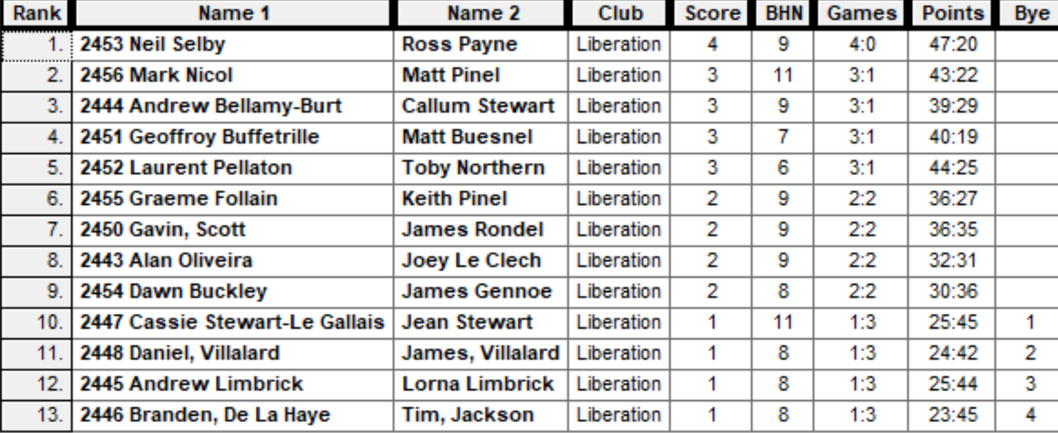

Quarter Finals

Ranked 1st Neil & Ross v Alan & Joey Ranked 8th

Ranked 2nd Mark & Matt v Gavin & James Ranked 7th

Ranked 3rd Andrew & Callum v Graeme & Keith Ranked 6th

Ranked 4th Geoffroy & Matt v Laurent & Toby Ranked 5th

The top ranked team broke the Swiss curse winning the quarter final match 13 – 8 over Alan & Joey.

Two shocks though as Mark & Matt were beaten 10 – 7 against Gavin & James who produced their best game of the tournament and Graeme & Keith knocked out the holders Andrew & Callum in a nail biter 12 – 11.

Laurent & Toby had a big lead going into the final two ends with Geoffroy & Matt only picking up 1 point needed a four point end just to tie and despite having a decent chance, couldn’t pull it off as last years runners up went out.

Semi Finals

Ranked 1st Neil & Ross v Laurent & Toby Ranked 5th

Ranked 6th Graeme & Keith v Gavin & James Ranked 7th

Neil and Ross showed composure in the opening ends to take a four-nil lead, but that was all they ended up win as a combination of placing and firing saw Laurent & Toby score eleven consecutive points and with a seven point lead didn’t need to play the last end.

Gavin & James kept up their good form to make their first final in the Club Doubles Cup winning 13 – 6 over Graeme & Keith.

The third place play off was won by Neil & Ross, taking the match 13 – 9 over Graeme 7 Keith for a good tournament for both teams.

The final was played to an exceptional standard with some brilliant placing on both sides from Laurent and James and great shooting from Gavin and Toby and despite just fractions being in each end Laurent & Toby moved 9 – 0 up before two ends saw Gavin & James get three points, but that was the end of the comeback as Toby sealed the win placing two boules on the coche at 9 meters to seal his fifth win in the competition and Laurent first win and Laurent forth title already this year!

Special thanks to all those who helped set up and prepare for the competition and tidy up at the end.

Photo below.

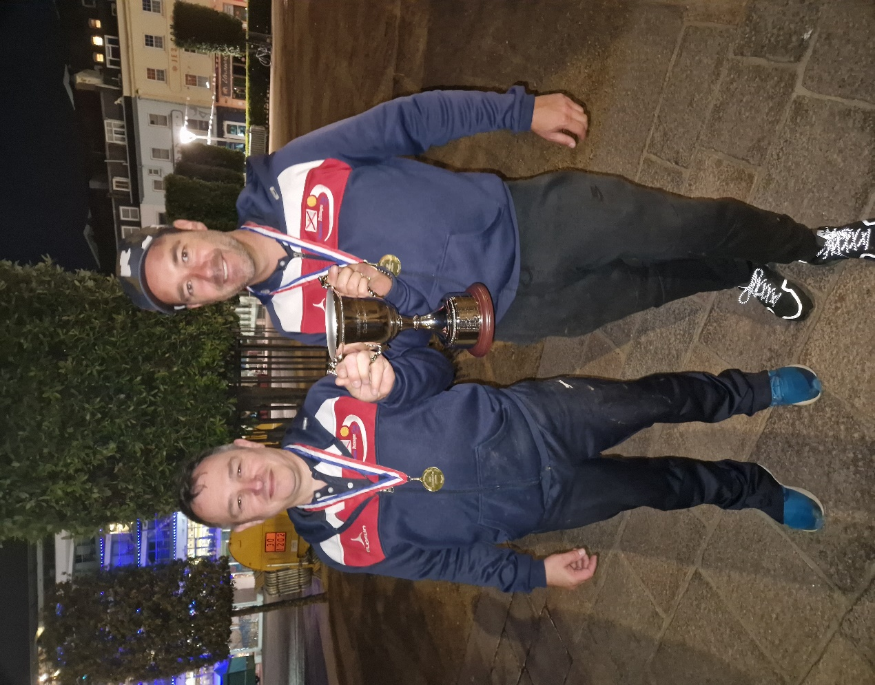

Sponsored by

SUMMER - 22 SEASON
WEEK 11 – 15th June 2022
DOUBLES LEAGUE

Great Summer weather to be playing petanque in at the moment.

Matt & Geoffroy are still playing catch up, they played Alan & Joey this week with a very close win and three important points.

Champions Matt & Laurent needed three points to keep their push for a third consecutive title after beating league leaders Neil & Ross in a catch up match last week. They played bottom of the table Cassie & Chris and made light work as they moved up to second with back to back wins.

This was the only match played in the Premier League!

In Division 1 league leaders Alice & Brigitte played bottom Luc & Martin as they looked to cement their position at the top of the league, which they did.

Kat & Paul have had a slow start so needed a win over Daniel & James but were comprehensively beaten 13 – 1, 13 – 2!

Colin & Steve had drawn all four matches to date and played Andrew & Lorna. Unfortunately their unbeaten run came to an end as Andrew & Lorna made it three wins from five matches.

Outstanding Matches

Premier League

Geoffroy Buffetrille & Matt Buesnel v Alex & Jean Stewart

Graeme Follain & Keith Pinel v Laurent Pellaton & Matt Pinel

Alex & Jean Stewart v Alan Oliveira & Joey Le Clech

Graeme Follain & Keith Pinel v Callum Stewart & Andrew Bellamy-B

Gary Cowburn & Wendy Ritzema v Gavin Scott & James Rondel

Neil Selby & Ross Payne v Geoffroy Buffetrille & Matt Buesnel

Division 1

Luc Rochefort & Martin Schwartz v John McGaw & Nick Pallot

John McGaw & Nick Pallot v Colin Floyd & Jim Waddell

Branden De La Haye & Tim Jackson v Dawn Buckley & James Gennoe

SUMMER - 22 SEASON
WEEK 12 – 22nd June 2022
SINGLES LEAGUE

Summer champion Laurent had already played and beat Alex weeks earlier but had the fixture of the week in his second scheduled match against Geoffroy whom had a bye in match one of the week.

A win for either player would be huge at this stage of the season, but with Andrew and Neil also hoovering around the top spot either player could move above them. Geoffroy started of well winning the first game 13 – 6, before Laurent took the initiative in the second game to win 13 – 8 for a draw.

Andrew had struggling Alice to play so would have been confident of three points but found himself 8 – 1 in the first game but fought back to win 13 – 10 and then more comfortable in the second game 13 – 5. This win for Andrew puts in on 14 points the same as Geoffroy and Laurent but has a slightly better points difference so sits in second place.

Alice also lost to Neil to remain bottom of the table with five defeats in six matches. Neil also beat Joey although only just taking the first game 13 – 12, these results put Neil top of the league albeit having played a match more than his rivals.

Toby played Gavin in match one with Toby gaining his first win of the season as Gavin still waits for his. Toby had played Alex a day earlier drawing that match.

Brian had played Ross earlier winning that one and followed it up with his third straight win with another one over Joey who is also on just one point with five defeats in six.

In Division 1 undefeated records were smashed to pieces as Matt lost not only to Andrew but Mo as well, despite this remains top for now.

Andrew then blew his chances of top spot with his first loss of the season after winning his first four matches to Cassie, which was Cassies first win. Andrew then could only draw against Branden.

Cassie also drew with David who then beat Jean to move up to fourth.

Callum though had two matches, he played Jean and then Tim but two draws see’s Callum to points off top spot but with matches in hand.

Paul Bell played Mo and won this match which was his 100th Singles League match, welcome to the one hundred Club Paul.

Just Single fixtures for Division 2. League leader Lorna played Daniel with just one point separating the two so no surprise in a draw.

Daniel also played his son James losing this one and with James also beating Colin he is now three points clear at the top.

Jim had played his match against John in advance with a draw giving both players good point. This was the same for Luc and doubles partner Martin.

Ian played Brigitte, with the latter handing out a heavy defeat to Ian, this win puts Brigitte second place on points difference above Lorna.

Outstanding Matches

Premier League

Gavin Scott v Alex Stewart

Gavin Scott v Ross Payne

Division 1

Mo De Gruchy v Tim Jackson

SUMMER - 22 SEASON
WEEK 13 – 29th June 2022
DOUBLES LEAGUE

Summer champions Laurent & Matt had a bye this week which could see them drop out of the top three as they have played a match more than their nearest rivals.

Geoffroy & Matt were hoping for another three points in their match against Graeme & Keith and they did just that with relative easy to take top spot.

Callum Stewart & Andrew Bellamy-Burt played Cassie & Chris and they moved second also with a comfortable win as Cassie & Chris remain bottom.

Neil & Ross match against Gary & Wendy and Alan & Mike against Alan & Joey, Gavin Scott & James Rondel against Alex & Jean all called off.

In Division 1 a huge match between Dawn & James against Alice & Brigitte at the top of the league. A draw was the outcome, meaning Alice & Brigitte remain top by two points.

Colin & Steve played Kat & Paul with both teams needing a big win, but it wasn’t to be as Colin & Steve win a close first match 13 – 11 before losing heavily in the second game 13 – 2 for a draw.

Colin & Jim v Luc & Martin and Andrew & Lorna v John & Nick, Daniel & James v Branden & Tim called off.

Outstanding Matches

Premier League

Alex & Jean Stewart v Alan Oliveira & Joey Le Clech

Graeme Follain & Keith Pinel v Callum Stewart & Andrew Bellamy-B

Gary Cowburn & Wendy Ritzema v Gavin Scott & James Rondel

Neil Selby & Ross Payne v Geoffroy Buffetrille & Matt Buesnel

Gary Cowburn & Wendy Ritzema v Neil Selby & Ross Payne

Alan Oliveira & Joey Le Clech v Alan Mitchel & Mike Robinson

Gavin Scott & James Rondel v Alex & Jean Stewart

Division 1

John McGaw & Nick Pallot v Colin Floyd & Jim Waddel

John McGaw & Nick Pallot v Andrew & Lorna Limbrick

Colin Floyd & Jim Waddel v Luc Rochefort & Martin Schwartz

Daniel & James Villalard v Branden De La Haye & Tim Jackson

SUMMER - 22 SEASON
WEEK 14 – 6th July 2022
SINGLES LEAGUE

What a week in the Premier League as Geoffroy and Andrew fought through an epic match to draw 13-11, 11-13 in a match lasting near two hours with some exceptionally placing and shooting. This meant they both moved onto 15 points with Neil at the top of the table.

Champion Laurent could not get a look in, in the first game against Toby losing 13 – 3 and was losing 11 – 7 in the second game before taking it 13 – 11 for a very good draw to also move onto 15 points.

Ross could not get the much need win as he drew with Alex and the same for Gavin and Joey sharing the points with both players yet to win.

The next round of fixtures see’s the top four players play each other in what will be an exciting week of fixtures.

No scheduled matches played in Division 1, but a match played in advance saw Matt beat Callum to remain top but having played a number of matches more than his nearest rivals.

In Division 2 only a few matches played as Brigitte beat Jim, his first defeat since joining the club, this moves Brigitte top, but she then lost a match played in advance against Martin. Martin had earlier drawn with Ian.

So, outstanding matches in the Singles League.

Premier League

Gavin Scott v Ross Payne

Brian Harris v Alice Dilks

Division 1

David Ibitson v Callum Stewart

Andrew Limbrick v Jean Stewart

Tim Jackson v Paul Bell

Division 2

John Flaherty v James Villalard

Daniel Villalard v Luc Rochefort

Colin Floyd v Lorna Limbrick

SUMMER - 22 SEASON
13th July 2022
Liberation Club Handy Cap Cup

Great Summer weather to be playing petanque in at the moment and another great event. In the end 21 players took part, the same number as last year.

Lower ranked players starting with positive points giving them more of a chance of a win and putting more pressure on those players at the top when starting a match already behind.

Some interesting matches in Round 1 with Alan Oliveira starting with +2 playing Callum Stewart, but Callum ran out 13 – 7 winner. A big win for Paul Bell over Brian Harris 13 – 2.

Andrew Bellamy-Burt played fellow Premier League player Joey also winning. Mo De Gruchy won against Martin Schwartz but only just.

Last years Third place finisher Andrew Limbrick lost heavily to Neil Selby, with Toby beating Jean Stewart 13 – 6 with Jean getting a 3-point start.

John Flaherty beat last years runners up Daniel Villalard 13 – 8.

Round 2 saw Paul Bell start with plus 2 against Toby but only score 5 points in total for a big win for Toby.

John Flaherty had the win of the round beating Cassie Stewart-Le Gallais 13 – 9, John with a 5 point start and Cassie 3 points.

Andrew Bellamy-B beat Neil Selby on the last end 12 – 11 for a crucial win. A big win for Callum 13 – 4 over Ross.

Some really close matches though as Jean beat Alan 13 – 11 and James Villalard beat Martin 13 – 12.

Round 3

Some big shocks in round three as Mo De Gruchy (+4) beat Andrew Limbrick 13 – 7 and Kat Stewart beat Joey.

Callum just beat John Flaherty (+5) 13 – 10. Ross also just won 13 – 10 over Jean (+3) and Cassie won 13 – 12 over James Villalard.

Toby was 11 - 4 up against Brian when time went so had won before Brian picked up two points to end 11 – 6.

Neil Selby recovered to beat Paul (+2) 13 – 7 and Andrew Bellamy-B beat Alex Stewart.

Kat Stewart (+5) won her second match this time against Alan Oliveira (+2) 13 – 12 and Tom Le Sueur beat Martin 13 – 8.

Round 4

So the final round saw Toby beat Callum 13 – 4 to top the rankings as the only player to win all four matches.

Andrew Bellamy-B lost to Ross 8 – 12 meant he finished second with Ross finishing fourth.

Kat beat Mo to make it three wins and finished seventh with Mo also finishing in the top 8 in 8th place.

Neil Selby only just beat John 13 – 11 to go through in fifth place with John just missing out in nineth place.

Daniel lost his last match 13 – 11 to Alan which unfortunately meant that last years runner up finished bottom of the table.

Alex Stewart beat Cassie Stewart Le Gallais 13 – 8 to go through in sixth place at Cassie’s expense.

Despite winning 13 – 3 against Jean (+3) Andrew Limbrick could only finish 13th having finished third last year.

FINAL SWISS RANKINGS

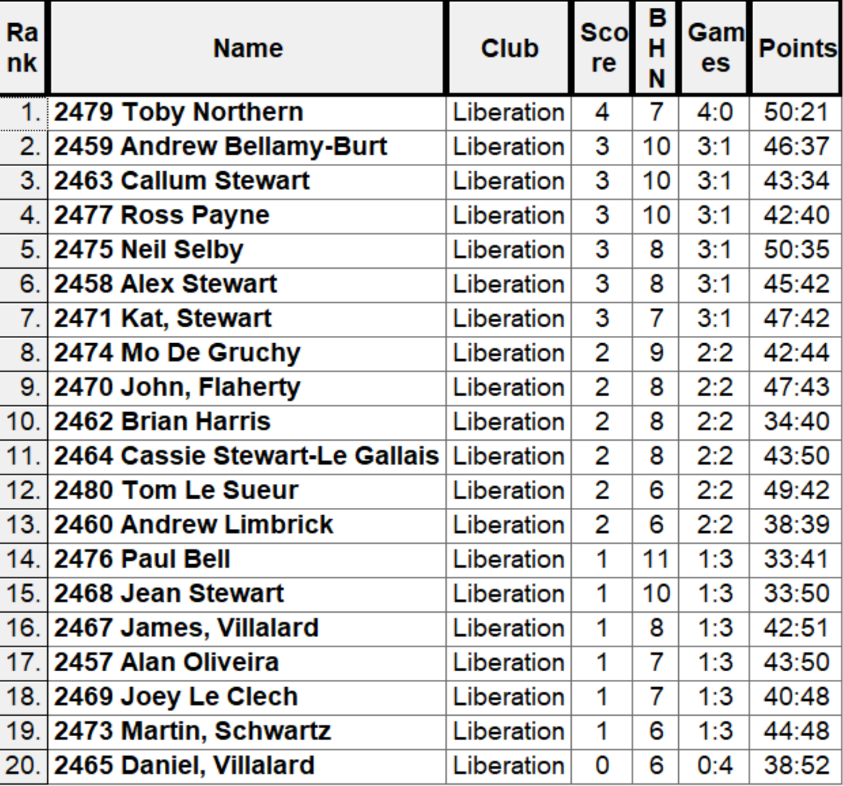

The Quarter Final draw was therefore as follows:

Ranked 1st Toby Northern v Mo De Gruchy Ranked 8th

Ranked 2nd Andrew Bellamy-B v Kat Stewart Ranked 7th

Ranked 3rd Callum Stewart v Alex Stewart Ranked 6th

Ranked 4th Ross Payne v Neil Selby Ranked 5th

The top ranked player from the Swiss system Toby was already up against it against Mo who started +4 and went 6 – 1 and 8 – 4 up before some important shots from Toby helped him quickly turn it around to won 13 – 9.

Andrew started five points behind Kat but this was close with Andrew just getting ahead 10 – 9 before Kat won the next two ends to win 13 – 10 for the biggest shock of the tournament. Callum against Alex was a very close match with Callum just going through 13 – 10. Neil beat doubles partner Ross 13 – 6 to make the semi-finals.

So the Semi Finals were played as follows:

Ranked 1st Toby Northern v Neil Selby Ranked 5th

Ranked 3rd Callum Stewart v Kat Stewart Ranked 7th

The first semi-final went back and forth between Toby and Neil as Neil fired out Toby boule on the second end to get three points only for Toby to fire all of Neil boules out on the next end for three points. This happened a few times but Neil pointing was more consistent giving him a narrow win 13 – 11.

Callum against Kat was even closer, with Kat starting on +5 started well and moved to 12 – 4 up, before Callum came back into the match to win 13 – 12 and make the final.

Kat beat Toby 13 – 8 to get third place.

In the final Callum just could not get going as Neil very consistent accurate pointing helped him run out a 13 – 3 winner for his first ever Club Cup win. Congratulations Neil.

Huge thanks to Toby for setting up and running the competition on the day and Callum and anyone else for helping out throughout the competition.

Photos Below

Sponsored by

CoinShares | Digital Asset Investment Strategies for Professionals 🚀

NEXT WEEK - DOUBLES LEAGUE

Club email address - liberationpc@gmail.com

Club Website - www.liberationpetanque.co.uk

Kind Regards

Toby Northern

Chairman

Liberation Petanque Club

2022 Liberation Club

Handy Cap Cup Winner

Neil Selby

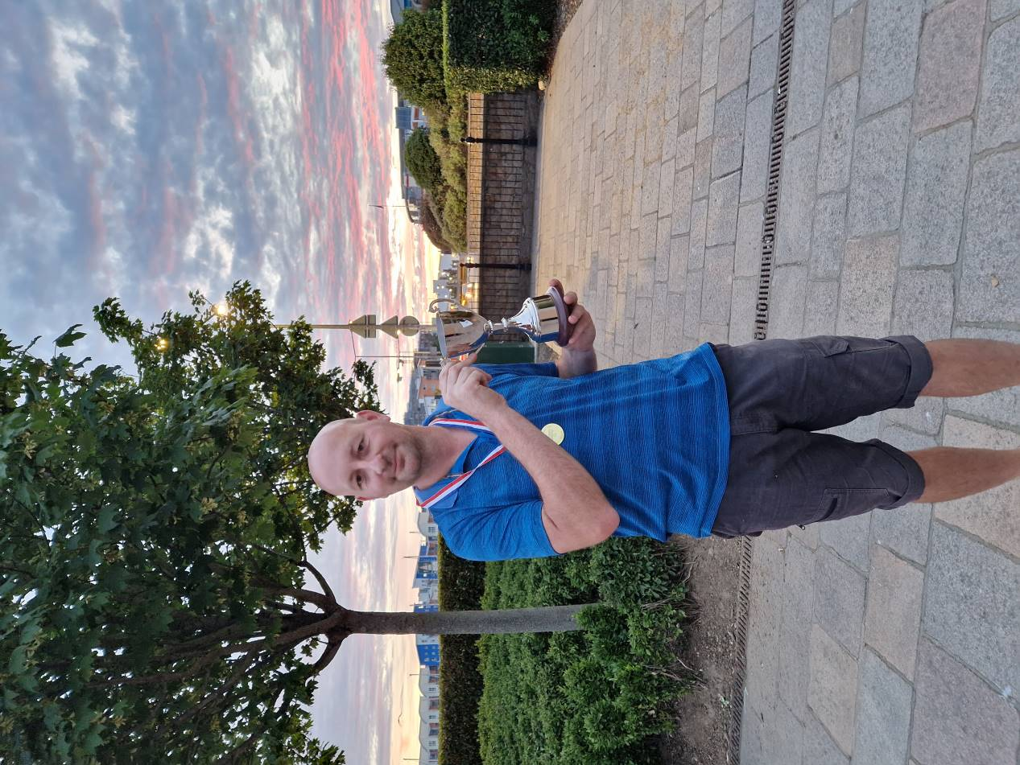

2022 2022

Liberation Petanque Club Liberation Petanque Club

Handy Cap Cup Runner Up Handy Cap Cup Third Place

Callum Stewart Kat Stewart




SUMMER - 22 SEASON
WEEK 16 – 20th July 2022
DOUBLES LEAGUE

What a week in the Premier League as champions Laurent & Matt took on Callum & Andrew. A must win match for both teams at this stage of the season. A very close match as expected with a 13 – 10 and 13 – 12 result going the way o the current champions Laurent & Matt who keep there hopes of a third consecutive title alive, whilst

League Leaders Neil & Ross played Alex & Jean with the latter still in with a chance of breaking into the top three. It was the second successive draw for Neil & Ross as a result losing the top spot to Geoffroy & Matt.

Previous champions Geoffroy & Matt played bottom team Cassie & Chris needing three points to keep their title hopes alive after losing to Neil & Ross in a catch up match. They did just that condemning Cassie & Chris to their sixth successive defeat this season.

Two teams struggling this season, with both in the bottom half of the table was Gary & Wendy against Graeme & Keith, a win for either would move them clear of relegation. Graeme & Keith pulled it off winning a close first match 13 -11 before a 13 – 8 win sealed all three points.

Alan & Mike did well to gain a good draw over Gavin & James but remain in the relegation zone.

Outstanding Matches

Gavin & James v Alex & Jean

In Division 1, John & Nick results have been removed from the league as they played less than 50% of their matches following them being removed from the league.

This meant that Dawn & James moved top of the league and they played Daniel & James who needed a win to move into contention for promotion. A big win in the first game for Daniel & James was reversed in the second game with Dawn & James winning 13 – 1, but although two points in the league have played two matches more than Alice & Brigitte.

Outstanding fixtures.

Daniel & James v Branden & Tim

Andrew & Lorna v Luc & Martin

Alice & Brigitte v Colin & Jim

Branden & Tim v Colin & Steve

SUMMER - 22 SEASON
WEEK 17 – 27th July 2022
SINGLES LEAGUE

What a week in the Premier League as champion Laurent took on four-time champion Andrew and Geoffroy took on Neil, all the top four players and all on fifteen league points.

A win for anyone at this stage would give a huge advantage with just two matches to play.

Who could take advantage? Well Andrew could, following a great come back in the second game against Laurent to win 13 – 9 and take the top spot in the league.

Geoffroy drew with Neil with a big win in game two 13 – 4 to move ahead of Neil on points difference but now two points of Andrew with two matches to play.

Elsewhere in the league Ross took on Toby with both players on eight points after Ross close win over Gavin in a catch-up match. Although the first game was close 13 – 10 the second was much quickly with Toby winning 13 – 4 to take all three points.

This was a similar situation for Joey who played Alex, with Alex also needing the points to keep clear of the relegation places. A draw was the result which leaves Joey in the relegation places.

In Division 1, Matt Buesnel had beaten Tim early on but could be caught by Andrew Limbrick if he could beat David Ibitson. David though had other ideas winning the first game comfortably 13 – 1, but credit to Andrew who took the second game 13 – 10 for a draw.

Callum needed a win over Paul to also keep his title hopes alive, with Paul still having a chance of promotion. Callum though was on good form taking all three points and then followed this up by also beating David to move top of the league by one point in another close league.

Cassie could also move within touching distance of the top three with a win over Mo, who beat league leader Matt last time out! Cassie took the first game but Mo then took the second for a draw, this virtually ending Cassie chances of promotion.

In Division 2 Martin had already beaten Brigitte to move him onto nine points so far in his maiden season.

Top of the league going into this week was James, he played Jim who was within touching distance of the promotion places. A big win for Jim puts him just two points off promotion. Despite this loss though James stayed top after Lorna also lost to John, his first ever league win, well done John. This moved him off the bottom of the league.

Outstanding Matches

Premier League

Brian Harris v Alice Dilks

Gavin Scott v Alice Dilks

Division 1

Andrew Limbrick v Jean Stewart

Division 2

Luc Rochefort v Daniel Villalard

Luc Rochefort v Colin Floyd

Daniel Villalard v Ian Black

SUMMER - 22 SEASON
WEEK 18 – 3rd August 2022
DOUBLES LEAGUE

Some surprises in Division 1 as all of the top three teams dropped points. Despite winning 13 – 2 in the first game Alice & Brigitte than lost to Daniel & James 13 – 8 to drop two points.

Andrew & Lorna survived a real scare against Colin & Jim who were one point off taking all three points but Andrew & Lorna just won the second game 13 – 12.

Early flyers, Dawn & James lost to experience pair Colin & Steve hampering their title challenge.

Kat & Paul gained a valuable three points against new team Luc & Martin who are still leaving the game.

Draw specialists John & Nick did it again sharing the points with Branden & Tim.

What a week in the Premier League with not one, not two but three 13 – 0 results. Alan & Joey received one in their first game against Gavin & James but fought back to take the second game 13 – 12!!

A real big shock it what should have been a very close match turned out far from it as Laurent & Matt Pinel hand out a 13 – 0 to Geoffroy & Matt Buesnel also winning the second game 13 – 6 which significantly hampered Geoffroy & Matt chances of the title.

Alan & Mike had a bad day as Neil & Ross on top form handed out a huge defeat winning 13 – 2, 13 – 0!. This keeps them well in the hunt for the title.

Gary & Wendy picked up all three points against struggling Cassie & Chris who remain bottom. Whilst Alex & Jean won against Graeme & Keith to keep their top three hopes alive.

Sponsored by

2022
CLUB SINGLES CUP

26 players took part in this years tournament, one of our best attended this year, enjoying great sunshine.

Round one saw Champion Andrew turn up late and almost paid the price but for Lorna moving the coche to give Andrew a 7 – 6 win.

Neil Selby lost to Andrew Limbrick and James Gennoe lost 13 – 2 to Tom Le Sueur. Brian Harris just got over the line 12 – 11 against Jean Stewart and Ross beat Paul 13 – 9.

Wins as expected for Laurent, Geoffroy, Toby and Callum with Cassie also beating Mo 13 – 2.

Round two saw a big shock as despite leading Callum lost to Daniel 12 – 10, some close matches though as Geoffroy just beat Brian 12 – 11 and the same result for James Villalard over Branden and Alex beat Tim 13 – 12.

Laurent beat Andrew Limbrick with ease 13 – 4, as did Toby winning 13 – 1 over Tom Le Sueur.

Ross beat Matt Buesnel 13 – 8 for a big result and Andrew Bellamy beat Cassie.

Round three saw a really close match between Laurent and Toby going down to the last end at 12 all, Toby fired out Laurent last boule on the terrain to win the match and make it three wins from three.

Andrew Bellamy handed Neil his second defeat ending his tournament early and this was also the case as Matt Buesnel beat Callum, his second defeat.

A surprise result as Geoffroy lost to Joey, despite playing on the same terrain as his first two matches.

James Villalard made it two in a row with a win over Cassie. Tom beat Jean to be in with a chance of qualifying and Brain did the same over James Gennoe.

Some big wins as Lorna beat Jim 12 – 5, Mo beat Martin 13 – 2 and Tim beat John 13 – 0!

The final round would decide the top eight players going through. Both players on three wins Toby and Ross played each other and despite his best efforts Toby ran out comfortable winner 13 – 1 to top the Rankings for the second singles competition in a row. Ross finishing third.

Andrew Bellamy-Burt also made it four wins from four beating Joey 13 – 7 to finish second with Joey still going through in fifth place.

Laurent was a comfortable winner 13 – 2 over Daniel to make sixth spot and Geoffroy beat Paul 13 – 7 to finish fourth.

Tom Le Sueur provided a shock 10 – 9 win over Andrew Limbrick to knock last years third place out of the tournament. Matt Buesnel just made it in eighth by one BHN point over Brian Harris after beating James Villalard 13 – 9.

FINAL SWISS RANKINGS

INCLUDEPICTURE "cid:dac0e182-a229-13a2-3edb-edf58a923f75@yahoo.com" \* MERGEFORMATINET INCLUDEPICTURE "cid:dac0e182-a229-13a2-3edb-edf58a923f75@yahoo.com" \* MERGEFORMATINET 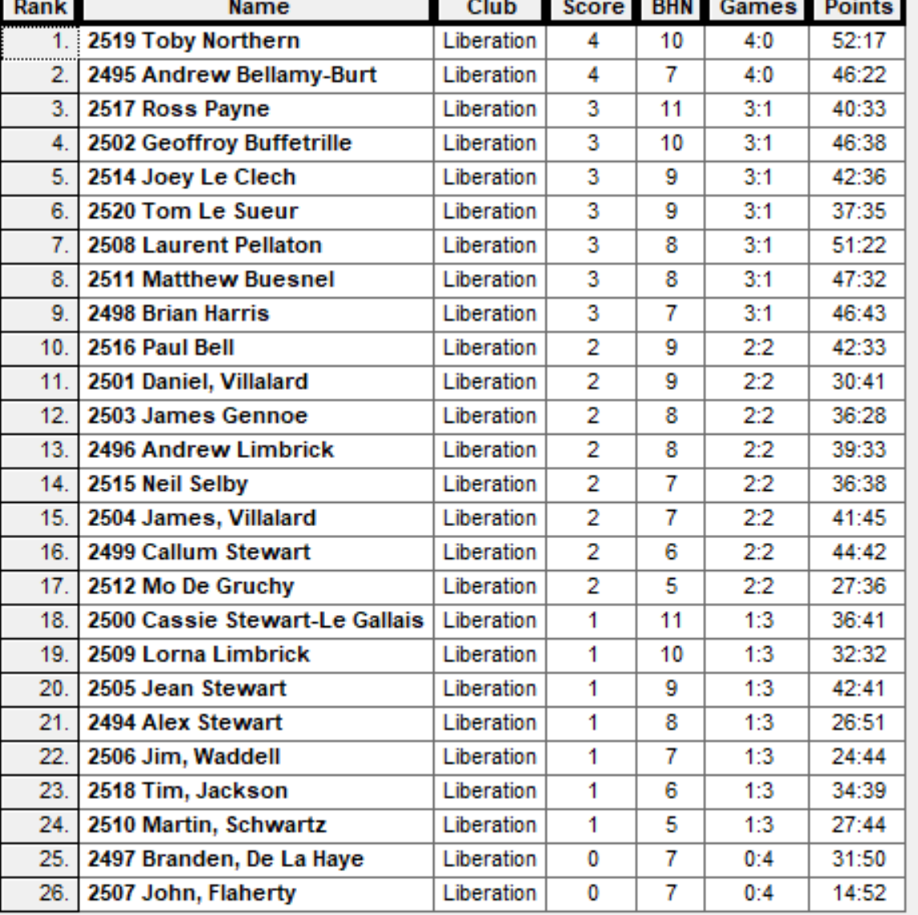

Quarter Finals

Ranked 1st Toby Northern v Matt Buesnel Ranked 8th

Ranked 2nd Andrew Bellamy-B v Laurent Pellaton Ranked 7th

Ranked 3rd Ross Payne v Tom Le Sueur Ranked 6th

Ranked 4th Geoffroy Buffetrille v Joey Le Clech Ranked 5th

No shocks in the quarter finals as Toby ended Matt’s hopes with to perfect fires to win 13 – 9. Andrew continues to have the best of Laurent winning 13 – 6 and big wins for Ross and Geoffroy 13 – 5, and 13 – 4 respectively.

Semi Finals

Ranked 1st Toby Northern v Geoffroy Buffetrille Ranked 4th

Ranked 2nd Andrew Bellamy-B v Ross Payne Ranked 3rd

Toby and Geoffroy went end to end in the scores until top took three perfect points to go 11 – 8 up, but unfortunately Geoffroy consistent pressure with perfect shooting saw him come back to win 13 – 11.

Another very close second semi final went down to one point as Ross hit top gear with his shooting making the difference as he made the final at Andrew expense.

Andrew went on to take third place beating Toby 13 – 10.

So a repeat of the 2015 final between Geoffroy & Ross, but with a final heavily reliant of shooting it was Geoffroy turn to win taking it 13 – 11.

2022 - Winner



Thanks to all those who helped out on the day to make it another great competition.

Sponsored by

CoinShares | Digital Asset Investment Strategies for Professionals 🚀

Club email address - liberationpc@gmail.com

Club Website - www.liberationpetanque.co.uk

Kind Regards

Toby Northern

Chairman

Liberation Petanque Club

SUMMER - 22 SEASON
WEEK 20 – 17th August 2022
SINGLES LEAGUE

Well just two matches played in the Premier League this week, but two big matches in the penultimate week of the season.

Champion Laurent needed to beat Ross to give himself a chance of retaining the title, but a big win in game one for Ross 13 – 3 put a huge whole in that chance despite winning the second game for a draw.

Geoffroy was also in the hunt, but he too lost the first game to his opponent, Brian before recovering for a point.

The other big game was Andrew v Neil but that was postponed, Neil needs to win that one with a draw meaning Andrew could still be caught, a win though will see him lift his first title since 2019.

In a catch up match Alice got her first win of the season against Gavin who has yet to win in his maiden season in the Premier League, anything other than a win in his last match will most likely see him relegated.

Outsider for the title going into the penultimate week Andrew Limbrick beat Callum Stewart and saw Matt Buesnel lose 13 – 12, 13-12 to Paul Bell which meant Andrew has won the Division 1 title.

With Tim beating Branden this means a win for him in his last match against Cassie, will see him take Matt place in the top three and give him his first promotion to the Premier League.

In Division 2 James Villalard beat title rival Brigitte Ibitson to seal the Division 2 title. Lorna draw with Jim see’s her promoted.

Colin drew his last match against Ian to end his maiden season on 12 points and three wins. His doubles partner Jim also finished on 12 points but with a much better points difference.

John ended his first season with his second win, over Luc, with all the new players this season getting wins, which is great to see.

Just one match left in this division, with Daniel due to play Martin. A win for Daniel is needed for him to gain promotion.

Outstanding Matches

Premier League

Neil Selby v Andrew Bellamy-Burt

Joey Le Clech v Toby Northern

Alice Dilks v Alex Stewart

Division 1

Mo De Gruchy v Jean Stewart

Division 2

Daniel Villalard v Martin Scwartz

SUMMER - 22 SEASON
WEEK 21 – 24th August 2022
FREE WEEK

Sponsored by

CoinShares | Digital Asset Investment Strategies for Professionals 🚀

NEXT WEEK - FREE WEEK

Club email address - liberationpc@gmail.com

Club Website - www.liberationpetanque.co.uk

Kind Regards

Toby Northern

Chairman

Liberation Petanque Club

SUMMER - 22 SEASON
WEEK 22 – 31st August 2022
FREE WEEK

Sponsored by

CoinShares | Digital Asset Investment Strategies for Professionals 🚀

NEXT WEEK - DOUBLES LEAGUE

Club email address - liberationpc@gmail.com

Club Website - www.liberationpetanque.co.uk

Kind Regards

Toby Northern

Chairman

Liberation Petanque Club

SUMMER - 22 SEASON
WEEK 23 – 7th September 2022
DOUBLES LEAGUE

As we return to league action after a break around our International Open Weekend, it’s the turn of the Doubles leagues with a few matches remaining a crucial time to pick up a win and three points.

Big match of the week with Callum & Andrew against Geoffroy & Matt, a must win for both teams, but it wasn’t to be as a draw leaves Geoffroy & Matt two points off the top having played a match more and Andrew & Callum four points off the top.

Neil & Ross had the chance to keep the pressure on those around them if they could beat Alan & Joey who were yet to win a match, but a shock result saw them change that handing Neil & Ross their second defeat of the season and although they are just one point off the top they have played a match more than Laurent & Matt who beat Gary & Wendy and now look odds on to make it three in a row.

Keith & Graeme could secure their survival with a win over Alan & Mike who would be relegated with a defeat. Graeme & Keith did it and also hand out Alan & Mike’s third 13 – 0 loss of the season as they return to Division 1.

Cassie & Chris needed a win over Alex & Jean to have a chance of surviving relegation but that match remains outstanding.

The final week in the Division 1 Doubles League only saw one match played with Daniel & James needing a win in their last match against Colin & Steve and hoped Dawn & James slipped up against John & Nick. But Colin & Steve won to end Daniel & James Premier League aspirations.

Outstanding fixtures.

Premier League

Cassie Stewart & Chris Le Gallais v Alex & Jean Stewart

Division 1

Luc Rochefort & Martin Schwartz v Andrew & Lorna Limbrick

Alice Dilks & Brigitte Ibitson v Andrew & Lorna Limbrick

Colin Floyd & Jim Waddell v Kat Stewart & Paul Bell

Dawn Buckley & James Gennoe v John McGaw & Nick Pallot

Luc Rochefort & Martin Schwartz v Branden De La Haye & Tim Jackson

SUMMER - 22 SEASON
WEEK 24 – 14th September 2022
DOUBLES LEAGUE

Only a hand full of games played but some big ones. Laurent Pellaton & Matthew Pinel secured their third straight Summer Premier League title with a win over Alex & Jean. This with one match to spare and this was after Andrew & Callum also failed to beat Gary & Wendy.

In Division 1 Andrew & Lorna Limbrick needed to win their outstanding match against Luc & Martin and get a result against league leaders Alice & Brigitte. Going into this week Andrew & Lorna were 42 points in points difference off Alice & Brigitte, but they won emphatically 13 – 1, 13 – 1 against Luc and Martin to give them a chance of catching Alice & Brigitte.

The final match of the season between the top two saw Andrew & Lorna take the first game 13 – 1 which put them up on points difference but Alice & Brigitte fought back in the second game to win 13 – 10, but this was short of the 13 – 8 win they would have needed meaning Andrew & Lorna take the Division 1 Doubles League title by three points on points difference!!

Congratulations to the two champions.

NEXT WEEK - SINGLES LEAGUE

WEBSITE www.liberationpetanque.co.uk
EMAIL liberationpc@gmail.com

Sponsored by

CoinShares | Digital Asset Investment Strategies for Professionals 🚀

SUMMER - 22 SEASON
WEEK 25 – 21st September 2022
SINGLES LEAGUE

What a week in the Premier League as champion Laurent handed Neil Selby his first defeat of the season, ending Neil chance of the title, but it also wasn’t enough for Laurent to retain his title as Andrew drew his final match against Brian Harris. Although having won the first game Andrew lost the second game 13 – 0!

Geoffroy couldn’t get over the line against Gavin losing the second game by a narrow margin 13 – 11 which gave Andrew the title. Gavin though relegated in his first season in the top flight.

Joey could only draw with Ross meaning he was also relegated. Alice and Toby drew.

The Division 1 title had already gone to Andrew Limbrick with Callum Stewart in second place. Third is still up in the air as Cassie Stewart Le Gallais and Tim Jackson haven’t played yet, a win for Tim will see him take the final promotion spot.

There were wins for Paul Bell over Branden De La Haye and David Ibitson over Mo De Gruchy

Outstanding Matches

Division 1

Cassie Stewart Le Gallais v Tim Jackson

Sponsored by

CoinShares | Digital Asset Investment Strategies for Professionals 🚀

NEXT WEEK - FREE WEEK

Club email address - liberationpc@gmail.com

Club Website - www.liberationpetanque.co.uk

Kind Regards

Toby Northern

Chairman

Liberation Petanque Club

SUMMER - 22 SEASON
WEEK 26– 28th September 2022
FREE WEEK

Sponsored by

CoinShares | Digital Asset Investment Strategies for Professionals 🚀

NEXT WEEK - DOUBLES LEAGUE

Club email address - liberationpc@gmail.com

Club Website - www.liberationpetanque.co.uk

Kind Regards

Toby Northern

Chairman

Liberation Petanque Club

SUMMER - 22 SEASON
WEEK 27– 5th October 2022
DOUBLES LEAGUE

The final week of the season saw the last remaining places settled in the Doubles Premier League.

Despite early season form Alex & Jean Stewart failed to capitalise getting just one point from their last two matches meaning they missed out on a medal position. Their draw with Andrew Bellamy-Burt & Callum Stewart saw the latter finish third with Neil Selby & Ross Payne finishing second for the second successive year.

A disappointing season for Geoffroy Buffetrille & Matthew Buesnel whose loss to Gary Cowburn & Wendy Ritzema saw them also miss out on a top three place.

Graeme Follain & Keith Pinel win over Gavin Scott & James Rondel saw them achieve their highest placement in the league for some time. Cassie & Chris Stewart-Le Gallais draw with Alan Oliveira & Joey Le Clech saw them relegated.

Alan Mitchell & Mike Robinson had already been relegated so no surprise as they lost to champions Laurent Pellaton & Matt Pinel.

Sponsored by

CoinShares | Digital Asset Investment Strategies for Professionals 🚀

NEXT WEEK - SEASON ENDS 9TH OCTOBER

Club email address - liberationpc@gmail.com

Club Website - www.liberationpetanque.co.uk

Kind Regards

Toby Northern

Chairman

Liberation Petanque Club



Summer 2022
End of Season
Report
What another great season it has been again this season with more new faces creating waves amongst the experienced members, we hope you all enjoyed it.
Premier League Double Champions
Laurent Pellaton & Matthew Pinel
Well, its now a hattrick of titles and undefeated in three consecutive championship seasons. Neil Selby & Ross Payne again finished in the top three, taking second place two seasons in a row. Andrew Bellamy-Burt & Callum Stewart finishing third.
Commiserations to Alan Mitchell & Mike Robinson and Cassie & Chris Stewart Le Gallais who returned to Division 1.
Division 1 Double Champions
Andrew & Lorna Limbrick
Wow, Andrew & Lorna stole the title from under Alice Dilks & Brigitte Ibitson nose, taking it on points difference in the final match against each other. Brande De La Haye and Tim Jackson also took third on points difference over Dawn Buckley & James Gennoe whose title and promotion chances fell off the tracks in the last three matches of the season.
Commiserations to Luc Rochefort & Martin Schwartz, John McGaw & Nick Pallot and Colin Floyd & Jim Waddell who were relegated.

Premier League Singles Champion
Andrew Bellamy-Burt
Winning his fifth Premier League title and doing so unbeaten for a remarkable Summer season for Andrew.
2021 Champion Laurent Pellaton missed out on retaining his title by one point, with Geoffroy Buffetrille finishing third.
Commiserations to Gavin Scott relegated after his first season in the top flight with Joey Le Clech also relegated.

Singles Division 1 Champion
Andrew Limbrick
Andrew defeated Callum Stewart in his last match to snatch the title from Callum who had to settle for second place.
A surprise was Matt Buesnel who lost his last match which meant Tim Jackson win over Cassie Stewart Le Gallais saw him finish third.
Commiserations to Mo De Gruchy on relegation.
Singles Division 2 Champion
James Villalard
James Villalard won a maiden title taking the Division 2 title, father Daniel made it a one two finishing second with Lorna Limbrick placing third.
Commiserations to Martin Schwartz, Luc Rochefort and Ian Black on relegation.

Club Singles Cup Winner
Geoffroy Buffetrille
Geoffroy won his second Singles Cup beating Ross Payne in the final with Andrew Bellamy-Burt in third.

Club Doubles Cup Winners
Laurent Pellaton & Toby Northern
This was Toby fifth win in the competition with Laurent winning his first one. They beat Gavin Scott & James Rondel in the final with Neil Selby & Ross Payne finishinh third.

Club Super 7’s Cup Winner
Toby Northern
Toby won his second Super 7’s title beating Callum Stewart in the final with Geoffroy Buffetrille taking third for the second successive year.

Club HandyCap Cup Winner
Neil Selby
Neil Selby beat Callum Stewart in the final with Kat Stewart finishing third.

Club Precision Shooting Cup Winner
Keith Pinel
Keith was the only player to score the minimum points required to go through. Matt Pinel took second in a play – off against Ross Payne.

Liberation Singles Open Winner
Laurent Pellaton
Laurent beat Carrefour player Alan Lahiffe in the final with Gavin Scott in third.
Liberation Doubles Open Winner
Neil Selby & Ross Payne
Neil & Ross beat fellow club members Brian Harris & Gary Cowburn in the final, with Andrew Limbrick & Matt Pinel finishing third.

Liberation International Singles Open Winner
Laurent Pellaton
Laurent beat Matt Pinel in the final with Toby Northern taking third place.

Liberation International Doubles Open Winners
Matthew Pinel & Matthew Ryan
Matt & Matt beat Andrew Bellamy-Burt and Geoffroy Buffetrille in the final with third place going to John Wilson & Robert Stronach from Scotland.

Liberation International Triples Open Winners
Matt Buesnel, Geoffroy Buffetrille and Laurent Pellaton
Matt, Geoffroy & Laurent beat Toby Northern, Callum Stewart and Paul Bell in the final with Neil Selby, Ross Payne & James Gennoe finishing third.

Player of the Seasons

To be confirmed at the end of season meal.



None club tournaments won by members
Island Singles Championship
Mark Nicol

Island Doubles Championship
Matt Pinel & Geoffroy Buffterille

Island Open Triples Championship
Matt Buesnel, Geoffroy Buffetrille and Laurent Pellaton

Island Mens Triples Championship
Andrew Limbrick
Andrew and his team
Carrefour Singles Open
Andrew Bellamy-Burt
Carrefour Doubles Open
Geoffroy Buffterille & Laurent Pellaton

Carrefour Triples Open
Geoffroy Buffterille & Laurent Pellaton & Gavin Scott

Special Thanks

Club Committee – Toby Northern, Matt Ryan, Matt Pinel, Matt Buesnel, Geoffroy Buffetrille and James Rondel for their hard work making this club a success.

Other Helpers –Laurent Pellaton for their hard work on the terrains and support throughout the season. Anyone else who has helped out setting up the terrains for competitions/leagues etc and running competitions, very much appreciated.

Well, I hope you have all enjoyed the season and are looking forward to playing again in the Winter 2022 / 23 season.

Kind Regards

Toby Northern

Chairman

Liberation Petanque Club

