Thurston County Humane Society, Inc.

DONATIONS

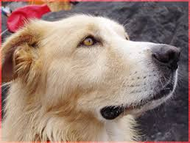
Yes, I want to send a donation to the Thurston County Humane Society Inc.:
Name: ____________________________
In the amount of: $_______________
Please send acknowledgement to:
__________________________________________
__________________________________________
__________________________________________
My mailing address is:
__________________________________________
__________________________________________
__________________________________________
_____ Please send me a receipt
____ Save the postage – I don’t need a receipt
Donation Address for the Thurston County Humane Society:
PMB #397
3403 Steamboat Island R. N.W.
Olympia, WA 98502

TCHS, Inc. E.I.N. #91-6057794

