THE HOWLING DAWG
FEBRUARY 2014
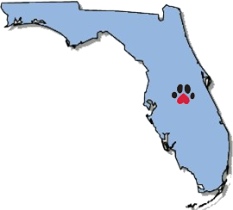
"150th Anniversary of The Battle of Olustee"

16th Georgia Volunteer Infantry Regiment, Company G
"The Jackson Rifles

SPECIAL: PRE- OLUSTEE ISSUE

WHY WE RETURN TO OLUSTEE
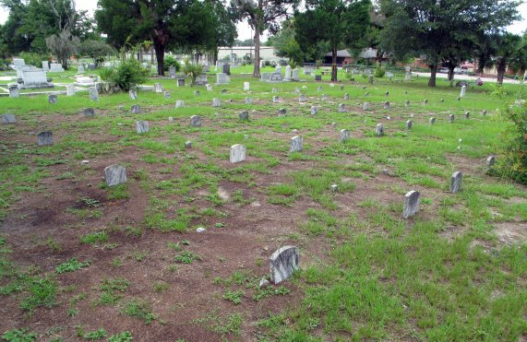
(Photo by William Lees, July 2008)

Unknown Confederate Dead from the Battle of Olustee
“The dead of the battle-field come up to us very rarely, even in dreams,” one period reporter mused. “We see the list in the morning paper at breakfast, but dismiss its recollection with the coffee. There is a confused mass of names, but they are all strangers; we forget the horrible significance that dwells amid the jumble of type.”
-1-

The Battle of Ocean Pond - 150 Years Past
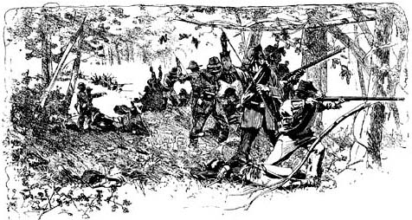
Early in the morning of February 20, 1864, General Seymour's Union Army left Barbers' Plantation and moved westward towards Lake City. After posting garrisons at Jacksonville and elsewhere, the Union force consisted of between 5,000 and 5,500 men - a small army, divided into 3 brigades of infantry, a mounted brigade and artillery.
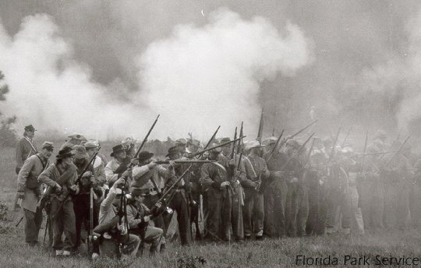
The Federals advanced in 3 columns along the Lake City and Jacksonville Road, which ran roughly parallel to the Florida Atlantic and Gulf-Central Railroad. Union cavalry took the vanguard, followed by slower-moving infantry. By mid-day they had reached Sanderson, and briefly stopped for a meal. In Sanderson, Seymour and his staff were warned by a defiant southern woman: "You will come back faster than you go." Her boldness amused them. By the early afternoon of February 20, a few miles west of Sanderson, the advance elements of the Union cavalry began skirmishing with a few southern horsemen that appeared in their front. This skirmishing was maintained for several miles, with the Federals driving the Confederates westward towards the railroad station at Olustee, about 10 miles east of Lake City. Southern resistance intensified as the Federals neared Olustee. In the days since a February 11th skirmish at Lake City, Confederate General Finegan had moved his force to Olustee Station, about 10 miles east of Lake City. There, the Confederates found one of the few defensible locations in the area where the railroad passed through a narrow corridor of dry ground, bordered by impassable swamps and bays to the south and a large body of water known as Ocean Pond to the north. The Southerners built strong earthworks and awaited the Federal advance. When Finegan learned of the Federal approach on February 20, he ordered his cavalry forward to skirmish with the Federals and lure them towards his main line. Unfortunately for Finegan, the fighting east of his main line intensified, forcing him to send out additional troops to help those already deployed, causing a major engagement to develop about 2 miles in front of the main Confederate line. As the skirmishing intensified, both Finegan and Seymour fed additional troops into the battle. Finegan first advanced the 64th Georgia and part of the 32nd Georgia, followed by the 6th, 19th and 28th Georgia Regiments, and Gamble's Florida Artillery. General Colquitt commanded the detached units, while Finegan remained behind with the main body. Union General Seymour brought forward the 7th Connecticut, followed by the remainder of Hawley's Brigade, the 7th New Hampshire and the 8th U.S. C.T. By mid afternoon the skirmishing has escalated into a major battle which threatened to turn into a quick rout of the Federals. While Colonel Hawley was positioning the 7th New
Hampshire, a wrong command was given and the unit fell into confusion. The 7th
-2-
soon collapsed, with some men running to the rear and others milling about in a disorganized mob. The collapse of the 7th New Hampshire directed Southern attention towards the 8th United States Colored Troops, which occupied the left of
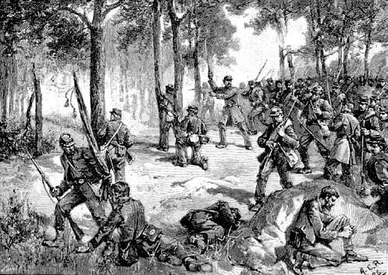
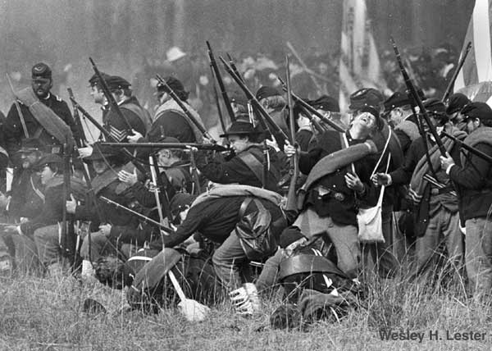
the Union line. The 8th was an untried unit, having been organized only several months before. Prior to Olustee the regiment had seen no combat, and in fact the men were not even completely trained. Colonel Charles Fribley tried to steady his men, but he soon fell mortally wounded. The raw troops of the 8th held their ground for a time, suffering more than 300 casualties. Finally, however, they retreated in some confusion, leaving the Confederates in virtual command of the battlefield. With the dissolution of Hawley's Brigade, General Colquitt ordered the Confederate forces to advance. Since the beginning of the engagement Finegan had sent additional units (the 6th Florida Battalion; the 1st, 23rd, 27th, and the remainder of the 32nd Georgia Regiments, and the Chatham Artillery) to Colquitt's support, so by now the Confederate lines stretched for about one mile, north to south. Colonel Harrison commanded the Confederate left, and Colquitt the right, although the units of their brigades were somewhat intermingled. To stop the Southern advance, General Seymour hastily ordered forward Colonel William Barton's Brigade of the 47th, 48th and 115th New York. The New Yorkers stopped the Confederates and the battle lines stabilized for a time. The Union commander would later be criticized for reacting slowly to an increasingly dangerous situation, and for deploying his forces piecemeal into the battle on terrain that somewhat limited his options. The Federals lines were bordered by swamps on both flanks so there was little room to maneuver, and the field itself was an open pine barren with little cover. The fighting during this middle period of the battle was particularly severe, with each side suffering heavy casualties. The Confederates captured several Union artillery pieces and threatened to overwhelm the Federal infantry. Although the Yankees were under intense pressure, at a critical moment the surging Confederates began running low on ammunition. Men searched the pockets and cartridge boxes of their wounded and dead comrades to obtain additional rounds, but still the southern fire slackened. Several regiments held their place in line despite being completely out of ammunition. After what seemed to be an interminable delay, ammunition was brought forward from Olustee, along with the remaining reserves: the 1st Florida Battalion and Bonaud's Battalion. General Finegan also reached the battlefield at about this time. With the arrival of these reinforcements, the Confederates, again, began advancing . By late afternoon, General Seymour had realized the battle was lost. To prevent a rout and to cover his retreat, he sent forward his last reserves, Colonel James Montgomery's Brigade, which consisted of the 35th United States Colored Troops and the 54th Massachusetts Infantry. Montgomery's Brigade stopped the Confederates for a brief time, enabling Seymour to begin withdrawing his other forces. By dusk, the Union forces had begun their long retreat back to Jacksonville. The 54th
-3-
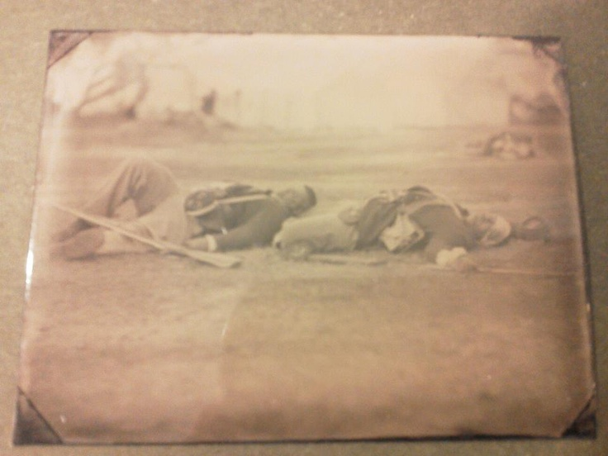
Massachusetts, the Federal cavalry, and part of the 7th Connecticut covered the withdrawal. Many wounded and a large amount of equipment had to be abandoned in the hasty retreat. Fortunately for the Federals, the Confederate pursuit was poorly conducted, enabling most of the Yankees to escape. The southern cavalry, led by Colonel Caraway Smith, was particularly criticized for its lackluster performance. That night the Federals retreated all the way back to Barbers, where they had begun the day. By February 22, Seymour's battered army was back in Jacksonville. The casualties at Olustee were staggering compared to the numbers that fought there. Each side had about 5,000 men present. Union casualties were 203 killed, 1,152 wounded, and 506 missing, a total of 1,861. Confederate losses were 93 killed, 847 wounded, and 6 missing, a total of 946. This works out to about 34 percent for the Federals and a little less than 19 percent for the Confederates. The 47th New York had 313 casualties and the 8th U.S.C.T. had 310. Among the Confederate units, the 32nd Georgia lost 164 men and Bonaud's Battalion 107. For the North, the casualty percentage was among the highest of the War, and Olustee ranks as the second bloodiest for the Union when comparing the casualties to the number on men engaged (265 casualties per 1,000 troops). Letters and diaries from the men involved indicate that the battle was the equal of, if not worse than, the savage fighting a number of the veteran regiments had experienced in the campaigns in Virginia or the Western theater. The defeat ended Union efforts to organize a loyal Florida government in time for the 1864 election. The Federals were somewhat more successful in meeting the expedition's military objectives. Jacksonville remained in Union hands until the end of the war, open for trade with the north; the operation had undoubtedly disrupted the supply of Florida cattle and other foodstuffs to the rest of the Confederacy; and the increased area of Federal control made it easier for Florida blacks to reach Union lines and for recruits to fill the ranks of northern military units. All objectives could have been met by the occupying Jacksonville without the 2,000 casualties.

7th Connecticut Dead on the Field at The Battle of Olustee
-4-
READ MORE ABOUT OLUSTEE

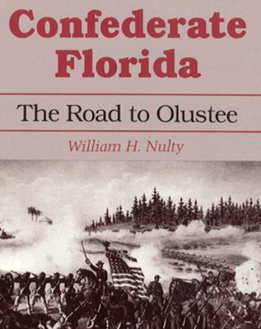
Confederate Florida:The Road to Olustee by William H. Nulty-
At the end of 1863 the Federal forces in the Department of the South were tied up in siege operations against Charleston and Savannah, operations that showed little progress or promise. The commander of the Department, Major General Quincy A. Gillmore, led an expedition into Florida to recruit blacks, cut off commissary supplies headed for other parts of the Confederacy, and disrupt the railroad system within Florida. Expedition forces landed at Jacksonville on February 7, 1864. The engagement at Olustee, not far from Gainesville, took place on February 20, 1864. it was the largest Civil War battle in Florida and one of the bloodiest Union defeats of the entire war. Nonetheless, because the engagement forced the Confederacy to divert 15,000 men from the thinly manned defense of Charleston and Savannah, it delayed critical reinforcement of the Army of Tennessee, which was fighting desperately to prevent the Union invasion of northwestern Georgia.
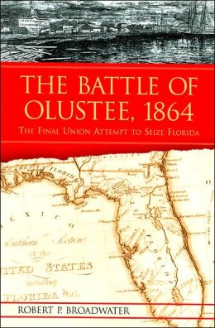
The Battle of Olustee: 1864 by Robert P. Broadwater -
When the Civil War began in 1861, Florida, although the 3rd state to secede from the Union, was of little strategic importance to North or South. By the end of 1863, this position had changed dramatically. For the struggling Confederacy, Florida had become a crucial source of supplies, most especially for the troops in Savannah and Charleston. Lincoln, soon to be seeking re-election and facing immense dissatisfaction due to the course which the war had taken, was desperately seeking some method of remedying his political situation. Bringing a reconstructed Florida back into the Union, with delegates who he hoped would be friendly to the Republican cause, seemed to be an ideal solution. Thus the Union launched a last-minute endeavor to regain control of Florida, an effort that culminated at Olustee.

*****
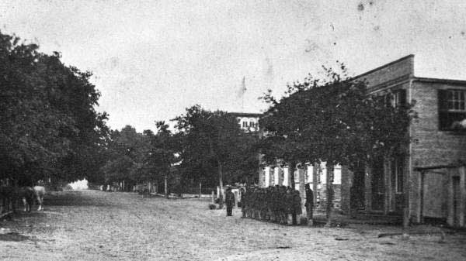
Florida State Archives: Provost Guard House, Jacksonville, 1864
-5-

OCEAN POND - FEBRUARY 20, 1864

Confederate Order of Battle
Brigadier General Joseph Finegan
Commander, District of East Florida
Brigadier General Alfred Colquitt's Brigade
6th Florida Infantry Battalion, Major Pickens Bird
6th Georgia Infantry, Lt. Colonel John Lofton
19th Georgia Infantry, Colonel James Neal
23rd Georgia Infantry, Lt. Colonel James Huggins
27th Georgia Infantry, Colonel Charles Zachry
28th Georgia Infantry, Captain William Crawford
Chatham Artillery (Georgia), Captain John Wheaton
Gamble's (Leon Light) Artillery (Florida), Captain Robert Gamble
Colonel George Harrison's Brigade
First Florida Infantry Battalion, LtColonel Charles Hopkins
32nd Georgia Infantry, Major Washington Holland (Colonel George Harrison)
64th Georgia Infantry, Captain Charles Jenkins (Colonel John Evans)
1st Georgia Regular Infantry, Captain Henry Cannon
28th Georgia Artillery Battalion, Major Augustus Bonaud
Abell's Artillery (Florida) [Milton Light Artillery], Captain Henry Abell, serving as infantry
Guerard's Battery (Georgia), Captain John Guerard
Colonel Caraway Smith's Cavalry Brigade
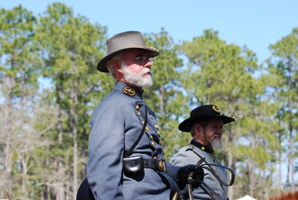
4th Georgia Cavalry, Colonel Duncan Clinch
2nd Florida Cavalry, LtColonel Abner McCormick (Colonel Caraway Smith)
5th Florida Cavalry Battalion, Major George Scott

FOR MORE OLUSTEE RE-ENACTMENT INFORMATION:
http://olusteefestival.com
A Friday afternoon skirmish is planned in Lake City. Check with your squad leaders for departure place and time.

Union Order of Battle
Brigadier General Truman Seymour
Commander, District of Florida
Colonel William Barton's Brigade
47th New York Infantry, Colonel Henry Moore
48th New York Infantry, Major William Coan (Colonel William Barton)
115th New York Infantry, Colonel Simeon Sammons
Colonel Joseph Hawley's Brigade
7th Connecticut Infantry, Captain Benjamin Skinner (Colonel Joseph Hawley)
7th New Hampshire Infantry, Colonel Joseph Abbott
8th United States Colored Troops, Colonel Charles Fribley
Colonel James Montgomery's Brigade
35th United State Colored Troops [1st North Carolina Colored Volunteers], Lt Col.Wm. Reed
54th Massachusetts Infantry, Colonel Edward Hallowell
Support Units:
Mounted Brigade, Colonel Guy Henry
40th Massachusetts Mounted Infantry, (Colonel Guy Henry)
Independent Massachusetts Cavalry Battalion, Major Atherton Stevens
Battery B, First U.S. Artillery [Elder's Horse Battery], Captain Samuel Elder
Battery E, Third U. S. Artillery, Captain John Hamilton
Battery M, First U. S. Artillery, Captain Loomis Langdon
Sections C and B, Third Rhode Island Artillery, Lieutenant Henry Metcalf
Companies A, D, G and I, 1st New York Engineers, Lt. Colonel James Hall
-7-
THE CAMP OF THE UNKNOWN SOLDIER # 2218
Camp # 2218 of Clinton, Jones County, Georgia, hosted their 1st annual Lee-Jackson Banquet on Monday, January 27, 2014 at their new home location of Firefly's Restaurant, 4171 Gray Hwy., Gray, GA. Our featured speaker was none other than Camp 2218 Commander J.C. Nobles who gave a most eloquent address. Too, it was the grand occasion of the induction of Camp officers for 2014, officiated by Brigade Commander Kim Beck. On a more personal note, Adjutant Dobson was absent due to illness. "I have never been one that felt that a relatively minor illness should ever prevent the performance of duty; however, my contagious condition compelled me to consider others. After being part of the labor to establish the Camp, it was particularly heartbreaking not to be with you all on this occasion. We press on, nonetheless, to the prospect of a an extraordinary remainder 2014."
The Camp of the Unknown Soldier does, indeed, look forward to a year of unprecedented growth and the blessings of Almighty God. Monthly meetings will, henceforth, be at this new (Firefly's) location on the 4th Monday of each month. For our February 24th meeting, we are so pleased to have Jim Brittain who is the great grandson of Wiley Jenkins, whom the SCV Camp in Eatonton is named for. He will present a program on his great grandfather and a collection documents that he inherited from him. On March 24th, we will welcome our long-time friend and compatriot Johnny Mack Nickles whose program will deal with Confederate Cutlery. As usual we will eat at 6pm and meet at 7pm, trying to adjourn by 8-8:30pm. Wives, children, family members and visitors are always very, very welcome. In fact, you are essential! It was good to see Matt Whitehead (although briefly) while he was home for Christmas from the U.S. Navy. Email his at: cheezit@windstream.net
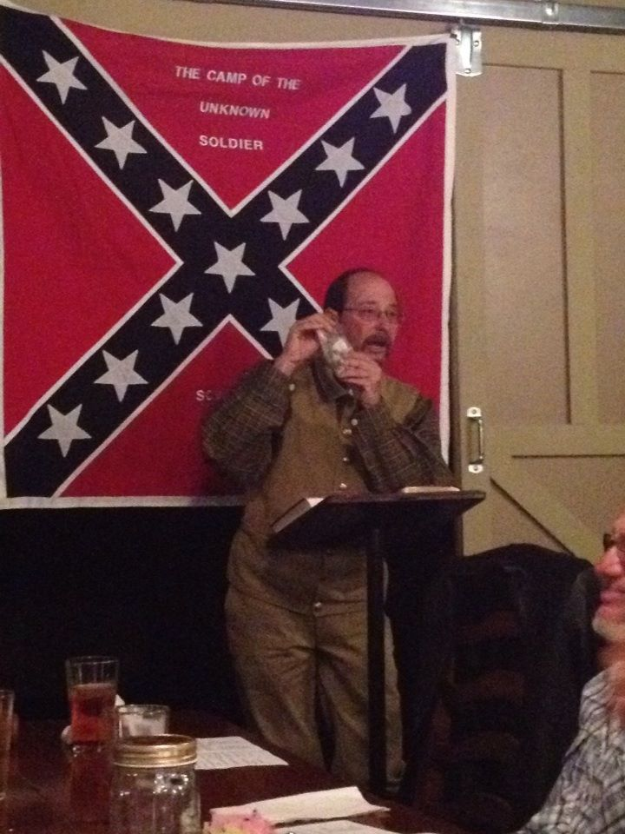
We have received the registration forms for the 117th GEORGIA. DIVISION CONVENTION/REUNION JUNE 13th & 14th, 2014 in COLUMBUS, GA, if anyone is interested in going, please contact Earl Colvin. Visit our website: scvcamp2218.com.
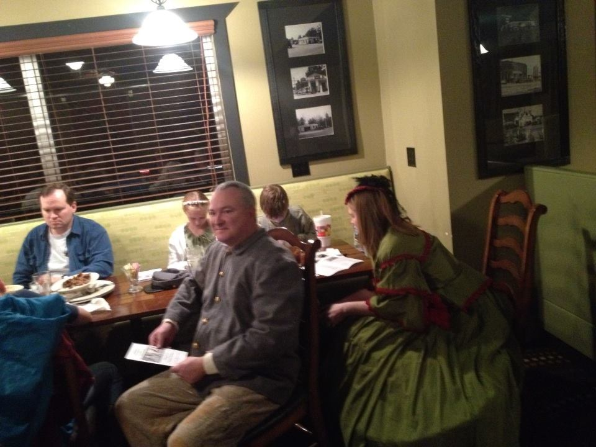
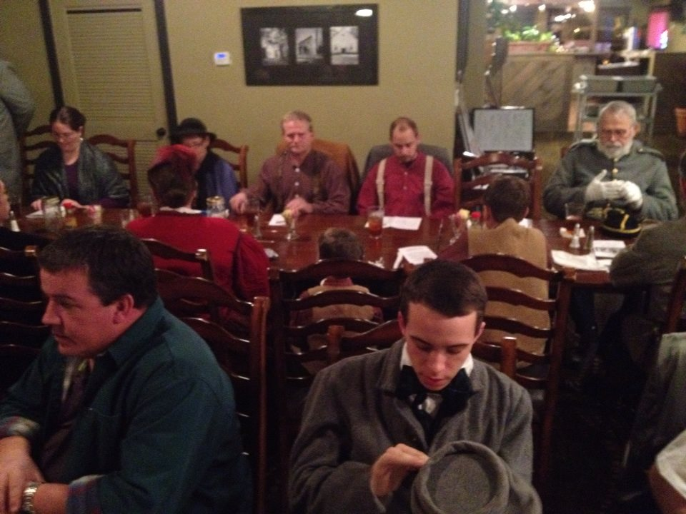
Camp 2218 Lee-Jackson Banquet, January 27, 2018

-8-

As most all of you know, Ray Cross, the stepfather of 1st Corporal Alan "Cookie" Richards went home on January 16 after an extended illness. Our most earnest expressions of sympathy go out to that family and we pray that God, by His Spirit, will send the only comfort that truly matters. Corporal Richards writes: "My family and I would like to express our sincere gratitude and appreciation for your thoughts, prayers and the flower during our time of loss. While losing a family member is not easy on your heart, having you as our brothers and sisters makes the task at hand much easier. We love each of you. Mama, Cookie, Nina and Family"

*****
"STANDING IN THE NEED OF PRAYER"
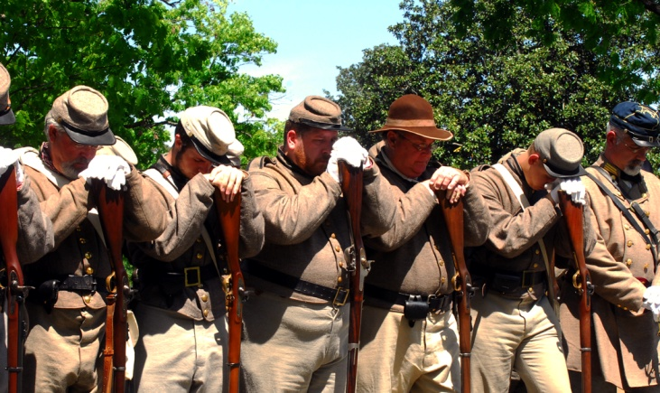
Health Issues: C.L. GRAY - Editor, Stainless Banner; TIM PILGRIM - GA State SCV Adjutant, FRANK FOULKE - cherished friend; and 16th GA members BOBBY DUSKIN, RICKY SMITH, TIM FOWLER . Please remember those who have lost loved ones - especially children, the time is short and there are always many unspoken requests which are among the nearest to the heart. God hears - He knows - He understands and He delivers!
*****
HAS THE NRA ABNADONED SOUTHERN HERITAGE?

This letter is to inform the National Rifle Association that I have no interest in sending my money to support you any longer. I am a Life Member of the historical group Sons of Confederate Veterans. If the NRA doesn’t wish allow us to advertise in your magazines, I will use my renewal fees as an extra donations to the SCV. I will encourage other members to do the same. Southerners are proud of their heritage and support the second amendment. We thought we had a lot in common with the NRA. Apparently the NRA feels if it doesn’t associate with the SCV that they will acquire the Liberal voters to jump onboard. I really think that is a misfire. Unless there is a change in the NRA concerning advertisements from the SCV, please stop sending magazines and renewal letters to me. I will be removing NRA stickers from my vehicles. Sincerely, K. M. Beck
-9-
FEBRUARY 14-16 -150TH OLUSTEE, FL -3 battles, parade, memorial.
MARCH - 14-16 - MANASSAS, GA; POC Tommy Wallace 912-557-6649.
APRIL 26 - CONFEDERATE MEMORIAL DAY - attend a service near you.
APRIL - OLD CLINTON WORKDAYS - DATES TO BE ANNOUNCED
MAY 2-4 - WAR DAYS- 150TH SUNSHINE CHURCH & GRISWOLDVILLE
MAY 16-18 - 150TH BATTLE OF RESACA, GA
MAY - OLD SOLDIER'S DAY AT ERVIN GARNTO'S (in 2012 on May 26th)
JULY 26 - OCMULGEE NATIONAL MONUMENT - Living History - Participation by invitation of the Park ONLY !
SEPTEMBER 19-21- BATTLE OF ATLANTA AT NASH FARM
SEPTEMBER - SCV SALUTE TO VETERANS IN DUBLIN,GA(2012,the 15th)
OCTOBER 3-5 - ANDERSONVILLE (1st weekend)
OCTOBER - BATTLE @ IRWINVILLE - POC LEE MURDOCK 478-986-5290.
NOVEMBER 7-9 - SHERMAN'S OCCUPATION OF SANDERSVILLE NOVEMBER 22- 150TH GRISWOLDVILLE MEMORIAL- SPEAKER: PASTOR JOHN WEAVER
NOVEMBER CANNONBALL HOUSE APPARITIONS (in 2013, the 9th)
NOVEMBER-DECEMBER- CHRISTMAS@RICHLAND CHURCH (in 2013 it was Dec.6-7)
DECEMBER - CHRISTMAS AT THE CANNONBALL HOUSE (in 2013 it was Dec. 14).
*****
16TH GA Co. G. “Jackson Rifles”
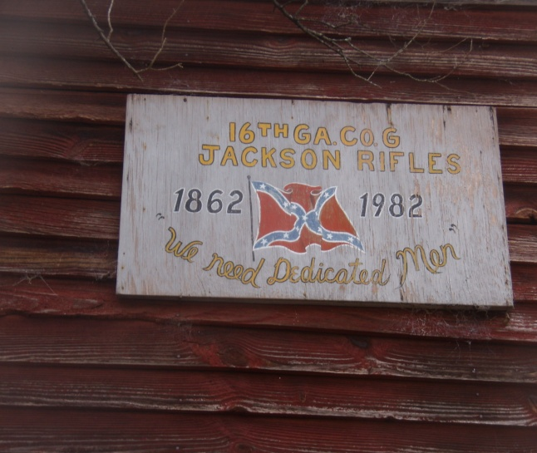
Brig. Gen. Herbert Burns - 478-668-3598
Capt. Wm."Rebel" Bradberry–404-242-7213
1 Lt. Noah Sprague – 706-491-9755
1st Sgt. Kevin Sark – 478-731-8796
2nd Sgt. Nathan Sprague – 478-320-8748
Adjutant John Wayne "Duke" Dobson 478-731-5531
1st Corp. Alan "Cookie" Richards 478-308-9739
2nd Corp. Chas."Goodtime" Whitehead 478-986-8943
3rd Corp. Lee "Pappy" Curtis -478-365-6785
Lead Chaplain – Joel Whitehead, Jr. - 478-986-8798
Hon. Chaplain Ronnie "Skin" Neal – 478-994-0958
Assistant Chaplain – Charles Hill – 770-845-6878
Treasurer - Pvt. Earl Colvin – 478-214-0687
Honorary Colonel J. C. Nobles - 478-718-3201
Musician - Landon Allen - 478-294-9870
Musician - Jacob Thompson – 478-214-0687
Musician - Aaron Bradford – 302-668-8029
Musician - Oliver Lummus – 302-668-8029
Musician - Al McGalliard - 478-986-4827
Musician - Ben Morris - 478-986-1184
ON FACEBOOK:"JACKSON RIFLES" - OVER 2,000 FRIENDS. All 2011-14 issues of The Howling Dawg are available @ scvcamp1399.org & some @ scv2218.com, thanks to Steve Scroggins and Al McGalliard.
-10-
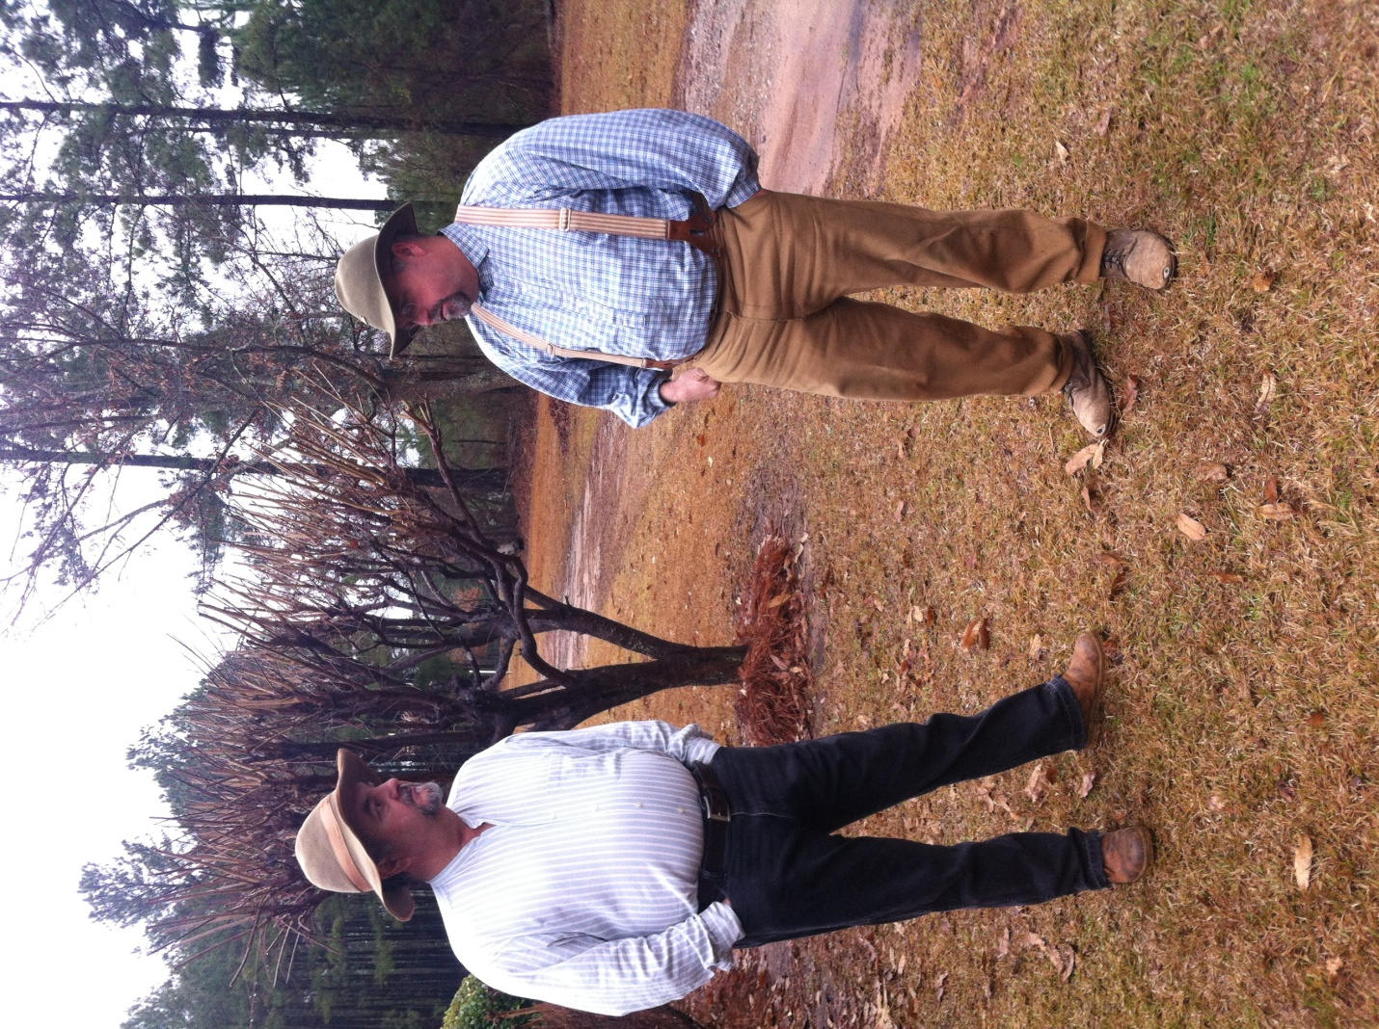
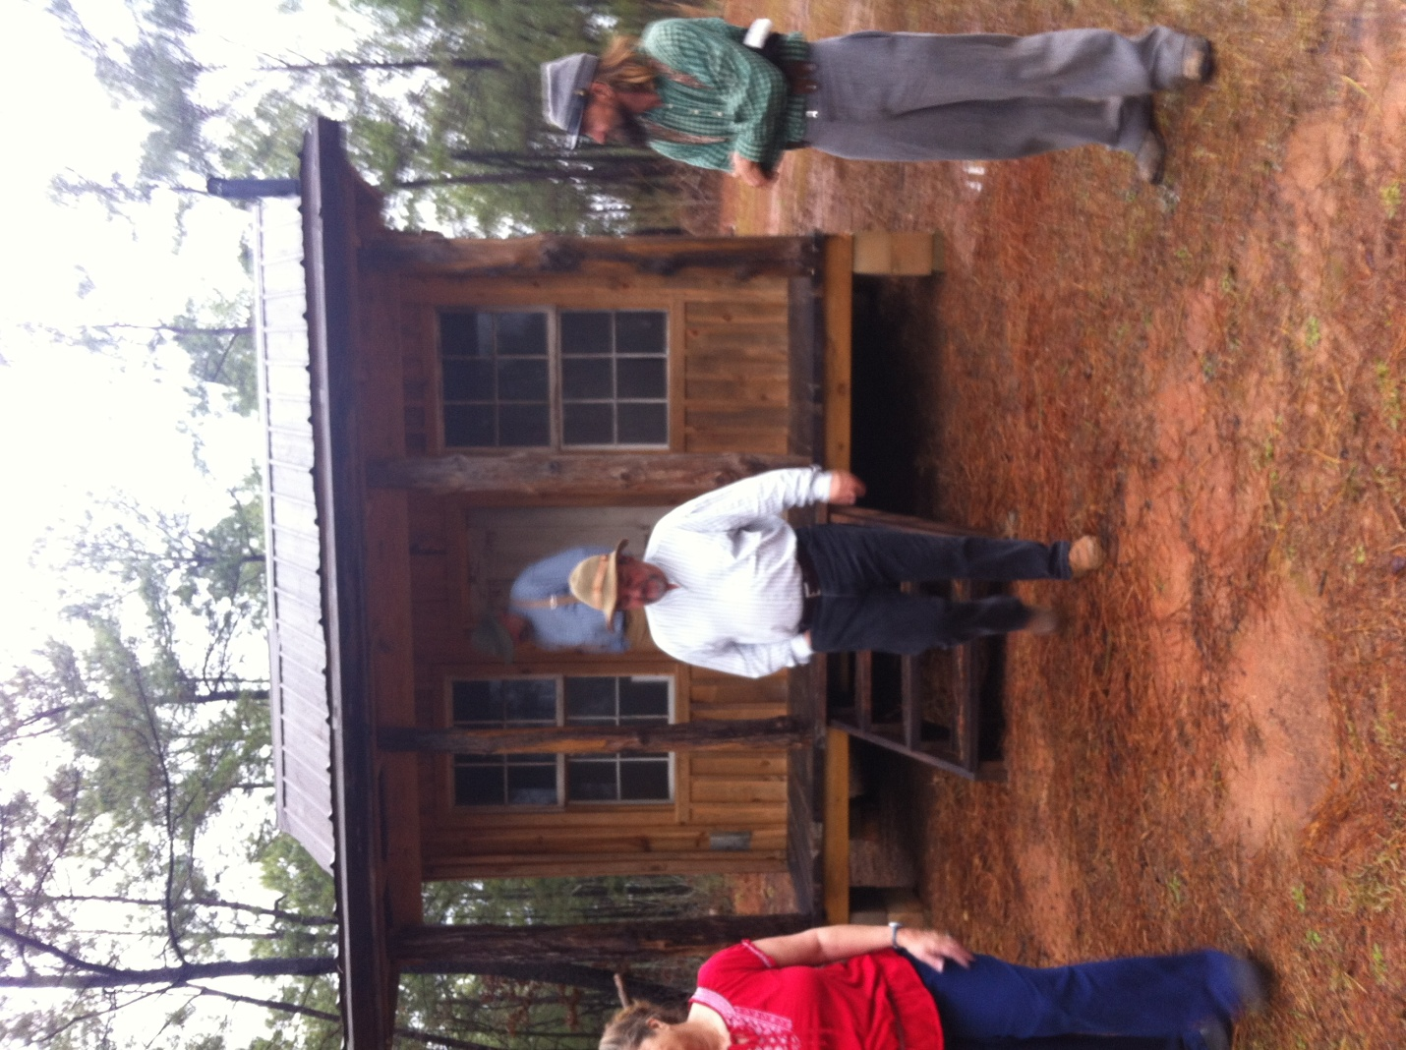
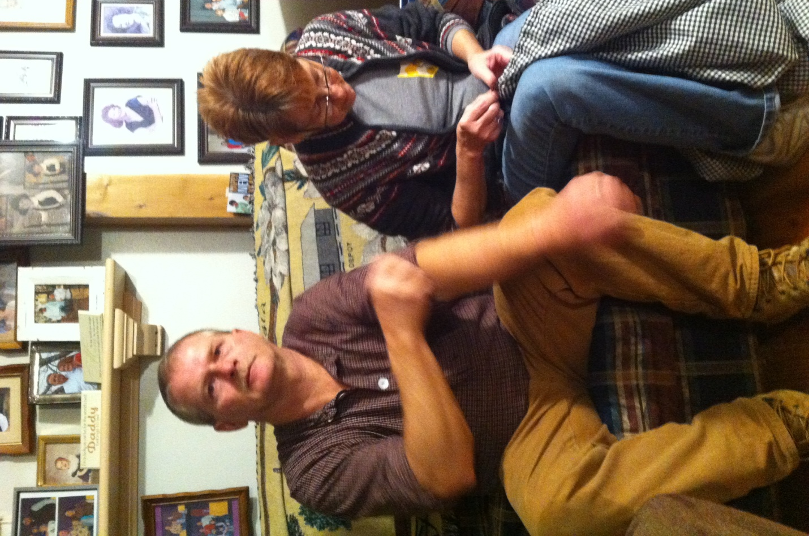
16TH GEORGIA WINTER MUSTER 2014
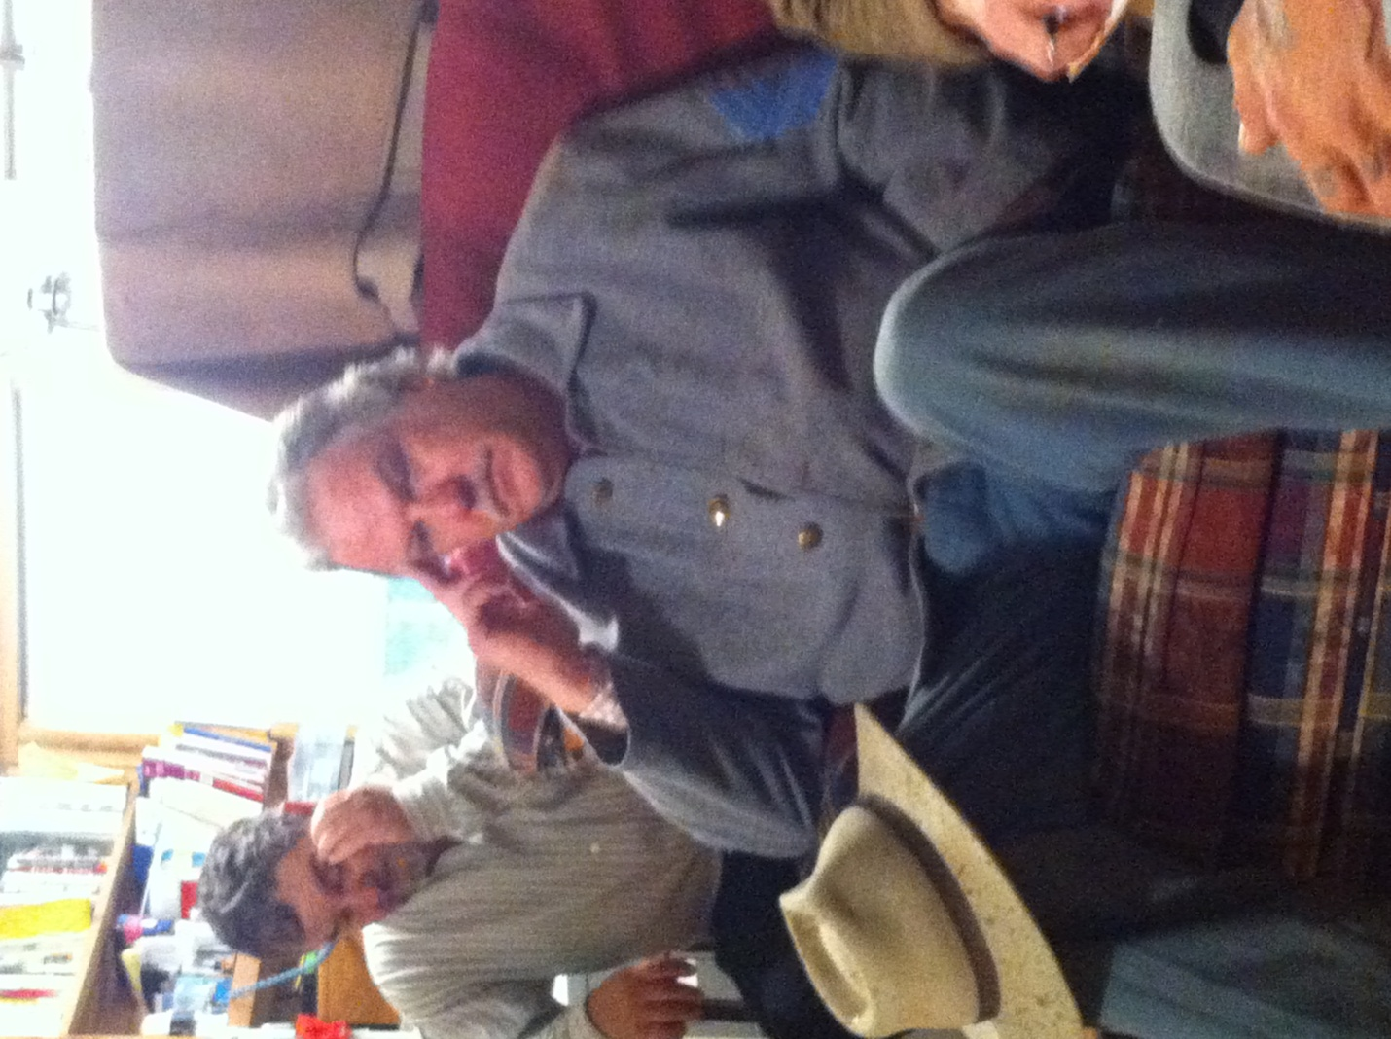
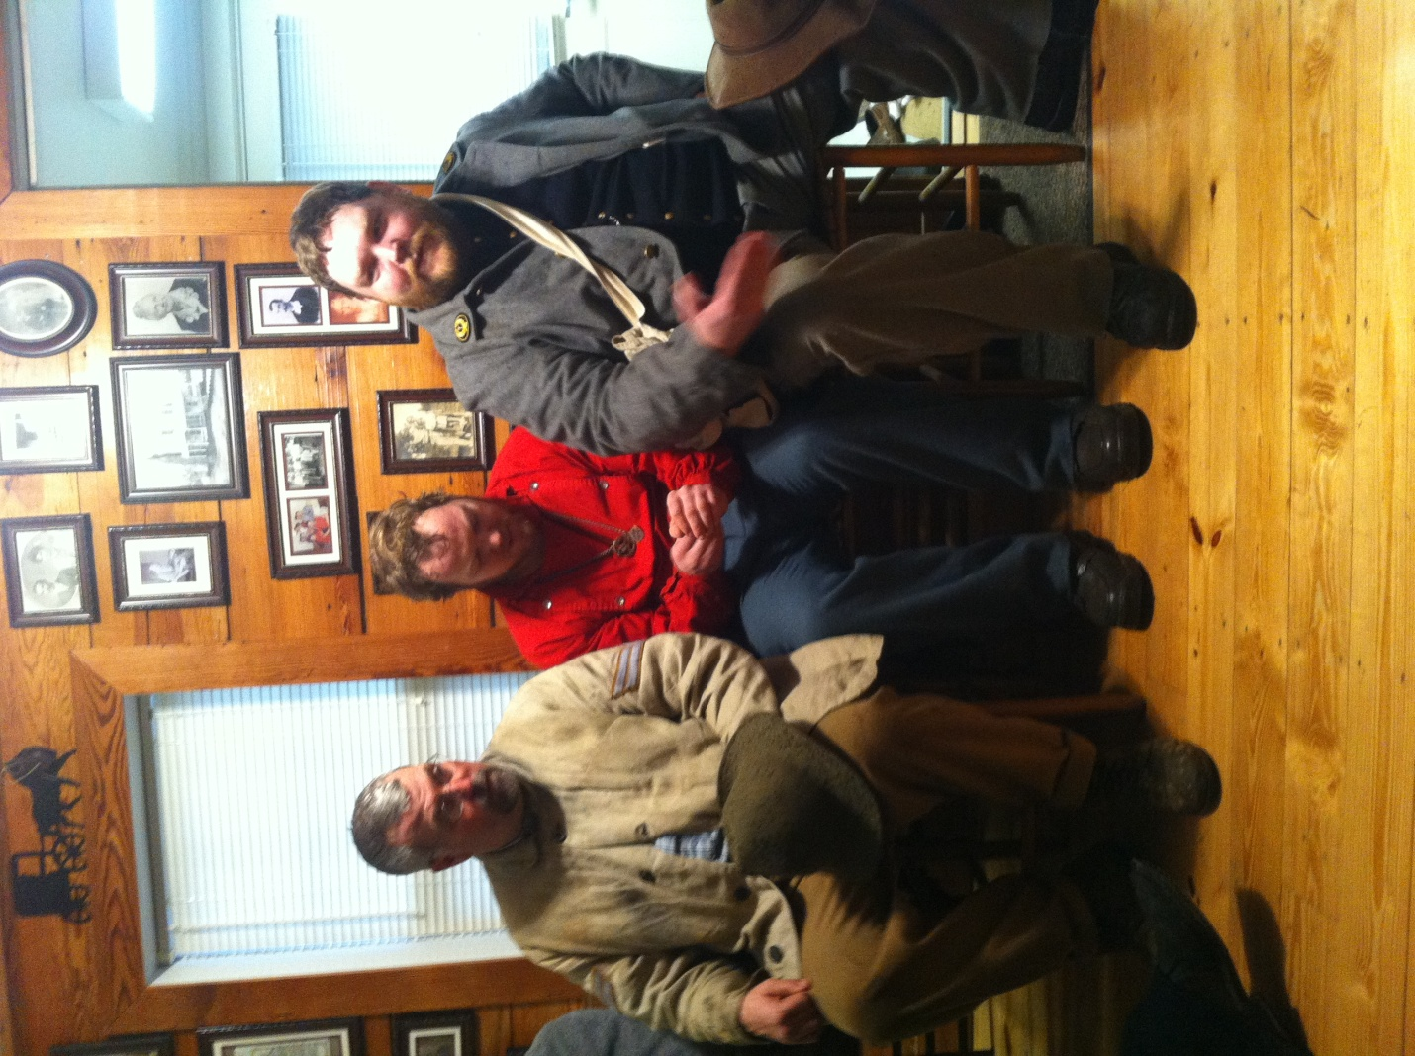
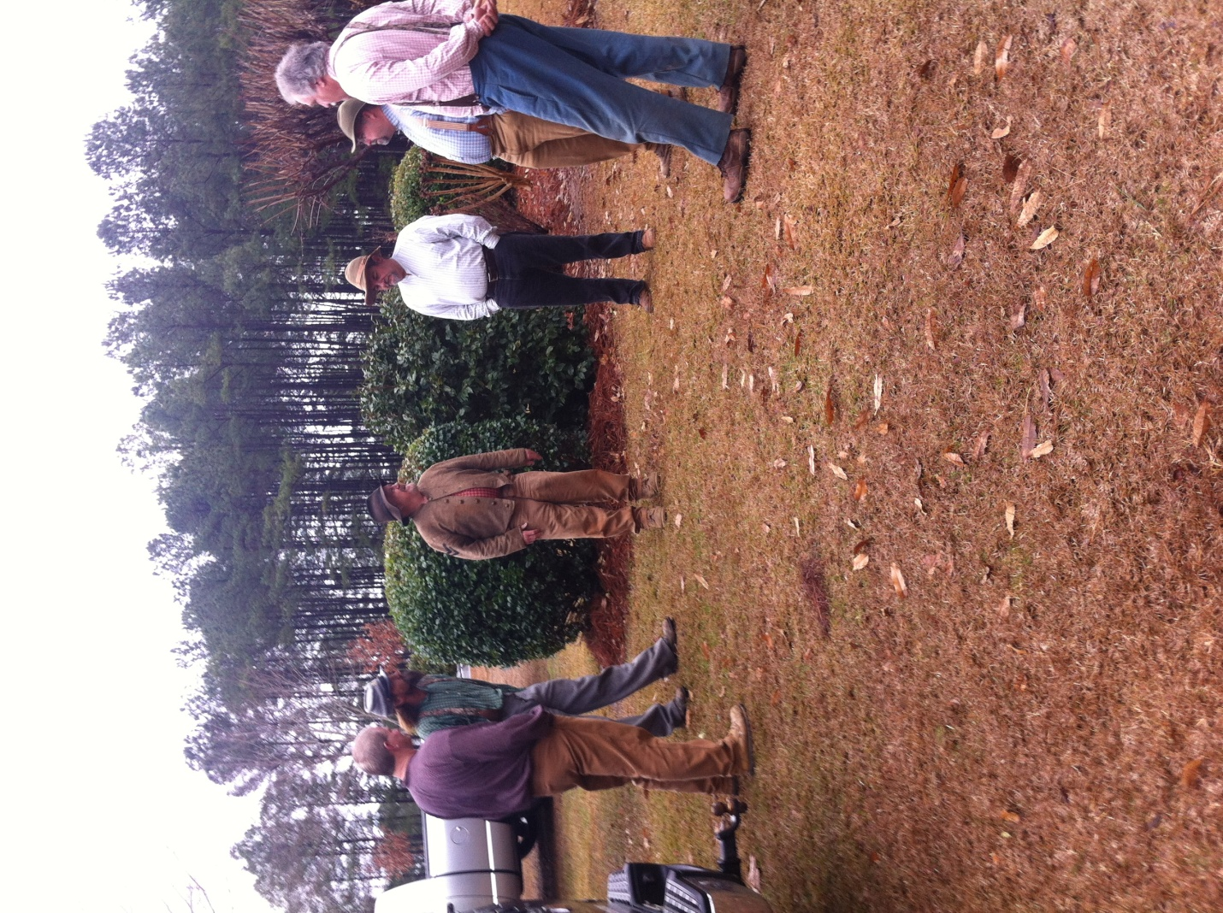
The 16th GA seemed to have picked up right where it left off last year - IN THE RAIN! Despite down powers we had an excellent drill, conducted by 1st Sgt. Kevin Sark and an productive unit meeting. Scenes above are taken from our pre-drill gathering and our unit meeting. We thank Earl and Beth Colvin for hosting it the event and for the delicious lunch. It was a good start for the new year.
-11-

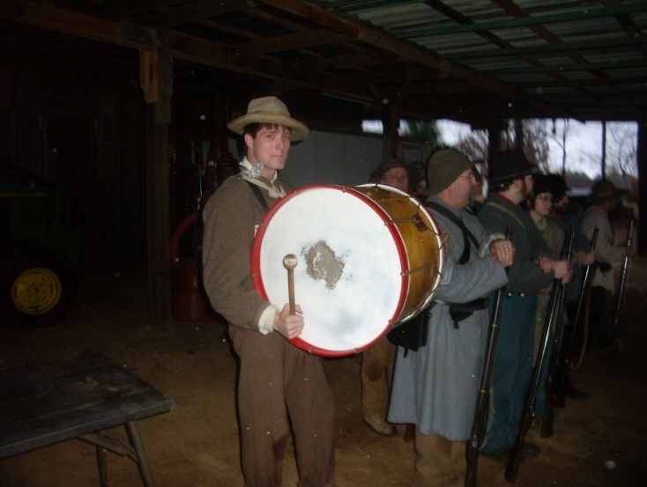
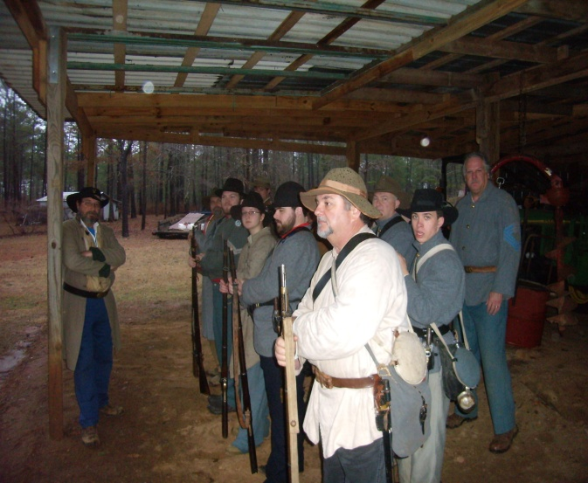
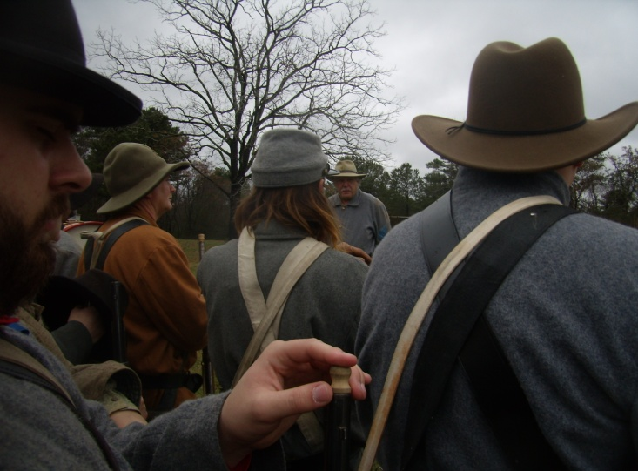
MORE SCENES OF WINTER MUSTER 2014
We drilled under heavy skies until the rain simply grew too heavy, then worked on
the manual of arms under shelter. Private Ben Morris showed up with a newly-acquired bass drum and did a splendid job with it, bring our musician total to 6.
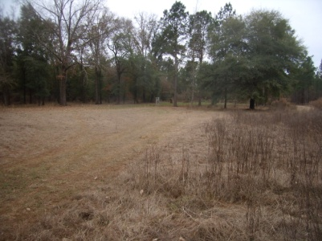
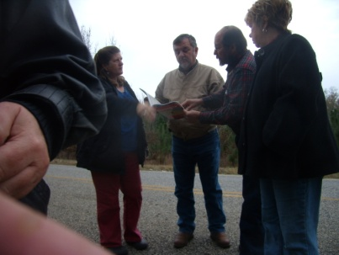
ROAD TRIP
On January 1st, Earl and Beth Colvin, Brenda and Wayne Dobson, J.C. Nobles and Cathy Wheeler toured the archeological excavation sites of Camp Lawton (Andersonville's replacement) at Magnolia Springs State Park. We also located what we believe to be one of two Louisville, GA plantation sites owned by Judge Asa Holt, who build the Cannonball House in Macon.

UNIT ELECTIONS
The 16th Georgia Infantry, Co. G, "The Jackson Rifles" will hold elections at Old Clinton War Days 2014 for the positions of Captain, 1st Lt. and 2nd Sgt. All candidates (including those currently holding these positions) MUST make their intentions known to the Adjutant, no later than midnight of April 1, 2014.
-12-

Ultimate Soldier Competition Clinton 2014
May 3rd, 2014 @ 1105 hrs. behind the McCarthy-Pope House
Each participant will be evaluated in 3 separate areas. Loading and firing from different positions, authenticity, and drill. Each soldier will start out with 50 points. Points will be deducted at each stage of the competition. Winner is awarded the following: $100.00 cash, 2 pounds of powder, Plaque. Cartridges will be provided for the competition. If you are participating, please let Adj. J.W. Dobson (waynedobson51@yahoo.com) or 478-731-5531 know prior to April 1st, 2014 so we can roll an accurate number of cartridges. You may enter either as Federal or Confederate. Questions about the competition itself: Lt. Noah Sprague 706-491-9755.
Moving, loading and firing:
- Participant will draw three pre-rolled cartridges and must have a 3 band rifle or musket.
- Participant will then be timed for the following:
- Move to a specific location, load and fire from the standing position using and returning ramrod.
- Move to another location, load and fire from a kneeling position behind cover.
- Move to a third location, load and fire from a prone position.
*Whoever has the fastest time will not lose any points. Second place will lose 1 point, third place will lose 2 points etc. Points will also be deducted for improper loading techniques. 1 point will be deducted for each loading and firing mistake such as dropping ramrod, firing cap only, dropping cartridge(s), dropping cap(s), not returning ramrod, not taking an AIMED shot etc. (An aimed shot should be an attempt to find an actual moving target down range looking through the sights).
Authenticity:
- Participant will be judged for overall authenticity guidelines either Federal or Confederate. Have a first person impression ready because there will be some first person questions. Points will be deducted for un-authentic items and also incorrect first person answers.
Drill:
- Participant will be judged on the Manual of Arms and questions on basic drill maneuvers. Points will be deducted for improper Manual of Arms and wrong drill maneuver questions.
The 1st place winner will receive $75.00 and a plaque.

2nd place, $50.00 and a plaque.

3rd place, $25.00 and a plaque.

-13-
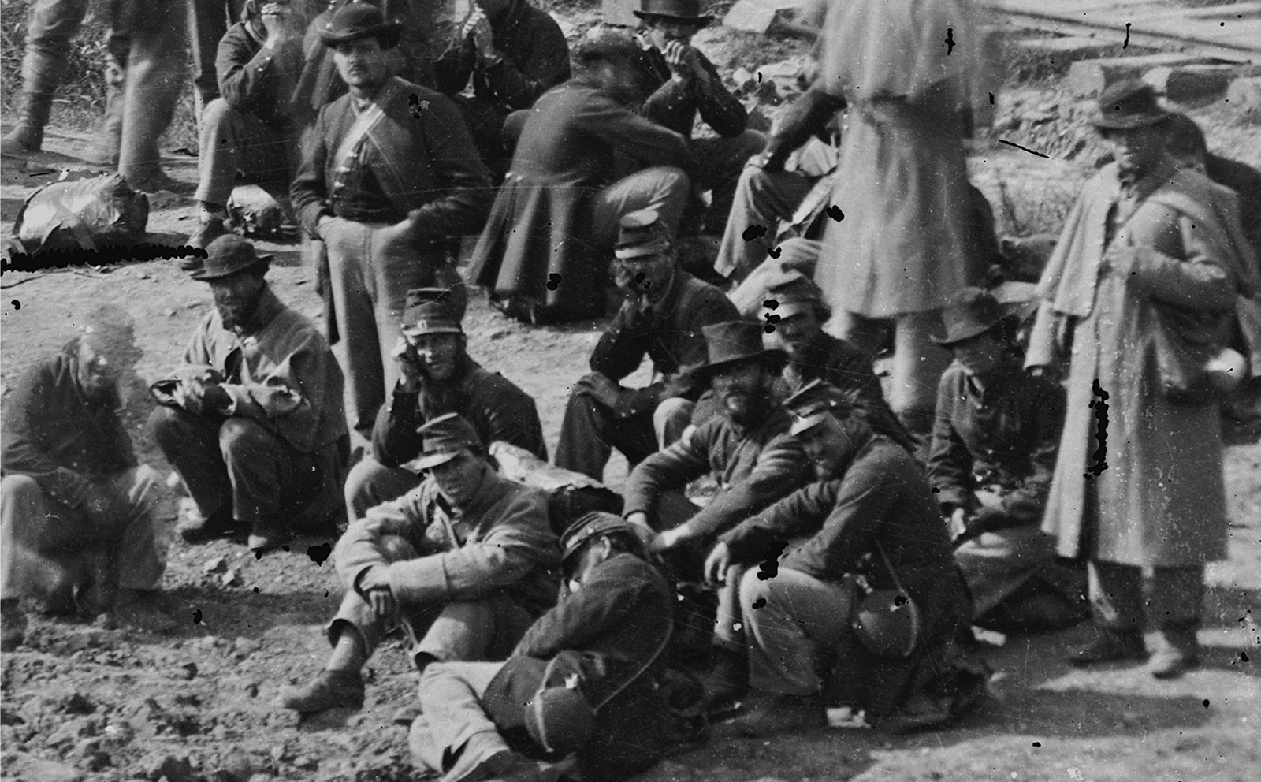
WHOSE BLOOD IS ON WHOSE HANDS?
“Starvation, literal starvation, was doing its deadly work. So depleted and poisoned was the blood of many of Lee’s men from insufficient and unsound food that a slight wound which would probably not have been reported at the beginning of the War would often cause blood-poison, gangrene, and death.
Yet the spirits of these brave men seemed to rise
Confederate Prisoners at Chattanooga

as their condition grew more desperate . . . it was a harrowing but not uncommon sight to see those hungry men gather the wasted corn from under the feet of half-fed horses, and wash and parch and eat it to satisfy in some measure their craving for food.” General John B. Gordon, “Reminiscences of the Civil War.”
“Winter poured down its snows and its sleets upon Lee’s shelterless men in the trenches. Some of them burrowed into the earth. Most of them shivered over the feeble fires kept burning along the lines. Scanty and thin were the garments of these heroes. Most of them were clad in mere rags.
Gaunt famine oppressed them every hour. One quarter of a pound of rancid bacon and a little meal was the daily portion assigned to each man by the rules of the War Department. But even this allowance failed when the railroads broke down and left the bacon and the flour and the mean piled up beside the track in Georgia and the Carolinas. One-sixth of the daily ration was the allotment for a considerable time, and very often the supply of bacon failed entirely.
At the close of 1863, Grant had one hundred and ten thousand men. Lee had sixty-six thousand on his rolls, but this included men on detached duty, leaving him barely forty thousand soldiers to defend the trenches that were then stretched out forty miles in length from the Chickahominy to Hatcher’s Run.” Henry Alexander White, “Life of Robert E. Lee.”
“When their own soldiers were suffering such hardships as these in the field, the Confederate leaders made every effort to exchange men so that helpless prisoners of war would not suffer in anything like equal measure, offering even to send back prisoners without requiring an equivalent. Hence, the charges brought against the Confederate government of intentional ill-treatment of prisoners of war are not supported by the facts.
In the South the same quantity and quality of rations were given to prisoners and guards; but that variety in food could not be had or transported on the broken-down railway system of a non-manufacturing country, which system could not or did not provide sufficient clothes and food even for the Confederate soldiers in the field.
The control of the prisons in the North was turned over by Secretary Stanton and the vindictive and partisan men (who were later responsible also for the crimes of Reconstruction) to the lowest element of an alien population and to Negro guards of a criminal type, and such men as President Lincoln, Seward, McClellan, and the best people in the North were intentionally kept in ignorance of conditions in Northern prisons while officially furnished with stories as to “the deliberate cruelties” practiced in the South.”

(The Women of the South in War Times, Matthew Page Andrews, Norman, Remington Co., 1920, pp. 399-406)
-14-

WHY JOIN THE 16TH GEORGIA ?
By Private Ethan Bloodworth
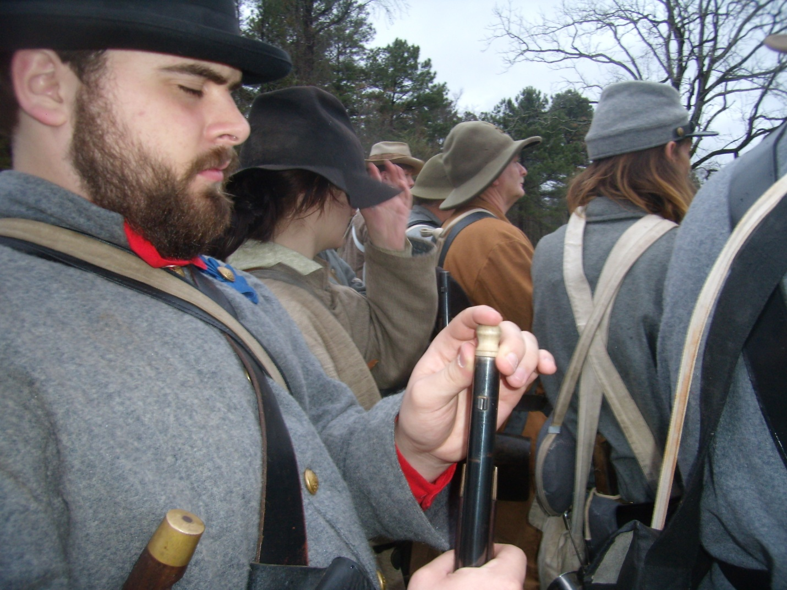
At our winter muster, it was asked of Mrs. Sheri Williams, "why would you want to join the 16th Georgia?"
As that question penetrated my brain, I began to think. "Why would one wish to join the 16th Georgia?" One will spend upwards of one thousand dollars to build a uniform, including rifle. One will slog through all weather and terrain, clay or mud, creek or ditch, in any temperature from 17 to 117 degrees, rain or shine, darkness or light. One will drive for hours on end to arrive at a site and set up a tent, if a tent is available, to more often than not shiver the night away. Faced with these circumstances, why would one wish to join the 16th Georgia? Why indeed! Faced with the above situations, one would have to be at least a bit crazy to want to join the 16th Georgia. But then again, none of us ever claimed to be completely right in the head. One joins the 16th Georgia for many reasons. The 16th Georgia is the unit to be. Our entire unit can outmarch, out drill, and outfight any unit around. We are nationally recognized, having received not only clearance, but invitations to portray our unit on both State and Federal land. But far beyond the unit's grandeur as a whole is the individual 16th Georgia member. As a whole, the unit is composed of a different sort of man or woman than you would meet every day. These men and women endure every hardship imaginable both as described above and out of uniform. These individuals are also the most passionate group of men and women you will ever have the privilege to meet and serve. The passion that spills from the lips of every man and woman in the 16th Georgia is palpable. One can tell that those who came before us hear the words and view of the actions of the 16th Georgia, recognize both sincerity and true dedication not for themselves, but for the ancestors, and said ancestors look down and smile.
Finally, the comradeship of the 16th Georgia is why one would wish to join. These men and women not only gather in uniform, but regularly gather whenever possible. We delight in one another's company, gathering together as often as possible and always having a large time. It is like having a second extended family, only you get to choose this one. So one may ask, why join the 16th Georgia? I ask,why join anywhere else?
-15-
^{DANGEROUS THINGS}
your body is the temple of the Holy Ghost which is in you, which ye have of God, and ye are not your own? For ye are bought with a price: therefore glorify God in your body, and in your spirit, which are God's.
- 1 Corinthians 6:19-20

Implantable technology proponent Amal Graafstra, of Seattle, demonstrates (photo above right) how one of the doors to his home can be unlocked just by passing either of his hands past a sensor that reads the signal from radio frequency identification tags implanted in each of his hands. It's likely the world in the not-so-distant future will be increasingly populated by computerized people like Amal Graafstra. The 37-year-old doesn't need a key or password to get into his car, home or computer. He's programmed them to unlock at the mere wave of his hands, which are implanted with radio frequency identification tags. The rice-size gadgets work so well, the Seattle resident says, he has sold similar ones to more than 500 customers through his company Dangerous Things. The move in the Bay Area and beyond to outfit people with electronic devices that can be swallowed, implanted in their bodies or attached to their skin via "smart tattoos" could revolutionize health care and change the way people interact with devices and one another. Critics call the trend intrusive, even sacrilegious. But others say it ultimately will make life better for everybody. Some researchers and executives envision a day when devices placed in people will enable them to control computers, prosthetic devices and many other things solely with their thoughts.
"In the next 10 to 20 years we will see rapid development in bioengineered and man-machine interfaces," predicted Graafstra, who wrote a book about the technology, adding that the trend is going to "push the boundaries of what it means to be human."Companies and researchers are keenly interested in the topic. In a patent application made public in November, Google's Motorola Mobility branch proposed an "electronic skin tattoo" for the throat - with a built-in microphone, battery and wireless transceiver - that would let someone operate other devices via voice commands. When asked, Google said it often seeks patents on employee brainstorms and that, while "some of those ideas later mature into real products or services, some don't." But Google CEO Larry Page apparently is intrigued with enhancing people electronically. A 2011 book about the Mountain View search giant quoted him saying, "eventually you'll have an implant, where if you think about a fact, it will just tell you the answer."Similar notions are under study by others, including UC Berkeley researchers. In a scholarly paper published in July, they proposed implanting people's brains with thousands of tiny sensors they called "neural dust." The idea initially is to have the little circuits gather detailed data on brain functions. But eventually, lead researcher Dongjin Seo said, the electronic swarms may prove useful for "controlling devices via thought" or stimulating malfunctioning brain regions to restore "limb motor control for paralyzed patients."
-16-

Ye shall not make any cuttings in your flesh … nor print any marks upon you: I am the Lord. - Leviticus 19:28

Among the most widely anticipated uses for implants, smart pills and electronic tattoos are medical. In October, Stanford doctors implanted the brain of a Parkinson's disease sufferer with a new device that gathers detailed data on the "neural signatures" of his illness. They hope to use the information to make a gadget that will ease Parkinson's symptoms with electrical impulses that adjust to any activity the patients do. Last year, Proteus Digital Health of Redwood City, Calif., won approval to sell a pill that relays information about a person's vital signs via a mobile phone to their doctor. And officials at Santa Clara, California-based Intel envision their microchips one day in devices ingested or implanted for medical and other uses.
And I beheld another beast coming up out of the earth; and he had two horns like a lamb, and he spake as a dragon. And he exerciseth all the power of the first beast before him, and causeth the earth and them which dwell therein to worship … and deceiveth them that dwell on the earth by the means of those miracles which he had power to do … And he causeth all, both small and great, rich and poor, free and bond, to receive a mark in their right hand, or in their foreheads: And that no man might buy or sell, save he that had the mark, or the name of the beast, or the number of his name. Here is wisdom. Let him that hath understanding count the number of the beast: for it is the number of a man; and his number is Six hundred threescore and six. - Revelation 13: 11-18
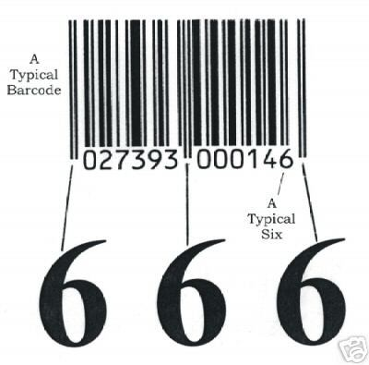
-17-

A FEW SCENES OF THE SNOW OF 2014
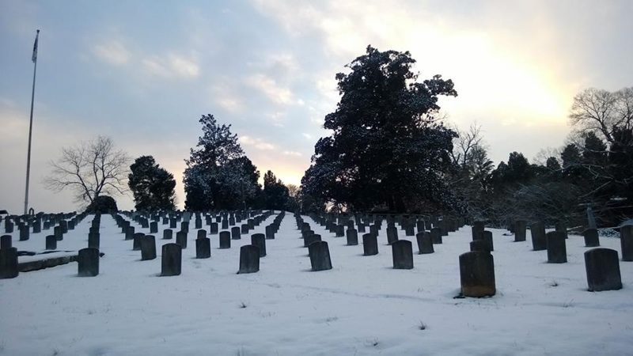
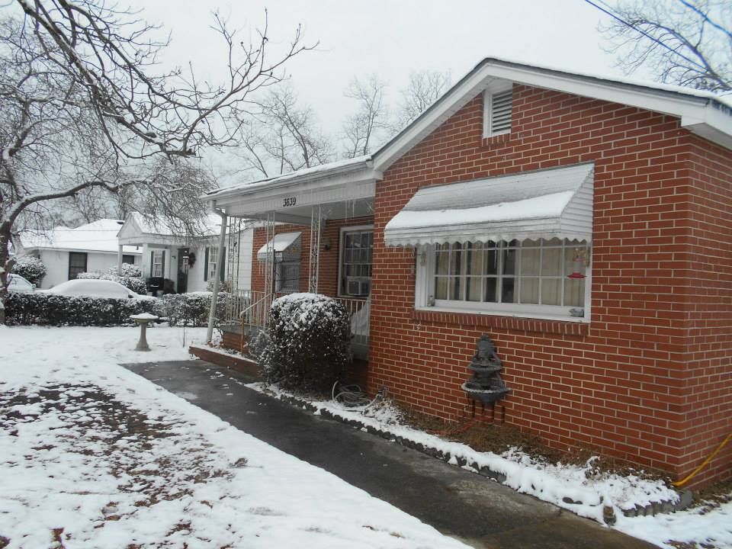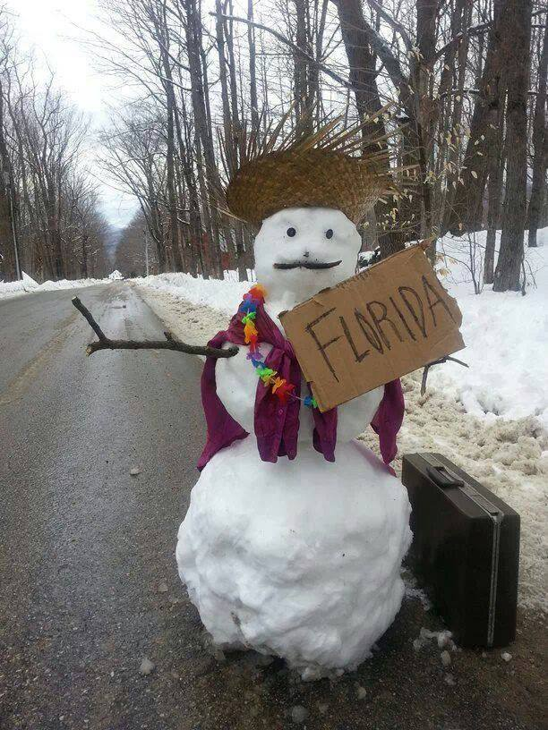
-18-

