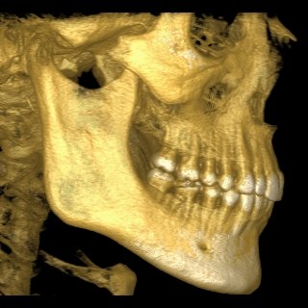
Oral, Maxillofacial & Implant Surgery

David M. Dugan, D.D.S., M.D., P.C.

Name: Date:
This patient has been requested to call your office for an appointment for the following:

- Extraction

- Pre-Prosthetic Evaluation

- Dental Implant Evaluation

- Oral Pathology Evaluation
(Please indicate using diagram on back)

1 2 3 4 5 6 7 8 9 10 11 12 13 14 15 16
A B C D E F G H I J

T S R Q P O N M L K
32 31 30 29 28 27 26 25 24 23 22 21 20 19 18 17
Remarks or Special Instructions:

Doctor’s Name
Welcome to Oral, Maxillofacial & Implant Surgery
- The initial visit, with the exception of certain situations, is for consultation only. This enables us to fully evaluate your problems and tailor the care to your specific needs.
- Bring all pertinent medical information and a list of all medications you are taking.
- Any unmarried patient under 18 years old must be accompanied by a parent or guardian during any office visit.
SEE MAP ON REVERSE SIDE
Phone (607) 432-8808
Fax (607) 432-2307
39 Country Club Rd.
Oneonta, NY 13820

