Just Add Wine Presents
Central Coast Wine Adventure featuring
Paso Robles and Santa Barbara

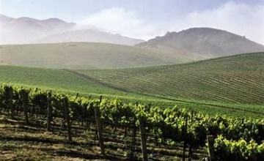
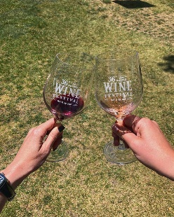
Halfway between the two main California metropolises of Los Angeles and San Francisco is Paso Robles Wine Country. Located along California’s famed Central Coast, the Paso Robles wine grape growing region’s climate is perfect to produce award-winning premium wines. A long growing season of warm days and cool evenings gives rise to vibrantly ripened fruit with dynamic flavor profiles that translate beautifully in your glass of Paso Robles wine. The Paso Robles American Viticulture Appellation (AVA) is home to more than 200 wineries and 40,000 vineyard acres focusing on premium wine production. The distinct microclimates and diverse soils make growing conditions ideal for producing more than 40 wine varietals from Cabernet Sauvignon and Merlot, to Syrah, Viognier and Roussanne, to Zinfandel, the area’s heritage wine variety.

In recent years, notable achievements include 2008, the Paso Robles AVA expanded by 2,635 to extend its southern border; in 2010 the Saxum Vineyard’s James Berry Vineyard 2010 wine designated number one in the world by Wine Spectator; in 2013, Paso Robles Wine Country named Wine Enthusiast Magazine’s 2013 Wine Region of the Year and in 2016, Paso Robles named Best Wine Region in the West by Sunset Magazine.

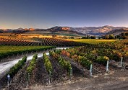
Santa Barbara wine country is quite literally “Sideways.” What this top wine movie’s title hints at is the unique geography of Santa Barbara wine country. It is the longest transverse valley (East to West) found on the western Pacific coast–from Alaska to South America. This creates climate conditions perfect for world-class cool climate wines (like Pinot Noir and Chardonnay). Let’s find out what makes this region awesome and what wines to explore from Santa Barbara wine country.

Santa Barbara is rightly named “America’s Riviera” as it gives visitors the ability to go from world class surf and coastline, chi-chi tasting rooms downtown, to the wine country itself… all within 30 minutes. You can do your own self-guided tour of the 26 urban tasting rooms after you sun, shop and dine downtown in the “funk zone,” located steps from the beach.

On your Just Add Wine Adventure, you will experience the best of Paso Robles and Santa Barbara and enjoy premium and reserved wines from the area’s best vintners. This 5-day adventure includes:
- Four nights lodging at premier accommodations
- Breakfast daily
- Admission to the Reserve and Grand Tasting at the Paso Robles Wine Festival
- Winemaker Dinner
- Wine Tasting Tour of Santa Barbara’s urban tasting rooms
- Dinner at one of Santa Barbara’s exclusive restaurants
- Transfers to and from LAX*

This premier adventure is only $1599 per person/double occupancy. $500 per person deposit required to reserve your space. Balance is due by March 14, 2019.

*Must arrive by Noon on Thursday, May 16 and leave after Noon on Monday, May 20th.

For more information visit www.justaddwinega.com and to reserve your space, email karen@justaddwinega.com.

