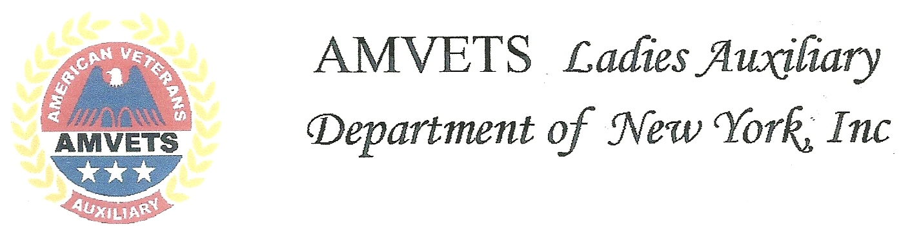
June 12, 2018
My name is Donna Smith. Thank you for electing me the Department of New York’s AMVETS Ladies Auxiliary President. I can promise you that I will try my best to serve you with honesty, integrity and with great pride.
I believed in the promise of a better tomorrow by standing together united in our efforts to serve our veterans and communities. I also believe that we can honor each other’s differences, working together as a TEAM, to continue to build our history as AMVETS and AMVETS Ladies Auxiliary, because Together Everyone Achieves More.
It is in tribute to my twin brother Dale that I continue his efforts to give a better, more peaceful nation to the generations that will follow. After his 38 years in the Army in which he served so proudly, three tours in Iraq and one in Afghanistan, retiring, he lost his battle to environmental lung cancer in December 2016.
I am very passionate for our veterans. My dad who is 91 and still living, along with his 3 brothers were all WWII vets. What a better way to give back to the veterans I thought, so I joined Auxiliary #8 in Malone, NY and became a lifetime member. I have served every office on the local many times over and presently serving as secretary. I am also a chartered member for The AMVETS Post 8 Riders. Our auxiliary has taken the Department of New York Auxiliary of The Year for the last three years. In the Department of New York’s Auxiliary I have served as PRO/Historian, Sgt-At-Arms, 3rd Vice 2nd Vice and 1st Vice and now President. I have also served on the Honors and Awards committee for three years.
I graduate from Newcomb Central High in 1973. I then attended North Country Community College where I earned my degree in Practical Nursing.
I have been married to my husband Lee Smith for 41 years. Lee is a lifetime member of Squadron 8, and charter member of the AMVETS Riders in Malone NY. He has served as squadron Commander from 2014-2016. He has held many other offices on the local level and now is currently Squadron 8’s Finance Officer. He has also held Provost Marshall on the Department level and has now served two years as Judge Advocate for the Sons Department of NY. Lee was awarded The Department of NY Commanders Award 2017-18. We have two children Angela, a lifetime member of the auxiliary and Corey, a member of the Sons. We have six grandchildren ranging from the age of two to seventeen. Except for the baby they all are Youth Volunteers at the AMVETS Post 8 in Malone, NY.
My theme for the year is TEAM. Together Everyone Achieves More. My President’s Project is The Franklin County Foster Care Unit. “Children are the world's most valuable resource and its best hope for the future” is a quote from John F Kennedy. We worry about what a child will become tomorrow, yet we forget that they are someone today. The number of children in foster care in NY State alone is over 25,000 and over 425,000 in the United States, all ranging from newborn to 18. Some of the older children show an interest in going into the military. We need to show these children love. The love of children inspires an interest in the welfare of all humanity
Congratulations to our new Commander, George Stondell, Son’s Commander Chip Smith, Riders President Jerry Didas Jr.and their Department officers. I look forward to working with you all and the officers in the year ahead, as we promote the principles of the AMVETS, AMVETS Ladies Auxiliary, the Sons of AMVETS and the Riders.
I would like to take this time to thank all those from Amvets Post 8, the Auxiliary, Sons and Riders and patrons for their continued support on my journey.

Donna Smith, President
AMVETS Ladies Auxiliary
Department of New York

