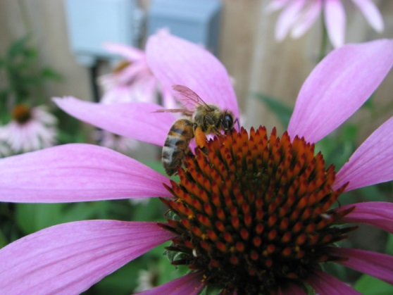
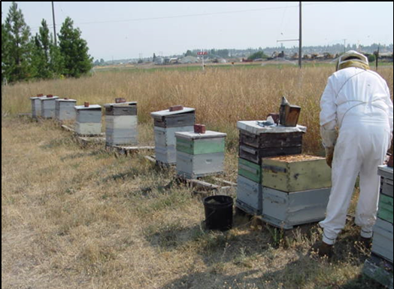
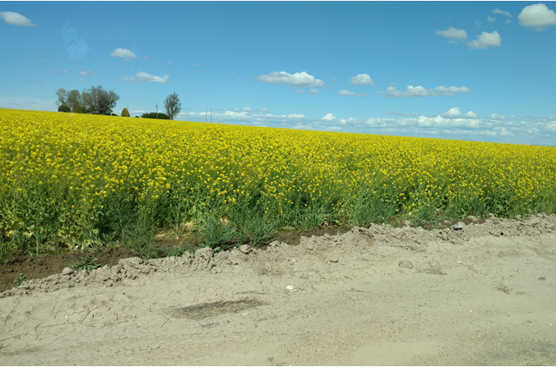
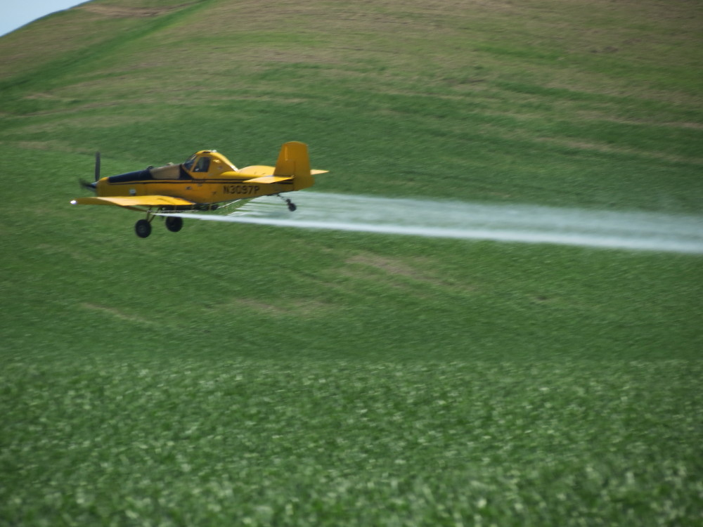
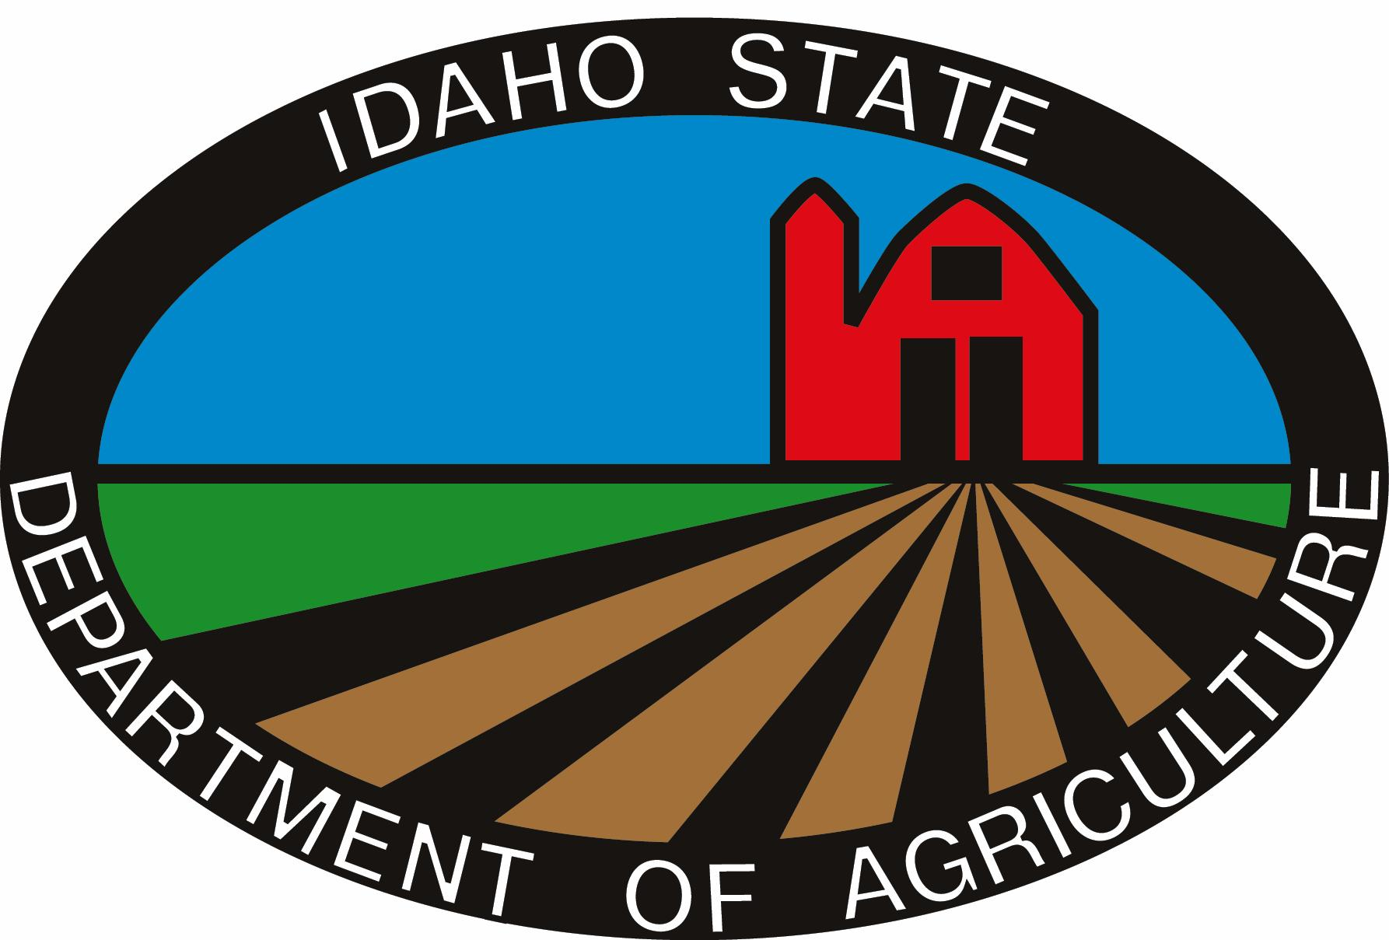
Prepared by: Division of Agricultural Resources and Division of Plant Industries
Idaho
Pollinator Protection Plan

Introduction

Wild and managed pollinators contribute substantially to the food production systems of Idaho, to the economic vitality of the agricultural sector, and to the biodiversity in the ecosystems they inhabit. Idaho has more than 11.8 million acres in agricultural production, and many of the state’s leading crops rely on insect pollination. Despite their importance to agriculture and natural ecosystems, pollinators are facing myriad problems leading to severe declines in their populations, health and habitats. The Idaho Pollinator Protection Plan has been developed to help offset some of those losses by introducing some ways that can address habitat loss, inform the general public about these issues and help pollinators maintain healthy populations.

The Plan

The goal of the Idaho Pollinator Protection Plan is to create awareness of the importance of pollination to the state, by both the commercial honey bee industry and by native pollinating insects. The plan presents beneficial actions and Best Management Practices (BMPs) that can address the major issues that are known to currently impact pollinators. BMPs suggested in this document aim to reduce risks and increase the health of pollinators. The primary purpose of the plan is to establish a systematic and comprehensive method for beekeepers, growers, pesticide applicators, private landowners and public land managers to cooperate and communicate in a timely manner that allows all parties to operate successfully within the state. The plan is not designed to eliminate or further restrict pesticide use or to ban the use of pesticides in hives or in close proximity to hives.

Implementing the Plan

This plan is meant to be an educational tool. Implementing the plan is not something any one person, organization, or industry can do alone. Idaho State Department of Agriculture will house the plan, but advertising the plan and putting it to use will take broad motivation and participation across and within organizations. The plan is meant as a starting point for action and the information it contains can be summarized and tailored for specific projects.

Factors Impacting the Health of Honey Bees

Idaho is home to over 400 species of pollinators and protecting and reducing the risks to pollinators is crucial for their long term survival. A wide range of factors has been associated with pollinator declines: habitat loss, nutritional deficiency, parasites, pathogens, pesticide exposure, beekeeping practices, and extreme weather events (e.g., drought or winter cold). Also, there are many other complex challenges facing beekeepers in keeping colonies alive and healthy.

Habitat loss and nutritional deficiency: Pollinator habitat needs differ by species, but one thing all pollinators require is blooming flowers that produce pollen and nectar throughout their lifetimes. Pollinators also need places to nest or lay eggs, host plants for larvae, and overwintering sites. Diverse plant communities can support diverse pollinator communities in gardens, roadsides, farm fields and prairies. In landscapes with fewer plant species, opportunities for pollinator nesting and foraging are more limited.

There are many opportunities to integrate pollinator habitat into both agricultural and urban areas in Idaho. These landscapes can incorporate nesting habitat and a diverse array of wildflowers, which are needed to accommodate both nesting and nutritional needs for a variety of pollinators. Bees and other pollinators require habitat for both nesting and feeding season to accommodate pollinators’ nesting and nutritional needs. Land managers, growers, lawn care professionals, and gardeners can aid pollinators by modifying current management practices to improve existing habitat, or by creating new habitats. With the right design, these actions can also provide other mutually beneficial ecosystem services, like erosion control, nutrient recycling, water purification and recharge, and harboring insects that feed on pests.

Pathogens and Parasites:
The invasive Varroa mite (Varroa destructor) appears to be the main culprit in pathogen-related honey bee colony loss. Not only does the mite weaken honey bees by feeding on their blood (hemolymph), mites can transfer a number of debilitating pathogens, like deformed wing virus (DWV) and Israeli acute paralysis virus (IAPV). The mite’s original host is the Asiatic honey bee (Apis cerana) but it now proliferates in European honey bee colonies, and since the 1950s, has been transported globally. The Asiatic honey bee displays grooming behavior that effectively combs off and kills the mites, but this grooming behavior is not common in the more vulnerable European honey bee.

Although the Varroa mite parasitizes only honey bees, honey bee viruses have been found in bumblebee, solitary bee, wasp, ant and flower fly species. Transmission of pathogens among individuals of different species can be direct or indirect. Direct transmission occurs when a pathogen spreads directly from one individual to another, for example, when bumble bees or wasps enter an infected honey bee colony and become infected themselves. It is critical for all beekeepers, including hobbyists, to periodically check their hives for disease and other pests and to control those pests. Controlling pests is critical to prevent disease and pest transmission to other pollinators and commercial hives.

Pesticide Exposure:
Pesticides are substances meant to deter or kill organisms considered to be pests, including insects (insecticides), weedy plants (herbicides), fungi (fungicides), mites (miticides), and many others. The use of some pesticides can affect pollinator health, when used improperly. Pesticide label directions are regulated by the Environmental Protection Agency (EPA) and State Departments of Agriculture. These label restrictions are intended to reduce risk to humans, other organisms and the environment. Pesticides that adversely affect pollinators include specific label language related to honey bees and pollinators and must be followed to prevent adverse effects. Pesticide regulations require that all pesticide label directions be followed.

Integrated pest management (IPM) aims to focus pest management on a variety of pest control actions, with pesticides being one of the options. IPM strategies prioritize preventative solutions to pest problems, such as crop rotation and providing habitat for natural predators of crop pests (biological control agents). This also decreases the probability of pesticide resistance (when a pesticide is no longer effective at controlling the target pest) and minimizes pesticide exposure to non-target organisms, including pollinators. When preventative IPM measures are not enough to contain a pest outbreak, use of pesticides is warranted. While each pest situation is different, these components for diagnosing and managing pest issues are common across IPM programs:

- Preventing pest problems
- Pest identification
- Monitoring and assessing pest numbers and damage
- Guidelines for when management action is needed
- Evaluating risk to the environment and non-target organisms, and choosing options that reduce risk
- Using a combination of biological, cultural, physical/mechanical and chemical management tools

Beekeeping Practices:
Good beekeeping practices can ensure managed bees have adequate sources of food and water while minimizing the spread of disease among nearby hives and wild pollinator populations. Beekeepers decide where to place hives based on a number of factors: nutritional quality of flowering plants in the area, presence of flowers that will produce desirable honey flavors, and opportunities to provide crop pollination services.

Pollinator health concerns in beekeeping heightened in the 1980s, when the Varroa mite was discovered in the United States. Effectively managing mites and pathogens in honeybee colonies is crucial for controlling disease spread among hives and from hives to wild pollinator populations, but treatments must be chosen carefully to minimize harm to colonies. Treating hives with pesticides or antibiotics can disturb the complex community of beneficial microbes that aid bee digestion, immune function, and larval development. It is therefore important to use approved products and treat only after hive ailments are accurately diagnosed.

Native and Solitary Bees

There are approximately 3,600 species of native bees in the United States. The vast majority of bee species are solitary, with about 70% nesting in ground tunnels and about 30% nesting in wood or stems. Native bees also provide important pollination services to the agriculture sector. Native bees play a key role in ecosystem function, as an estimated 85% of flowering plants require a pollinator. In addition to the contributions made to our food supply, native pollinators also provide pollination services for approximately one-quarter of the plants that provide the diets for wild birds and mammals. Solitary bees (mason bees, leafcutter bees) are excellent pollinators, making them increasingly important components of natural and agricultural systems, especially in light of ongoing declines of honey bees and other native pollinators.

While solitary and other native bees face many of the same threats as managed honey bees, their biology, behavior, and size are different enough that some honey bee protections do not protect their habitat. There are many issues surrounding solitary bees that are different from those faced by honeybees. Solitary bees (Leafcutter and Mason Bees) use leaves and mud to build nests and cannot be easily moved out of harm’s way. Most solitary bees have been reported to use only a single kind of nesting material and some ground nests require specific soil characteristics. Solitary bee populations are typically more vulnerable to losses, due to low reproductive potential (females lay few eggs and reproduce only once per year) that hinders their ability to recover from habitat loss, severe weather events, or biocide application. Each female killed while foraging, impacts production for an entire pollination season. New research about the effects of chemical sprays on solitary bees is readily available and exposure may be reduced by incorporating additional information into application decisions and management plans. Native pollinator decline is often linked to habitat degradation, fragmentation, and loss, which can be lessened by enhancement of pollinator habitat featuring native plants on private, state and federal lands, including parks, natural areas and roadsides. Private, state and federal land caretakers are encouraged to conserve and/or enhance pollinator habitat by planting native pollinating plant species whenever possible.

Extreme Weather:
Annual surveys of honeybees and monarch butterflies show that some of the most significant population losses follow harsh seasons or extreme weather events. Unlike other bee species, honeybees overwinter as adults. Each honeybee colony needs at least 60 to 90 pounds of honey to survive a moderate winter, and starvation may result from inadequate honey stores if colonies are not provided supplemental food. Migratory monarch butterflies also overwinter as adults, with eastern North American populations congregating in the Oyamel Fir forests of central Mexico, and western populations migrating to coastal California. Extreme winter storms in either area can decimate the monarch population, necessitating many generations to recover from such a setback. Monarchs are sensitive to large temperature fluctuations; they cannot survive consistent temperatures below freezing, but may use up their fat stores before spring migration if winter temperatures are too warm. In the summer, droughts can adversely affect all pollinators by limiting the availability of nectar-producing flowers.

Idaho Apiary Program

The Idaho State Department of Agriculture (ISDA) has statutes and rules that require commercial beekeepers to register their colonies. Registered beekeepers are also required to mark their colonies with the name, address, phone number and state registration number of the owner. Title 22, Chapter 25, Bee Inspection statute is located at the following link: http://www.legislature.idaho.gov/idstat/Title22/T22CH25.htm. The Idaho Rules Under the Idaho Bee Inspection Law, IDAPA 02.06.03, are located at the following link: http://adminrules.idaho.gov/rules/current/02/0630.pdf. ISDA maintains a list of registered beekeepers, by county, with contact information available to licensed pesticide applicators, abatement or pest control district, or University of Idaho extension personnel, to help prevent accidental poisoning of pollinators with pesticides. Copies of these lists must be requested, in writing, from ISDA.

Idaho Pesticide Law and Rules

ISDA also has statutes and rules that require growers and professional applicators to be licensed for certain types of pesticide applications. There are specific rules to help reduce the risks in protecting pollinators from pesticide exposure. Certain pesticide labels are designed to help protect pollinators. Title 22, Chapter 34, Pesticides and Chemigation statute is located at the following link: http://www.legislature.idaho.gov/idstat/Title22/T22CH34.htm. The Idaho Rules Governing Pesticide and Chemigation Use and Application are located at the following link: http://adminrules.idaho.gov/rules/current/02/0303.pdf. When reported, ISDA may investigate pollinator kills that are allegedly caused from an exposure to pesticides. ISDA uses the guidelines developed by the Environmental Protection Agency https://www.epa.gov/sites/production/files/2013-09/documents/bee-inspection-guide.pdf.

Idaho State Wildlife Action Plan
The Idaho State Wildlife Action Plan (SWAP) is the state’s guiding document for managing and conserving at-risk species—or Species of Greatest Conservation Need (SGCN)—and the habitats upon which they depend (https://idfg.idaho.gov/swap). Beyond assessing the health of Idaho’s wildlife and habitats, this proactive plan prescribes actions to conserve wildlife and vital habitat before they become too rare and costly to protect. In contrast to the first iteration of the SWAP in 2005, the 2015 revision includes at-risk invertebrate taxa, including insect pollinator taxa, and recognizes pollinator declines as an emerging conservation issue. Of the 205 SGCN identified in the SWAP, 22 are native bee, butterfly, and moth pollinators. The SWAP provides key partners and other interested stakeholders voluntary guidance on conservation actions intended to benefit SGCN pollinators stepped down to Idaho’s 14 ecological regions. The SWAP also includes individual species assessments for each SGCN, summarizing species conservation status and classification, distribution and abundance, habitat and ecology, threats, and conservation actions.

Issues for Growers

Idaho growers are responsible for producing an affordable, safe, abundant and high-quality food and feed supply for the U.S. and worldwide. They must be good stewards of the land and protect the environment to continue producing the crops that are in high demand. Growers understand the importance of protecting pollinators, but they also have to deal with a significant number of pest problems in order to maintain high yields, provide quality products and to stay in business.

There are a number of control measures growers can use when dealing with various pest management decisions, such as cultural, biological and chemical control. Any one of these types of control measures can have a negative impact to pollinators. Biological and cultural control measures could be used to remove or control weeds that are attractive to pollinators, but also reduces habitat. Alternative control measures may not be as good or cost effective for growers. When a pest problem is not adequately controlled, this can reduce yields and profit margins for a grower. Growers often face big challenges in their efforts to balance the use of pesticides to protect orchards and crops from insect pests, and yet protect the pollinators that are also necessary to pollinate the same crops. Other instances are when growers are unaware of where pollinator colonies are located. Crops that are not attractive to pollinators can be sprayed with pesticides at any time during the day, but the pollinators may be flying over these fields to get to a blooming field that they are attracted to, which can result in significant pollinator kills. Keeping adequate distances between the hive and treated field is an important factor in preventing pollinator deaths from treatments to fields not directly being visited by the pollinators.

Issues for Pesticide Applicators

Idaho has over 10,000 individuals certified and licensed to apply pesticides. Approximately 9,600 applicators are certified to apply insecticides in agricultural and/or nonagricultural settings. The 9,600 applicators consist of over 3,600 licensed private applicators and approximately 6,000 professional applicators. Licensed applicators are aware of the adverse effects pesticides can have to pollinators and the environment, and they understand what precautionary measures are needed to prevent adverse effects from pesticides. There are many factors that applicators must consider when making a pesticide application to a labeled site, such as pest type, infestation level, class of pesticide, timing of application, stage of growth for the target pest, weather conditions, buffers for sensitive areas, pollinators, ground and surface water, organic crops, etc. In many instances, professional applicators may not be familiar with the area and they rely on the grower or crop consultant to inform them of sensitive crops or pollinators in the area. Unfortunately, this information may not always be communicated to the applicator or it is unknown whether pollinator colonies are located in the general vicinity. At times, applicators are caught in the middle when having to control insect pests for the grower and protecting pollinators.

When Pollinators Become a Pest Problem

On occasion, pollinators can become a pest problem when they swarm or establish hives in residential areas. This can be a major medical concern for individuals who are highly allergic to bee stings or for parents that are concerned for the safety of their children. When these situations occur, it is recommended that the homeowner or applicator first contact a local beekeeper to collect the honey bees. Check the following website to find beekeepers willing to collect honey bee swarms in residential areas: www.idabees.org. If a beekeeper is unable to collect the bees, then it may be necessary to control them with a properly labeled pesticide.

Communication

Communication between the beekeeper, grower and the applicator is critical in protecting pollinators from exposure during pesticide applications. All individuals must work cooperatively in determining what the best pest management strategy is and how to protect or reduce the risks to pollinators. Communication seems to work well when growers contract with beekeepers for pollination services; however, it is much more difficult when beekeepers locate their colonies in agricultural areas and don’t inform other growers in the area that hives are present. Growers and applicators also need to understand that it can be very difficult for beekeepers to move their colonies. There is a certain amount of bee loss when beekeepers move their hives, but it may also be difficult to find a location where no pesticides are being applied in agricultural areas. When beekeepers locate their pollinator colonies in agricultural areas, they must also understand that there is a risk of losing some of their pollinators from exposure to pesticides. Beekeepers need to let growers know if there are pollinator colonies in the area and work with growers and applicators, so growers can protect their crops from invading insect pests, while reducing the risks to the pollinators.

- Maintain positive and open relationships with growers who lease your hives for pollination.
- Agree upon timing and location of hive placement prior to crop bloom and colony removal after bloom.
- Discuss and determine the pesticide spray schedule and types of pesticides used (including insecticides, fungicides, and insect growth regulators (IGRs)). A helpful online tool (http://www2.ipm.ucanr.edu/beeprecaution/) ranking pesticides and tank mixes by honey bee toxicity is available from University of California Statewide Agricultural & Natural Resources Integrated Pest Management Program (UC IPM).
- Use a contract that protects both the grower and beekeeper. A template contract based on USDA guidelines is provided by University of Florida, Extension 13.
- Be aware of property boundaries. Public land agencies differ in their policies regarding managed species – some allow hives with a conditional use permit, and some do not allow them in any case. Public lands are often attractive areas for honey bee foraging, and beekeepers sometimes place hives on private land adjacent to natural areas.
- Be neighborly. If you are considering keeping hives near property lines, communicate your intentions with neighbors and be sensitive to their concerns about the placement of hives.
- Check with your local municipality for any beekeeping ordinances.

Best Management Practices

Best management practices (BMPs) are methods and techniques used to achieve a desired outcome in an efficient and cost-effective manner. As defined in this plan, BMPs are voluntary actions protecting native and managed pollinators in a way that ensures both a healthy pollinator population and a thriving agriculture industry in Idaho. Successful implementation of BMPs requires regular, positive communication and is the responsibility of all stakeholders. Please refer to the appendices below for all BMPs recommended by ISDA.

Beekeeper BMPs

Work with landowners when choosing hive locations. Get permission from the landowner every year prior to placing colonies in a specific area. It is important that everybody understands that hives are not placed without first obtaining permission. Select a location to ensure that the pollinators or hives do not create a nuisance. Ideal hive locations will have minimal impacts on agricultural activities, but will still have adequate access to forage and water. Be familiar with cropping practices and changing crop rotations in a specific area. Avoid placing hives in low lying areas or right next to roads to minimize the impacts from drift or temperature inversions. Beekeepers should also request applicator contact information from the landowner in order to help coordinate spray activities or take precautions to protect hives when applications take place. If hives are placed within a Mosquito Abatement District, notify the District concerning hive locations and provide them with beekeeper contact information so that spray activities in the area can be communicated. Districts should be notified when bees are moved.

Be cognizant of impacts to neighboring landowners when placing and choosing hive locations. Avoid blocking roads, trails or rights-of-way with colonies. Placing hives away from roadsides (300+ feet) can also help to avoid drift from roadside applications of pesticides. Take steps to avoid potential negative impacts when locating hives near residential areas, equipment yards, grain bins, storage sites, livestock feeding and watering areas, etc.

Ensure pollinators have sufficient resources throughout the year. Availability of pollen and water sources can change throughout the year. If blooming forage crops become limited, pollinators may become stressed, if they need to fly long distances in search of a new nectar source. An insufficient food source puts stress on the overall health of the hive, and natural sources of water may become unavailable during drought or late summer. Beekeepers should consider using stock water tanks, similar to what ranchers do to water their livestock. Avoid using the rancher’s watering tanks, as this could be bothersome for landowners and their livestock.

Work cooperatively with the landowner and the applicator when pesticide applications are scheduled to control pest problems. Beekeepers should inform applicators regarding what options are available for moving hives or protecting the hives to prevent pesticide exposure to the pollinators. Applicators need to know how much notification is necessary to move or put netting over the hives. It is also important to notify them concerning pollinator location and when they are moved. Determine the best time of day for the spray application, based upon pollinator activity. Mark hives in a way that applicators can easily identify that there are hives in the area, who owns the hives and how to contact the beekeeper. It is recommended that hives be painted white or another color that stands out from the surrounding area.

Report suspected pesticide-related bee kills to ISDA. It is important to monitor pollinators more frequently when pesticide applications are taking place in the area. When beekeepers monitor hives every 10 – 14 days, it is very difficult to determine exactly when a bee kill actually occurred. Due to multiple applications taking place in an area on multiple days, it is also difficult to determine who the responsible party might be. Some pesticides breakdown very rapidly and it is helpful to report the incident as soon as possible, so that ISDA can collect a good sample for analyzing pesticide residues. In some scenarios, the beekeeper may be asked to assist with collecting pollen and pollinator samples, especially when pollinators are highly agitated. Beekeepers can also help by maintaining good records of the number of pollinators that are dying on a daily basis to determine if the bee kill is a result of natural mortality or if the kill is rated to be low, moderate or high.

Use registered pesticides according to the label. When pests become a problem within a hive, beekeepers should use pesticides that are registered with EPA and ISDA. Beekeepers are required to read and follow the pesticide label directions. Failure to follow the label directions may decrease the effectiveness of the pesticide(s), increase the risk of adverse effects to the pollinators, result in illegal pesticide residues in the honey or honeycomb, or lead to pesticide resistance. Avoid using animal drugs or home remedies. These products do not have specific directions for use in controlling pests within a hive and can result in similar problems when applicators fail to follow the directions on a pesticide label.

Comply with all requirements of the Idaho beekeeping law and associated rules. Commercial beekeepers are required to register their pollinators and hive locations with the ISDA. ISDA will not investigate pollinator kill complaints, if the commercial beekeeper does not register their hives in accordance with the Apiary laws and rules. Although not required, some pollinator hobbyists will also register their hives with ISDA. Beekeepers must clearly post contact information and beekeeper ID number at all hive locations. Beekeepers should provide ISDA with up-to-date hive locations throughout the season.

Ensure native bumble bees are protected from risks posed by managed bumble bees
Diseases transferred from commercially managed bumble bees can pose a significant challenge to populations of wild, native bumble bees.
Recommendations:
- Avoid the use of non-native commercial bumble bees.
- If native bumble bee species are used in commercial operations, ensure that they are produced within their native ranges.
- Develop a screening system to ensure that any managed bumble bees are free of pathogens and parasites.

Landowner/Grower BMPs

Work with beekeepers to select hive locations. Choose an area that will have minimal impact on farming/ranching operations, but still allow pollinators to access forage and water. The area should be easily visible for applicators to identify hive locations. Inform beekeepers of the preferred routes to travel when gaining access to hive locations.

Communicate with beekeepers. Communicate with beekeepers to let them know when pesticide applications are being scheduled and allow adequate time for notifications, so the beekeeper can take precautions to protect or move hives. Provide contact information to the beekeeper for the applicator(s), renter and neighbors.

Communicate with renters, pesticide applicators and agronomists. Landowners and renters should discuss pollinator issues and determine which one has the authority to allow pollinators on the property, as well as how long they will be present and where the hives should be located on the property. When hiring a professional applicator, make sure the applicator is aware that pollinators are present on the property and where the hives are located. Let your agronomist or crop consultant know that pollinators are present. This will enable them to make proper recommendations for pesticide selections, select the proper timing of applications for controlling pest problems and reducing risks to pollinators. If there are multiple pesticides that can adequately control the pest problem, choose the pesticide that has a lower toxicity to pollinators whenever possible. Avoid plants that are, or potentially could become, invasive species. Do not plant or distribute weeds from the Idaho Noxious Weed list, which can be found at http://invasivespecies.idaho.gov/plants/. A plant is designated noxious in Idaho when it is considered to be injurious to public health, agriculture, recreation, wildlife, or property.

Plant pollinator friendly forage areas. Planting flowering plants, trees and shrubs that are attractive to pollinators in non-farmable or non-cropland areas can provide pollinators with a nearby forage source. Each landowner should strive to allocate some cropland to native pollinating plants.

Some pesticide labels require untreated vegetative buffer strips near surface waters. Selecting flowering plants that are attractive to pollinators for vegetative buffer strips can help maintain healthy hives by providing a good forage area near a water source. This may also help keep pollinators from visiting or traveling over agricultural crops to get to foraging areas long distances away from the hives.

Beneficial Practices for Pollinators

Location of Practice | Management Practice | Potential Benefits
Outside crop fields | * Leave existing nesting habitat (dead wood, bare patches of soil, hollow stems, bunch grasses)  *Add wildflower strips or flowering hedgerows on slopes, field margins or roadside ditches. | *Pollinator communities can be maintained long-term if nesting habitat is located near flowering crops.  *Higher yields of adjacent pollinator-dependent crops. Strips can be configured to prevent loss of water, soil and nutrients from crop fields.
Within crop fields | *Use pollinator attractive plants for intercropping or cover cropping  *Grow multiple types of blooming crops  *Reduce tillage intensity | * Higher yields of adjacent pollinator-dependent crops.  * Increased pollinator health and diversity; higher yields of pollinator-dependent crops; diversified income streams.
Within and outside crop fields | *Minimize the use of pesticides with negative effects on beneficial species  * Change mowing or haying practices  * Reduce field size | * Choosing pesticides with less negative effects to pollinators can often increase all beneficial species populations.  * Pollinators benefit when flowering plants are allowed to bloom in field margins or between crop rows (particularly when crop is not blooming)
Pastures | * Incorporate legumes into pastures. Rotate grazing so that some paddocks allowed to fully bloom. | * Blooming forage crops like clovers can increase pasture production while benefiting both grazers and pollinators.

Pesticide Applicator & Crop Advisor BMPs

Use Integrated Pest Management (IPM) Principles. Scout fields and determine economic thresholds before using pesticides to manage pest problems. Look at other alternatives for controlling pests, before using pesticides. Applicators are required to only use pesticides that are registered with the state and the USEPA and only apply them in accordance with the product’s labeling and the Pesticide Rule.

Identify and notify beekeepers in the area prior to pesticide applications. Growers and crop advisors need to communicate with the applicator to determine if there are pollinators located in the area. Applicators can obtain a list of beekeepers from ISDA to determine in which cities or counties hives are located (See the section on the Idaho Apiary Program for more details). Pollinators are known to travel several miles to find quality forage. Growers or crop advisors should notify beekeepers with hives located within a 1-2 mile radius of the treated field (“pollinator awareness zone”). Notification should be provided at least 48 hours prior to the application, in order to give the beekeeper ample time to protect or move the hives. If the hives cannot be netted or moved, the grower or crop advisor and beekeeper should develop a mutually acceptable strategy to control the pest, while mitigating risk to the pollinators. Notification of beekeepers does not exempt applicators from complying with pesticide label requirements, or the rules protecting pollinators.

Choose products with lower risk to pollinators. The Oregon State University Extension Publication, PNW 591, “How to Reduce Bee Poisoning from Pesticides” is located at the following link: https://catalog.extension.oregonstate.edu/files/project/pdf/pnw591.pdf . This publication provides a list of pesticides and rates for the level of toxicity to pollinators. Selecting the proper formulation of a pesticide can also influence the impact to pollinators. Dusts and wettable powder formulations can leave residues that may stick to the hairs on pollinators and be transported back to the hives. Choose products with less residual toxicity to pollinators. A highly toxic insecticide with a short half-life may be better than a low toxic insecticide with a longer residual half-life.

Use proper timing to apply pesticides that are toxic to pollinators. Some residual pesticide applications may be made pre-bloom to help control anticipated pest problems for crops that are attractive to pollinators. If blooming crops attractive to pollinators must be sprayed, it is best to spray in early morning (no later than three hours after sunrise) or late evening (no sooner than three hours before sunset) when pollinator activity is lowest. Night time spraying can also help protect pollinators from pesticides. Pollinators typically become active once ambient temperatures start to get above 50° F.

Supporting Pollinator Forage & Habitat

Providing a high diversity of flowering plants throughout the growing season is the most important action that can be taken to promote healthy pollinator communities. Pollinator habitat can be provided in small patches of land, large continuous fields, or linear strips, as in the case of roadsides and other rights-of-way. Collectively, these efforts can improve pollinator health, diversity and abundance. Open prairies, savannas and forest edge habitats provide plentiful nesting and forage opportunities for pollinators throughout the year. Because a small fraction of Pacific Northwest land contains these habitat types, each opportunity for restoring or improving pollinator habitat is crucial.

Providing pollinator habitat is a goal that complements other management goals including erosion control, native plant propagation, and wildlife habitat. Included is a section devoted to the special considerations for roadsides, but most of the BMPs outlined below apply to a wide array of habitat improvement projects on public, private and tribal land.

Pollinator Forage. Everyone can help plant forage for pollinators. Plants that support pollinators are also beneficial for other wildlife, are often visually attractive, and can help improve soil health. Flowers often come to mind when thinking about pollinators, but pollinators also utilize trees, shrubs, and other less-noticeable plants for pollen and nectar sources. It is important to consider diversity when choosing plants to ensure adequate forage throughout the entire growing season, but care must be taken to not plant noxious and harmful plants, even though they may be a good source of pollen. Diversity will also ensure that pollinators have access to all of the nutrients they require to be healthy throughout the year. Everyone can also use internet sites, such as the Xerces Society page at http://www.xerces.org/pollinators-mountain-region/, to help identify and select pollinator friendly plants for our region. Here are some easy, efficient ways to improve pollinator forage.

Municipalities can plant trees, shrubs and flowers that provide good forage for all types of pollinators. Diversity is important, the pollen and nectar of each species carries a different nutrient load for the pollinators. This can be worked into new plantings as well. Every time a plant is added or replaced, choose a variety that will contribute to pollinator forage. Foraging pollinators are typically not aggressive.

Counties can create pollinator forage along secondary roads. Secondary road ditches often contain several species of plants that provide forage for pollinators. It is a common practice to mow ditches for the safety of motorists and to prevent drifting snow. Consider spot spraying noxious weeds and mowing ditches later in the year to ensure that pollinator forage is available. Incorporate short forbs into secondary road ditches to minimize attracting large wildlife.

Homeowners can put out flower pots, create flowerbeds, plant trees or shrubs, or establish gardens that provide food and habitat for pollinators. Homeowners should also take special precaution to protect pollinators from their pesticide applications. The pesticide user BMPs apply to anyone using pesticides. Remember, the pesticide label is the law and it is in place to minimize risks to the environment and human health.

Roadsides and other rights-of-way: Rights-of-way provide nesting and egg-laying habitat for pollinators and have the potential to act as corridors for pollinator movement. When possible, rights-of-way should include flowering plants that offer nectar and pollen for pollinators. Rights-of way with native plants are especially beneficial to pollinators. Roadside maintenance requires a balancing act to control erosion, stop the spread of invasive weeds, protect driver safety, and provide attractive vistas for drivers. Once established, native plants along roadsides can fulfill all of these goals.

Create habitat for beneficial, wild pollinators. Roughly 70 percent of native bees nest in the ground. They burrow into areas of well-drained, bare, or partially vegetated soil. Other bees nest in abandoned beetle houses in snags or in soft-centered, hollow twigs and plant stems. Bees will also utilize dead trees and branches. Habitats can be created by leaving deadfalls and brush piles as nesting habitat. Consider the type of habitat you wish to create and the pollinators you want to attract.

Public land access. Since some federal and state agencies encourage pollinators on state and federal lands, beekeepers should seek out those opportunities and get permission from the agency to take advantage of pollinator-friendly habitats. Hives placed on state or federal lands also need to be registered with ISDA. Many federal agencies are putting a new emphasis on planting ground cover and trees that are pollinator-friendly. Continued emphasis on this process should be encouraging and everyone should support those activities.

It is our hope that by following these guidelines pollinator populations will increase to the benefit of all Idaho’s agricultural production and environment.

References and other resources:

Xerces Society (suggestions for choosing pollinator friendly plants)
http://www.xerces.org/pollinators-mountain-region/

Bee Informed: https://beeinformed.org/

Pollinator Partnership (Made up of 140 organizations): www.pollinator.org

North American Pollinator Protection Campaign: www.pollinator.org/nappc/

CropLife Briefing Document https://croplife.org/wp-content/uploads/pdf_files/Briefing-Preserving-the-Wellbeing-of-the-Honey-Bee.pdf

National Pollinator Health Strategy https://www.whitehouse.gov/sites/default/files/microsites/ostp/Pollinator%20Health%20Strategy%202015.pdf

EPA Best Management Practices to Protect Pollinators
https://www.epa.gov/pollinator-protection/find-best-management-practices-protect-pollinators

National Association of State Departments of Agriculture (NASDA)
http://www.nasda.org/File.aspx?id=34760

Idaho Agricultural Statistics
http://www.nass.usda.gov/Statistics_by_State/Idaho/index.php

National Pest Management Association (NMPA) http://npmapestworld.org/pollinator/bmps/

Bee Culture http://www.beeculture.com/catch-the-buzz-get-involved-in-your-states-plan-or-dont-complain-when-its-done/

Massachusetts Beekeepers Association Best Management Practices http://www.massbee.org/addons/BestPractices/BMP03-14.pdf

USDA Diagnosis of Honey Bee Diseases http://www.ars.usda.gov/is/np/pollinatordiseases/pollinatordiseases.pdf

