Join the raffle to
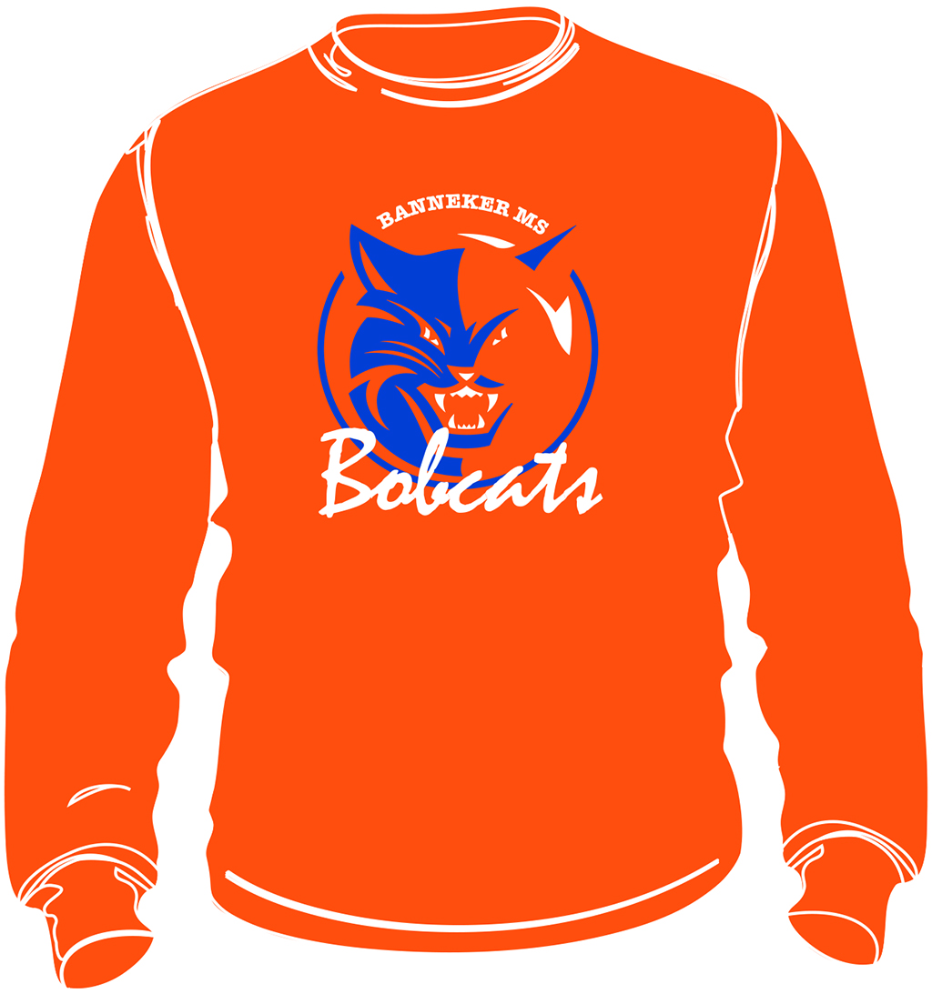
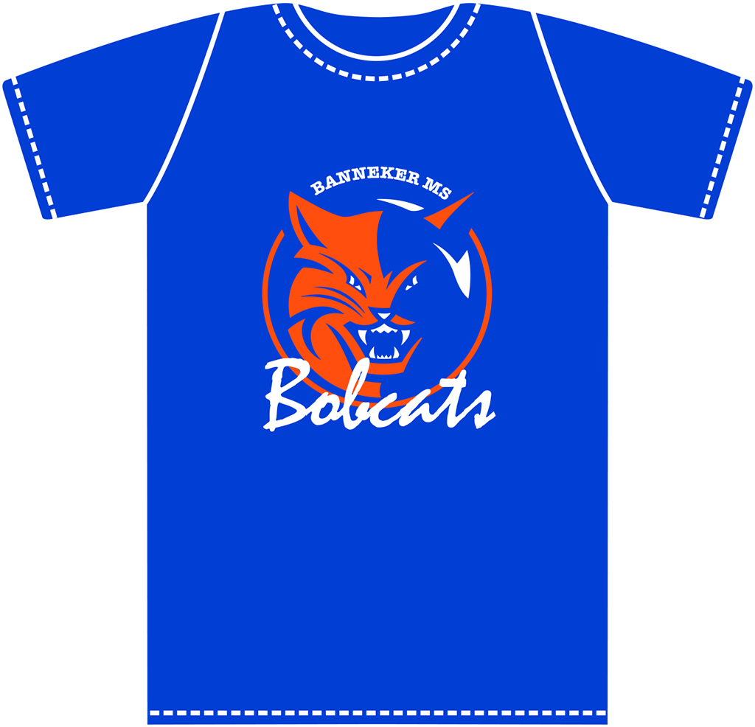
WIN A SHIRT TONIGHT!

“Like” Banneker Middle School PTSA
Tweet pix! #BannekerBTSN to @BBMSPTSA
Join online at BannekerPTSA.org

