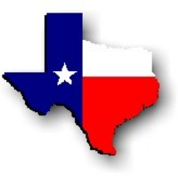Texas History with Mr. Brown Name ____________________ Period _____
Ch 11.2 Review: A Different Vision for Texas

Directions: Use Chapter 11 or your study guide to define the following terms in the space provided.
1) Cabinet -
2) Revenue –
3) Promissory Note -
4) Public Debt –

Directions: Use Chapter 11 or your study guide to answer to the following questions.
5) _______________________________________ was the second elected President of Texas.
6) Lamar wanted to continue to fight _________________________________.
7) Lamar also wanted to rid Texas of all _______________________________.
8) Lamar created more ______________ for Texas by funding military campaigns to work towards achieving his goals.
9) Who was more supportive of Natives in Texas, Sam Houston or Mirabeau Lamar? _____________________
10) Several ______________ Chiefs agreed to meet in San Antonio to discuss terms for peace on March 19, 1840.
11) This meeting broke out into a fight known as the _____________________________________________________.
12) As President of Texas, Lamar sent the Texas Navy to the Yucatecan region of _______________ to help rebels there fight against ___________________.
13) Lamar sent the _______________ _______________________ in to New Mexico to convince the people there they were part of Texas.
14) Under Lamar the Texas Congress voted to move the capital to what city? ______________________________
15) One of the complaints Texas listed in its declaration of Independence was that Mexico failed to establish a __________________________________ in Texas.
16) Because of his vision on education Lamar became known as the “____________________________________”.

