***ST. MICHAELS PATRIOT CRUISE &***

**OCEAN CITY**

**CHAPTER 1917**



***LUNCH AT THE CRAB CLAW***

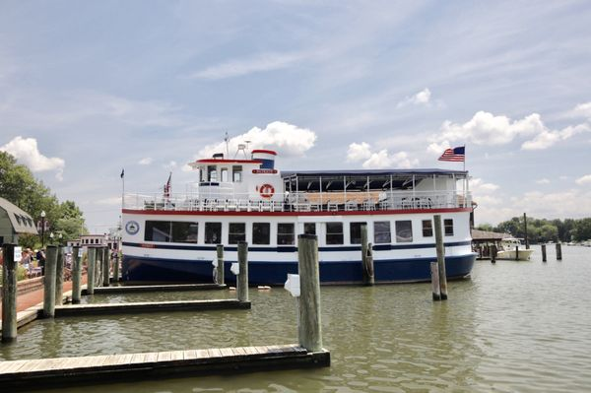

**Wednesday - June 7, 2023**

**9:15 am Departure to be determined**

# **11:00 am** Arrive at Historic St. Michaels

# **11:30 pm** Lunch at the Crab Claw Restaurant, followed by

# free time to explore the Chesapeake Bay Maritime Museum, on your own, or to stroll the waterfront and visit the shops.

# **2:10 pm** Prepare to board **“The Patriot”** for a cruise on the Miles River

**3:45 pm** Depart for Ocean City

**5:15 pm** Approximate return time to Ocean City

*Join us for a delicious luncheon featuring a combination platter of chicken and crabcake, baked potato, and vegetable. Your meal includes non alcoholic beverages, including soft drinks, roll, and sherbet for dessert.*

*Your75 minute Patriot cruise will offer you a unique view of beautiful 300 yr. old mansions, including the estate seen in “The Wedding Crashers.” Our guide will tell us about the local ecosystems and, hopefully, we’ll observe some of the wildlife.*

*The Patriot is a replica of a 1930’s working ferry. You will, however, enjoy the modern amenities of handicap accessibility; onboard restrooms; open-air upper and climate controlled lower decks; and cash beverage and snack bars.*

**TOTAL COST PER PERSON: $105.00**

**Payment Due by May 10th**

***Includes: Cruise, Lunch, Bus Transportation, Driver Tip & Water***

Cancellation Policy: Refund by replacement only*For* ***RESERVATIONS*** *and additional information, please contact:* **FRANCINE SCHAFFER AT** [**fschaffer6@gmail.com**](mailto:fschaffer6@gmail.com) **or 443-604-0955**

**---------------------------------------------------------------------------------------------------------------------------**

**NAME: _______________________________________STREET:______________________________________**

**CITY: ____________________________________STATE:_________________ZIP:_______________________**

**PHONE: _________________________CELL: _________________________E-MAIL______________________**

**TRIP: ST. MICHAELS PATRIOT CRUISE & LUNCH AT CRAB CLAW, JUNE 7, 2023__ # People: ____________**

**CASH: _____________________ CHECK#:______________________ CHECK AMT:___________________**

**I ACKNOWLEDGE THAT I HAVE READ THE TRAVEL-TRIP RULES AND AGREE TO ACCEPT [ ]**

**SIGNATURE: _____________________________________________________Date__________________**

**MAKE CHECKS FOR TRIP PAYABLE TO: AARP 1917 Travel**

**MAIL TO: PO Box 4193, Ocean City, MD 21843** *DISCLAIMER: These trips are a project of and are offered to the Ocean City, MD Chapter 1917 of AARP. The chapter and any agent it may use in arranging these or any other trips are not responsible in whole or in part to the traveling member for any loss, damage, or injury, whether financial or otherwise, to persons or property, however caused during or in with these or any other trips. These trips are activities conducted by Ocean City, MD AARP 1917 and are in no way offered, sponsored or conducted by AARP, which has no responsibility with such trips.*