Do you remember Santa Claus Lane? Do you love to decorate for the holidays?
Please consider participating in the…
1St Annual California Borough
HOLLY DAY HOUSE
Decorating Contest!
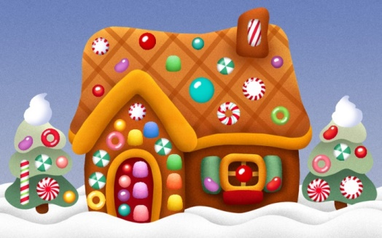

Decorate the outside of your house & your yard and encourage your neighbors to decorate, too!

Registration
Wednesday November 1st – Thursday November 30th, 2017
Registration forms can be found at locations around California Borough and online at www.caboroughrecauth.com

The 1st Annual Holly Day House winners will be announced on Sunday December 3rd, at 5PM during CALIFORNIA BOROUGH’S HOLLY DAY FESTIVAL! Applicants are encouraged to attend the festival but need not be present. Prizes will be awarded from California Borough Recreation Authority and Local Businesses!

Please see application for contest rules and general information.
Sponsored by California Borough Recreation Authority with the support of many local businesses.

1st Annual California
Holly Day House Decorating Contest Application
NAME
STREET ADDRESS
APARTMENTCOMPLEX NAME APARTMENT #
PHONE NUMBER
EMAIL
PLEASE LIST ANY SPECIAL DIRECTIONS ON FINDING YOUR DECORATED HOME/YARD:

Contest Rules and Information:
We encourage many to participate, however to be eligible for prizes, participants must currently have a home to decorate in California Borough, PA. All registrations must be completed and received by Thursday November 30th at 3PM. Applications can be found at various locations around California and on our website at www.caboroughrecauth.com. Completed registrations must be hand delivered to CALIFORNIA RECREATION AUTHORITY ENTRY BOX AT THE CALIFORNIA BOROUGH BUILDING. Please be aware of their office hours. All questions or concerns can be directed via email at calboroughrecauth@gmail.com or by calling Michelle at 724-255-8545.
ELVES (JUDGES) WILL BE SELECTED FROM OUTSIDE COMMUNITIES WITH LITTLE TO NO KNOWEDGE OF CALIFORIA AND ITS RESIDENTS. ELVES WILL BE ESCOURTED TO APPLICANTS ADDRESSES ON SATURDAY DECEMBER 2ND AFTER 6:30PM. PLEASE KEEP ANY AND ALL DECORATIONS AND LIGHTS ON UNTIL MIDNIGHT. PICTURES AND/OR VIDEOS MAY BE TAKEN OF YOUR DECORATED HOUSE.
A map of participating homes, registered before the deadline, will be available for viewers to ride or walk around town and look at your neighbors lights.
One 1ST Place cash prize of $250, various donations from local businesses and a bragging rights trophy with your family name on it will be awarded to the single dwelling that the elves deem most California Holly Day spirt. You must be willing to pass along the trophy the following year.
One 1St Place surprise prize will be awarded to the neighborhood/apartment complex (2 or more dwellings) or business that the elves deem most California Community Holly Day spirit.
There will also be a category voted by YOU with the Neighborhood Choice Award. You can visit the dwellings and then vote via Facebook at California Borough Recreation Authority by Saturday December 2nd 11PM. A must photo of your location must be submitted via FB prior to deadline and then you encourage people to vote for your dwelling. (Anyone that likes this page can vote 1 time.) One 1st place prize trophy will be awarded.
ALL 1st Annual Holly Day House winners will be announced on Sunday December 3rd, at 5PM during the HOLLY DAY FESTIVAL! Applicants are encouraged to attend the festival but need not be present. A Live feed on FB will also be available. Winners will be notified (if not present) by phone/email or a house visit.
*Please remember to check all lights and decorations for any and all hazards. Please use caution when using ladders, electricity, etc. Remember, Safety first. California Borough Recreation Authority cannot be held liable to any injuries, fires, etc.*
*California Borough Recreation Authority Council Volunteers and their households are not eligible for Cash prize. They are eligible for the surprise community prize and Facebook neighborhood vote.

